English Language Arts/Literacy

1st Grade

Implementing the English Language Arts Common Core State Standards

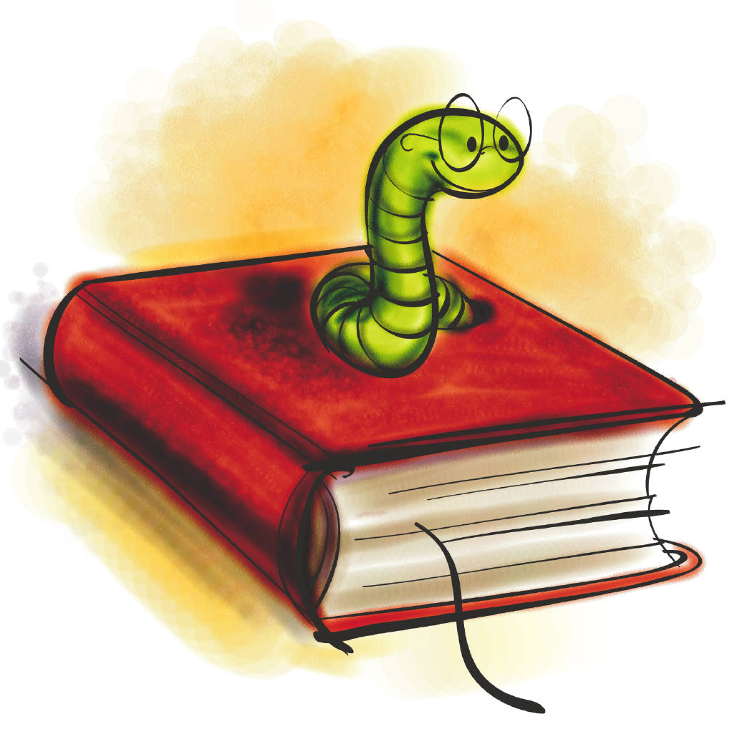

A Teacher’s Guide to the Common Core Standards: An Illinois Content Model Framework

A

*The Letter and Spirit of 1st Grade…..*

***Reading***

* *Read grade-appropriate complex poetry, literature, and informational text (RL/RI.1.10) so that students can ask and answer questions about key details in a text. (RL/RI.1.1).*
* *Delve deeply into texts to uncover both the central message and supporting details, describing the connection between individuals and events.*
* *Apply reading strategies to improve understanding and fluency.*
* *Compare and contrast two or more works with the same topic, author, or character, describing feelings of characters and the similarities and differences in text forms and the purpose of their uses.*
* *See RL/RI 1.2-9 for detailed expectations.*

***Speaking/Listening***

* *Use skills and grade appropriate vocabulary from K-1 to participate in collaborative conversations about grade1 topics to deepen understanding and comprehension.*
* *Emerge from grade 1 with an ever-expanding academic vocabulary that can be used in writing and speaking.*
* *Utilize information gathered from oral or multimedia presentations to clarify meaning or build on others’ conversations through multiple exchanges.*
* *Ask and answer questions about key details and events when appropriate to: task, situation, and audience.*

***Writing***

* *Develop and organize writing in a manner appropriate to the task and purpose through introductions, a supporting point, and a sense of closure. (W1.1-3)*
* *Participate in writing projects that focus on sequenced instructions and temporal words.*
* *Include a balance of on-demand and process writing and short, focused research projects, incorporating digital texts where appropriate and use technology and media to deepen learning and draw attention to evidence and texts as appropriate.*

***Language***

* *Locate, organize, analyze, and evaluate information acquired from a variety of sources to answer questions, solve problems, and communicate ideas through active exploration.*
* *Apply acquired information, concepts, and ideas to communicate in a variety of formats.*
* *Demonstrate and apply knowledge of the command of conventions of standard English grammar and usage when writing or speaking.*

***Word Analysis & Foundational Skills***

* *Demonstrate the basic understanding and organization of print, phonemes, and grade level phonics with sufficient accuracy and sufficiency*
* *Build word analysis skills so that students can demonstrate awareness and competency in grade appropriate phonics and decoding (RF1.3).*
* *Reading fluency assessments administered at the start of the year (and throughout the year as necessary) should be used to determine a student’s fluency level as students are given opportunities to analyze closely how syntax and the meaning(s) of the text influence expression and phrasing. (RF.1.4)*

\*Please note this tool is only one possible outline for Common Core State Standard (CCSS) classroom practice and is not intended to serve as a guide for replacing a full incorporation and implementation of the CCSS.**Model Content Frameworks**

[**www.parcconline.org**](http://www.parcconline.org)

Although PARCC has not yet designed K-2 Model Content Frameworks, the following information will assist district staff in understanding the design of these tools. Illinois has chosen to move ahead with a teacher’s guide for First grade that compliments the 3rd -11th grade teacher guides based on the PARCC information and current Illinois State Early Learning Standards.

The PARCC Model Content Frameworks are voluntary resources offered by PARCC to help curriculum developers and teachers as they work to implement the standards in their states and districts. The Model Content Frameworks offer one way of organizing the standards — in this instance into quarterly modules. Equally successful models could be based around semesters, trimesters or other school schedules. Model Content Frameworks allow educators the flexibility to order the modules and the content within the modules in any way that suits their desired purposes. Because the knowledge and skills embedded across the four modules address all the standards for a given grade level, the order in which the four modules may be used is not critical. The Model Content Frameworks are designed with the following purposes in mind:

1. Supporting implementation of the Common Core State Standards, and
2. Informing the development of item specifications and blueprints for the **PARCC assessments** in grades 3–8 and high school.

The proposed **PARCC Assessment System** will be designed to measure knowledge, skills and understandings essential to achieving college and career readiness. In ELA/Literacy, these include the following areas as defined by the standards:

***Reading complex texts:***

1. This requires students to read and comprehend a range of grade-level complex texts, including texts from the domains of ELA, science, history/social studies, technical subjects and the arts.
2. Because vocabulary is a critical component of reading comprehension, it will be assessed in the context of reading passages.
3. Students are expected to conduct close, analytic readings as well as compare and synthesize ideas across texts.

Each module suggests both the number and types of texts that students read and analyze. Students then write about these texts either to express an opinion/make an argument or to inform/explain. In addition, research and narrative writing tasks appear in each module.

**Writing effectively when using and/or analyzing sources:**

This requires students to demonstrate the interrelated literacy activities of reading, gathering evidence about what is read, as well as analyzing and presenting that evidence in writing.

**Conducting and reporting on research:**

This expands on “writing when analyzing sources” to require students to demonstrate their ability to

1. gather resources,
2. evaluate their relevance, and
3. report on information and ideas they have investigated (i.e., conducting research to answer questions or to solve problems).

***Speaking and listening:***

This requires students to demonstrate a range of interactive oral communication and interpersonal skills, including (but not limited to) skills necessary for making formal presentations, working collaboratively, sharing findings and listening carefully to the ideas of others.

***Language use for reading, writing and speaking:***This requires students to have a strong command of grammar and spoken and written academic English.

The importance of the above skills is reflected in the emphasis the Model Content Frameworks place on students’ needing regular opportunities to grapple with the **close, analytic reading** of grade-level complex texts and to construct increasingly sophisticated **responses in writing**. The Model Content Frameworks therefore provide a helpful guide in preparing students for the future **PARCC assessments**.

Skills to Be Woven Throughout the Year

**Cite Evidence**

Students should be able to refer explicitly to the text and illustrations and photographs as the basis for answers.

**Analyze Content**

Students should carefully gather observations about a text by examining its meaning thoroughly and methodically. Teachers should encourage students to read and reread deliberately.

**Decode Words**

Students should apply their knowledge of phonics and word analysis to be able to recognize the words they encounter when reading texts.

**Conduct Discussions**

Students should engage in a range of collaborative discussions (one-on one, small group, teacher-led), to check understanding and stay on topic while explaining their understanding.

**Report Findings**  Students should tell a story, recount an experience, or report on a topic or text with appropriate facts and descriptive details, speaking clearly at an appropriate pace. .

**Read Fluently**

Students should be able to read with accuracy and fluency to comprehend texts.

**Understand and Apply Vocabulary**

Focus on academic words, or Tier 2 words, within the context of the reading and writing process; provide students with opportunities to acquire meaning through reading, writing, speaking and listening.

**Study and Apply Grammar**

While the teaching of grammar and usage should be integrated throughout the year, students may need explicit instruction and additional practice in certain areas of grammar as they appear in the context of reading, writing, and speaking.

**Digital Integration and Application**

Students will use digital tools to produce and publish writing along with analyzing multimedia illustrations and text to demonstrate understanding.

**Examples of Informational texts**: biographies and autobiographies; books about history, social studies, science and the arts; technical texts (“how to” texts), including directions, forms and information displayed in graphs, charts or maps; and digital resources on a range of topics written for a broad audience.

**Examples of Literature**: adventure stories, mysteries, folktales, legends, fables, fantasy, realistic fiction, and drama, as well as nursery rhymes, narrative poems, limericks and free verse.

**1st Grade Illinois Model Content Frameworks**

*Optional model to consider when constructing a year long course of instruction.*

**1st Quarter-Length Module**

**Reading Complex Texts**

Read grade level texts of appropriate complexity

**Read Aloud Texts to Include: (Students working toward independent reading)**

Fiction, rhymes, Draw evidence from texts and

poetry, present ideas and information.

Folktales/Fables through speaking.

Science Model responding to text through Social Studies or Arts writing.

Short Texts

Literature - 50%

Connect the extended texts to 1 or more short text(s).

Informational – 50%

**Various Extended Read Aloud Texts**

Perform a close reading allowing students to ask and answer questions to identify key ideas and details

Compare and contrast ideas across other related texts

Have text-focused discussions

Produce written work with guidance and support from adults.

Extended Text

Literature - 1 (novel, play, or longer story)

**Writing about Texts – Balance of Opinion & Informative/Explanatory**

Mix of on-demand, review, and revisions writing tasks

Build confidence and competence with technology.

C:\Users\jbrown.ROE_4\AppData\Local\Microsoft\Windows\Temporary Internet Files\Content.IE5\T79BXFNT\MC900413460[1].wmf

**Writing Piece - 1 Piece That Focuses on Opinion**

* Draw, dictate, or write one opinion piece.
* Introduce a topic or title of a book about which the student is writing.
* State an opinion and supply a reason for the opinion.
* Provide some sense of closure.
* With guidance and support from adults, respond to questions and suggestions and add details to strengthen

writing.

**Writing Research Projects**

Beneficial for the project if it connects to a short or extended text.

* Draw, dictate or write one research project to address a

topic/problem/issue with guidance and support from adults.

* Recall information from experiences or gather information from provided sources to answer questions.
* Name a topic and supply some facts about the topic.
* Provide some sense of closure.
* Present findings in a variety of modes, including in collaboration with peers.

**Writing Narratives**

* Use a mix of drawing, dictating, and writing to create one narrative in which a student recounts two or more appropriately sequenced events.
* Include some details regarding what happened, including temporal words to signal event order.
* Provide a sense of closure.
* Present findings in a variety of modes, including in collaboration with peers.

**1st Grade Illinois Model Content Frameworks**

*Optional models to consider when constructing a year long course of instruction.*

**2nd Quarter-Length Module**

**Reading Complex Texts**

Read grade level texts of appropriate complexity

**Suggested Independent Reading Texts to include but not limited to:**

Literature 1-3 Draw evidence from texts and

Poems 1-3 present ideas and information in writing

Folktale/Fable 1-2 as well as through speaking with

Science 1-2 guidance and support from

Social Studies or Arts 1-2 adults.

Short Texts

Literature - 50%

Connect the extended text to 1 or more short text.

Informational – 50%

**Various Extended Read Aloud Texts**

Perform a close reading allowing students to ask and answer questions to identify key ideas and details

Compare and contrast ideas across other related texts

Have text-focused discussions

Produce written work with guidance and support from adults.

Produce written work

Extended Text

Informational – 1 (e.g., biography, “how to”

technical text)

**Writing about Texts - Balance of Opinion and Informative/Explanatory**

Mix of on-demand, review, and revision writing tasks

Build confidence and competence with technology

C:\Users\jbrown.ROE_4\AppData\Local\Microsoft\Windows\Temporary Internet Files\Content.IE5\T79BXFNT\MC900413460[1].wmf

**Writing Piece– One Piece That Focuses on Informing/Explaining**

* Use a mix of drawing and writing for one informational or

explanatory piece.

* Name a topic and supply some facts about the topic.
* Provide some sense of closure.

**Writing Research Projects**

Beneficial for the project if it connects to a short or extended text.

* Use a mix of drawing and writing for one research project to

address a topic/problem/issue.

* Recall information from experiences or gather information from provided sources to answer questions.
* Name a topic and supply some facts about the topic.
* Provide some sense of closure.
* Present findings in a variety of modes, including in collaboration with peers.

**Writing Narratives: (move most expectations to writing by end of second quarter)**

* Draw and write one narrative in which a student recounts two or more appropriately sequenced events.
* Include some details regarding what happened, including temporal words to signal event order.
* Provide a sense of closure.
* Present findings in a variety of modes, including in collaboration with peers.

**1st Grade Illinois Model Content Frameworks**

*Optional models to consider when constructing a year long course of instruction.*

**3rd Quarter-Length Module**

**Reading Complex Texts**

Read grade level texts of appropriate complexity

**Suggested Independent Reading Texts to include but not limited to:**

Literature 1-3 Draw evidence from texts and

Poems 1-3 present ideas and information in writing

Folktale/Fable 1-2 as well as through speaking with

Science 1-2 guidance and support from

Social Studies or Arts 1-2 adults.

Short Texts

Literature - 50%

Informational – 50%

Connect the extended text to 1 or more short text.

**Various Extended Read Aloud Texts**

Perform a close reading allowing students to ask and answer questions to identify key ideas and details

Compare and contrast ideas across other related texts

Have text-focused discussions

Produce written work with guidance and support from adults.

Produce written work

Extended Text

Literature - 1 (novel, play or longer story)

**Writing about Texts– Balance of Opinion and Informative/Explanatory**

Mix of on-demand, review, and revision writing tasks

Build confidence and competence with technology

**Writing Pieces – One Piece That Focuses on Opinion**

* Write one opinion piece.
* Introduce a topic or name the book they are writing about.
* State an opinion and supply a reason for the opinion.
* Provide some sense of closure.
* With guidance and support from adults, respond to questions and suggestions and add details to strengthen

writing.

**Writing Research Projects**

Beneficial for the project if it connects to a short or extended text.

* Write one research project to

address a topic/problem/issue.

* Recall information from experiences or gather information from provided sources to answer questions.
* Name a topic and supply some facts about the topic.
* Provide some sense of closure.
* Present findings in a variety of modes, including in collaboration with peers.

**Writing Narratives: (expectations are to write and exclude most drawing to represent ideas)**

* Write one narrative in which a student recounts two or more appropriately sequenced events.
* Include some details regarding what happened, including temporal words to signal event order.
* Provide a sense of closure.

**1st Grade Illinois Model Content Frameworks**

*Optional models to consider when constructing a year long course of instruction.*

**4th Quarter-Length Module**

**Reading Complex Texts**

Read grade level texts of appropriate complexity

**Suggested Independent Reading Texts to include but not limited to:**

Literature 1-3 Draw evidence from texts and

Poems 1-3 present ideas and information in writing

Folktale/Fable 1-2 as well as through speaking with

Science 1-2 guidance and support from

Social Studies or Arts 1-2 adults.

Short Texts

Connect the extended text to 1 or more short text.

Literature - 50%

Informational – 50%

Extended Text

**Various Extended Read Aloud Texts**

Perform a close reading allowing students to ask and answer questions to identify key ideas and details

Compare and contrast ideas across other related texts

Have text-focused discussions

Produce written work with guidance and support from adults.

Produce written work

Informational -1 (e.g., science or social studies

or “how to” technical text)

**Writing about Texts- Balance of Opinion & Informative/Explanatory**

Mix of on-demand, review, and revision writing tasks

Build confidence and competence with technology

**Writing Pieces– One Piece That Focuses on Informing/Explaining**

* Write one informational or explanatory piece.
* Name a topic and supply some facts about the topic.
* Provide some sense of closure

Beneficial for the project if it connects to a short or extended text.

**Writing Research Projects**

* Write 1 research project to address a topic/problem/issue.
* Recall information from experiences or gather information from provided sources to answer questions.
* Name a topic and supply some facts about the topic.
* Provide some sense of closure.
* Present findings in a variety of modes in including in collaboration with peers.

**Writing Narratives**

* Write one narrative in which a student recounts two or more appropriately sequenced events.
* Include some details regarding what happened, including temporal words to signal event order.
* Provide a sense of closure.

Writing Standards Progression from Grade K to Grade 1

In grade 1, students write to introduce topics and support ideas from experiences and sources. Additionally, with guidance and support from adults, they use technology to produce and publish writing. They are also expected to meet the grade-specific grammar and conventions standards and retain or further develop the skills and understandings mastered in preceding grades (refer to L.1.1-2).

|  |  |
| --- | --- |
| **Grade K, Standard 4 (W.K.4)** | **Grade 1, Standard 4 (W.1.4)** |
| (Begins in grade 3) | (Begins in grade 3) |
| **Grade K, Standard 5 (W.K.5)** | **Grade 1, Standard 5 (W.1.5)** |
| With guidance and support from adults, respond to questions and suggestions from peers and add details to strengthen writing as needed. | With guidance and support from adults, focus on a topic, respond to questions and suggestions from peers, and add details to strengthen writing as needed. |
| **Grade K, Standard 6 (W.K.6)** | **Grade 1, Standard 6 (W.1.6)** |
| With guidance and support from adults, explore a variety of digital tools to produce and publish writing, including in collaboration with peers. | With guidance and support from adults, use a variety of digital tools to produce and publish writing, including in collaboration with peers. |
| **Grade K, Standard 7 (W.K.7)** | **Grade 1, Standard 7 (W.1.7)** |
| Participate in shared research and writing projects (e.g., explore a number of books by a favorite author and express opinions about them). | Participate in shared research and writing projects (e.g., explore a number of “how-to” books on a given topic and use them to write a sequence of instructions). |
| **Grade K, Standard 8 (W.K.8)** | **Grade 1, Standard 8 (W.1.8)** |
| With guidance and support from adults, recall information from experiences or gather information from provided sources to answer a question. | With guidance and support from adults, recall information from experiences or gather information from provided sources to answer a question. |
| **Grade K, Standard 9 (W.K.9)** | **Grade 1, Standard 9 (W.1.9)** |
| (Begins in grade 4) | (Begins in grade 4) |
| **Grade K, Standard 10 (W.K.10)** | **Grade 1, Standard 10 (W.1.10)** |
| (Begins in grade 3) | (Begins in grade 3) |

Specific changes in the Writing Standards from grade K to grade 1 are highlighted in the chart below:

|  |  |
| --- | --- |
| **Grade K, Standard 1 (W.K.1)** | **Grade 1 Standard 1 (W.1.1)** |
| Use a combination of drawing, dictating, and writing to compose opinion pieces in which they tell a reader the topic or the name of the book they are writing about and state an opinion or preference about the topic or book (e.g., *My favorite book is…).* | Write opinion pieces in which they introduce the topic or name the book they are writing about, state an opinion, supply a reason for the opinion, and provide some sense of closure. |
| **Grade K, Standard 2 (W.K.2)** | **Grade 1, Standard 2 (W.1.2)** |
| Use a combination of drawing, dictating and writing to compose informative/explanatory texts in which they name what they are writing about and supply some information about the topic. | Write informative/explanatory texts in which they name a topic, supply some facts about the topic, and provide some sense of closure. |
| **Grade K, Standard 3 (W.K.3)** | **Grade 1, Standard 3 (W.1.3)** |
| Use a combination of drawing, dictating, and writing to narrate a single event or several loosely linked events, tell about the events in the order in which they occurred, and provide a reaction to what happened. | Write narratives in which they recount two or more appropriately sequenced events, include some details regarding what happened, use temporal words to signal event order, and provide some sense of closure. |

Speaking and Listening Standards Progression from Grade K to Grade 1

In grade 1, students speak with growing maturity to convey ideas and information clearly. They are simultaneously developing listening skills that allow them to participate effectively and contribute to groups.

Specific changes in the Speaking and Listening Standards from grade K to grade 1 are highlighted in the chart below:

|  |  |
| --- | --- |
| **Grade K, Standard 1 (SL..K.1)** | **Grade 1, Standard 1 (SL.1.1)** |
| Participate in collaborative conversations with diverse partners about *kindergarten topics and texts* with peers and adults in small and larger groups.   1. Follow agreed-upon rules for discussion (e.g., listening to others and taking turns speaking about he topics and texts under discussion). 2. Continue a conversation through multiple exchanges. | Participate in collaborative conversations with diverse partners about *grade 1* *topics and texts* with peers and adults in small and larger groups.   1. Follow agreed-upon rules for discussion (e.g., listening to others with care, speaking one at a time about the topics and texts under discussion). 2. Build on others’ talk in conversations by responding to the comments of others through multiple exchanges. 3. Ask questions to clear up any confusion about the topics and texts under discussion. |
| **Grade K, Standard 2 (SL.K.2)** | **Grade 1, Standard 2 (SL.1.2)** |
| Confirm understanding of a text read aloud or information presented orally or through other media by asking and answering questions about key details and requesting clarification if something is not understood. | Ask and answer questions about key details in a text read aloud or information presented orally or through other media. |
| **Grade K, Standard 3 (SL.K.3)** | **Grade 1, Standard 3 (SL.1.3)** |
| Ask and answer question in order to seek help, get information, or clarify something that is not understood. | Ask and answer questions about what a speaker says in order to gather additional information or clarify something that is not understood. |
| **Grade K, Standard 4 (SL.K.4)** | **Grade 1, Standard 4 (SL.1.4)** |
| Describe familiar people, places, things, and events and, with prompting and support, provide additional detail. | Describe people, places, things, and events with relevant details, expressing ideas and feelings clearly. |

|  |  |
| --- | --- |
| **Grade K, Standard 5 (SL.K.5)** | **Grade 1, Standard 5 (SL.1.5)** |
| Add drawings or other visual displays to descriptions as desired to provide additional detail. | Add drawings or other visual displays to descriptions when appropriate to clarify ideas, thoughts and feelings. |
| **Grade K, Standard 6 (SL.K.6)** | **Grade 1, Standard 6 (SL.1.6)** |
| Speak audibly and express thoughts, feelings, and ideas clearly. | Produce complete sentences when appropriate to task and situation. (See grade 1 Language standards and 3 on page 26 for specific expectations.) |

Model Content Frameworks: Grades 3-11

PARCC

English Language Arts/ Literacy

For more information visit:

www.parcconline.org