**REQUEST FOR PROPOSAL**

**Prototype to Contract With**

**Food Service Management Company (FSMC)** **Fixed Price Per Meal**

**in the School Nutrition Programs**

This prototype document is provided by the Illinois State Board of Education for use by a school food authority initiating a new contract with a food service management company to provide meal services for the School Nutrition Programs. In order to ensure compliance with federal regulations and statutes, the school food authority must thoroughly read the [***Guidance regarding the Solicitation (Print and read first)​[PDF Document](https://www.isbe.net/Documents/FSMC-Vended-Formal-Solicitation-Guidance.pdf)***](https://www.isbe.net/Documents/FSMC-Vended-Formal-Solicitation-Guidance.pdf)***.***

In addition, all documents used in the solicitation process must be reviewed by the Illinois State Board of Education **prior to beginning the solicitation process**. If the documents submitted are deemed in compliance with federal and state regulations and statutes, the Illinois State Board of Education will provide written notification to the school food authority authorizing the school food authority to begin the solicitation process.

**ISBE Legal Disclaimer**

ISBE does not review or judge the fairness, advisability, or efficiency of fiscal implications of the contract. ISBE is not a party to any contractual relationship between the SFA and Selected FSMC. ISBE is not obligated, liable or responsible for any action or inaction taken by the SFA or Selected FSMC based on this template contract and subsequent changes and/or amendments to this RFP or subsequent Awarded Contract.

*(October 2023)*

**REMOVE—DO NOT INCLUDE THIS PAGE WITH YOUR SOLICITATION DOCUMENTS**

**Request for Proposal (RFP):**

**Food Service Management Company (FSMC)**

**Fixed Price per Meal Contract**

**in the School Nutrition Programs**

**RFP issued by:**

**Name of School/District**

**Street Address**

**City, State, Zip**

**Contact Person**

**Contact Person Title**

**Contact Person Phone Number**

**Contact Person E-mail address**

**RFP Release Date: insert date**

**RFP Submission:**

**Completed proposals must be submitted no later than:**

**insert date by insert time CST.**

**Completed proposals must be submitted:**

**(outline detailed instructions on proposal submission.)**

**ISBE Legal Disclaimer**

ISBE does not review or judge the fairness, advisability, or efficiency of fiscal implications of the contract. ISBE is not a party to any contractual relationship between the SFA and Selected FSMC. ISBE is not obligated, liable or responsible for any action or inaction taken by the SFA or Selected FSMC based on this template contract and subsequent changes and/or amendments to this RFP or subsequent Awarded Contract.

**Read SOLICITATION carefully!**

This institution is an equal opportunity provider. ​

Table of Contents

Definitions

Schedule of Events

1. Instruction to Proposers
2. Terms and Conditions
3. General Conditions
4. Scope of Services
5. School Food Authority Responsibilities
6. Food Service Management Company Responsibilities
7. Food Distribution Program
8. Purchases/Buy American
9. Use of Facilities, Inventory, Equipment and Storage
10. Food Safety and Sanitation
11. Employees
12. Designation of Program Expenses
13. Invoicing and Payment Terms
14. Revenue
15. Licenses, Certifications and Taxes
16. Recordkeeping
17. General Contract Terms
18. Insurance
19. Meal Pattern and Nutritional Standards
20. Evaluation Criteria
21. Proposed Fixed Meal Rates
22. Independent Price Determination Certificate
23. Proposal Agreement
24. Certifications

Exhibits

A-1 School/Site Data Form

A-2 School/ Site Average Daily Participation

SNP

CACFP, if applicable

SFSP, if applicable

A-3 School/ Site Meal Service Information

SNP

CACFP, if applicable

SFSP, if applicable

A-4 Current and Projected Enrollment

B-1 21-Day Cycle Menu-

SNP

CACFP, if applicable

SFSP, if applicable

B-2 Meal Choices and Options

B-3 A la Carte Price List

C Minimum Food Specifications

D School Year 2022-2023 Sponsor Claims for Reimbursement

E School Year 2023-2024 Sponsor Claims for Reimbursement

F FSMC Equipment List

G Minimum Operational Labor and Benefits

H-1 Projected Operations- In-School Revenue

H-2 Projected Operations- Federal and State Reimbursement Revenue

H-3 Projected Operations –Total overall Revenue

I School/District Operation Calendar

J Local Wellness Policy

K Taste Testing and/or Site Evaluation Form (SFA delete if not applicable)

L Collective Bargaining Agreement (SFA delete if not applicable)

**Definitions**

For purposes of this RFP, the following definitions, which are consistent with the federal Child Nutrition Programs’ regulations, apply:

[**2 CFR 200**](https://www.ecfr.gov/current/title-2/subtitle-A/chapter-II/part-200?toc=1) means the Uniform Administrative Requirements, Cost Principles, and Audit Requirements for Federal Awards published by OMB. The part reference covers applicable: Acronyms and Definitions (subpart A), General Provisions (subpart B), Post Federal Award Requirements (subpart D), Cost Principles (subpart E), and Audit Requirements (subpart F). (NOTE: Pre-Federal Award Requirements and Contents of Federal Awards (subpart C) does not apply to the National School Lunch Program).

**Afterschool care program** means a program providing organized childcare services to enrolled school-age children afterschool hours for the purpose of care and supervision of children. Those programs shall be distinct from any extracurricular programs organized primarily for scholastic, cultural or athletic purposes.

**Afterschool Snack Program (ASSP)** is a component of the National School Lunch Program and is a federally assisted snack service that fills the afternoon hunger gap for school children. The snack service is administered at the Federal level by USDA's Food and Nutrition Service. At the state level, it is administered by state agencies, which operate the snack service through agreements with local school food authorities (SFAs). SFAs are ultimately responsible for the administration of the snack service.

**A la Carte means any food or beverage sold by the school foodservice that is not part of a reimbursable meal.**

**Applicable credits** shall have the meaning established in [2 CFR 200.406](https://www.ecfr.gov/current/title-2/subtitle-A/chapter-II/part-200/subpart-E/subject-group-ECFRea20080eff2ea53/section-200.406), applicable credits.

**Awarded contract** is the agreement between the SFA and Selected FSMC that submitted a winning proposal in response to the SFA’s RFP. The awarded contract is used by the Selected FSMC to provide the SFA with the services outlined in the RFP.

**Best and Final Offer (BAFO)** is a process requested from one proposer or short-listed proposers from their best price(s) for a specific solicitation prior to determining contract award.

**Breakfast** means a meal which meets the meal requirements set out in [7 CFR 220.8](https://www.ecfr.gov/current/title-7/subtitle-B/chapter-II/subchapter-A/part-220/section-220.8), and which is served to a child in the morning hours. The meal shall be served at or close to the beginning of the child's day at school.

**Child and Adult Care Food Program (CACFP)** is a federal program that provides reimbursements for nutritious meals and snacks to eligible children and adults who are enrolled for care at participating childcare centers, day care homes, and adult day care centers. CACFP also provides reimbursements for meals served to children and youth participating in afterschool care programs, children residing in emergency shelters, and adults over the age of 60 or living with a disability and enrolled in day care facilities as outlined in  [7 CFR 226](https://www.ecfr.gov/current/title-7/subtitle-B/chapter-II/subchapter-A/part-226).

**Child means:** (a) a student of high school grade or under as determined by the State educational agency, who is enrolled in an educational unit of high school grade or under as described in paragraphs (a) and (b) of the definition of “School,” including students who are mentally or physically disabled as defined by the State and who are participating in a school program established for the mentally or physically disabled; or (b) a person under 21 chronological years of age who is enrolled in an institution or center as described in paragraph (c) of the definition of “School;” or (c) For purposes of reimbursement for meal supplements served in afterschool care programs, an individual enrolled in an afterschool care program operated by an eligible school who is 12 years of age or under, or in the case of children of migrant workers and children with disabilities, not more than 15 years of age.

**Child Nutrition Programs (CNP)** are federally funded programs to ensure that children have access to nutrition meals and snacks in schools, summer programs, childcare centers and homes, and afterschool programs in accordance with  [7 CFR 210-249](https://www.ecfr.gov/current/title-7/subtitle-B/chapter-II/subchapter-A).

**Commodity School Program/ Food Distribution Program (FDP)** means the Program under which participating schools operate a nonprofit lunch program in accordance with this part and receive donated food assistance in lieu of general cash assistance. Schools participating in the Commodity School Program shall also receive special cash and donated food assistance in accordance with [7 CFR 210.4(c)](https://www.ecfr.gov/current/title-7/section-210.4#p-210.4(c)).

**Community Eligibility Provision (CEP)** is a non-pricing meal service option for schools and school districts in low-income areas. CEP allows the nation’s highest poverty schools and districts to serve breakfast and lunch at no cost to all enrolled students without collecting household applications. Instead, schools that adopt CEP are reimbursed using a formula based on the percentage of students categorically eligible for free meals based on their participation in other specific means-tested programs, such as the Supplemental Nutrition Assistance Program (SNAP) and Temporary Assistance for Needy Families (TANF).

**Contractor** means a commercial enterprise, public or nonprofit private organization, or individual that enters into a contract with a School Food Authority (SFA).

**Fixed meal price contract** means a firm-fixed-price per meal that provides for payment of a fixed meal price that is not subject to any adjustment on the basis of a FSMC's cost experience in performing the contract.

**Fixed meal price** means an agreed upon amount that is fixed at the start of the contract.

**Food Service Management Company (FSMC)** means a commercial enterprise or a nonprofit organization which is or may be contracted with by the school food authority to manage any aspect of the school food service.

**Food Service Management Company- Vended Meals (FSMC) contract** means a commercial enterprise or a nonprofit organization which is or may be contracted with by the school food authority to manage any aspect of the school food service but prepares the meals in a facility not associated with the SFA and delivers the meals to the SFA site(s).

**Free Lunch** means a lunch served under the Program to a child from a household eligible for such benefits under [7 CFR 245](https://www.ecfr.gov/current/title-7/part-245) and for which neither the child nor any member of the household pays or is required to work.

**Fresh Fruit and Vegetable Program (FFVP)** is a grant, that must be applied for, to increase fresh fruit and fresh vegetable consumption during the school day in elementary schools that participate in the National School Lunch Program (NSLP). Priority is given to elementary schools based on free and reduced eligibility.

**Local Educational Agency (LEA)** means a public board of education or other public or private nonprofit authority legally constituted within a State for either administrative control or direction of, or to perform a service function for, public or private nonprofit elementary schools or secondary schools in a city, county, township, school district, or other political subdivision of a State, or for a combination of school districts or counties that is recognized in a State as an administrative agency for its public or private nonprofit elementary schools or secondary schools. The term also includes any other public or private nonprofit institution or agency having administrative control and direction of a public or private nonprofit elementary school or secondary school, including residential child care institutions, Bureau of Indian Affairs schools, and educational service agencies and consortia of those agencies, as well as the State educational agency in a State or territory in which the State educational agency is the sole educational agency for all public or private nonprofit schools.

**National School Lunch Program** means the Program under which participating schools operate a nonprofit lunch program in accordance with this part. General and special cash assistance and donated food assistance are made available to schools in accordance with  [7 CFR 210](https://www.ecfr.gov/current/title-7/subtitle-B/chapter-II/subchapter-A/part-210).

**Negotiation** means a process of planning, reviewing, analyzing, and conferring used by two or more parties to reach a mutually acceptable agreement in a contracting relationship. Theyare conducted with more than one of the sources submitting proposals, and either a fixed- price or cost-reimbursable type contract is awarded, as appropriate.

**Nonprofit school food service account** means the restricted account in which all of the revenue from all food service operations conducted by the SFA principally for the benefit of school children is retained and used only for the operation or improvement of the nonprofit school food service. This account shall include, as appropriate, non-Federal funds used to support paid lunches as provided in [7 CFR 210.14(e)](https://www.ecfr.gov/current/title-7/section-210.14#p-210.14(e)), and proceeds from nonprogram foods as provided in [7 CFR 210.14(f)](https://www.ecfr.gov/current/title-7/section-210.14#p-210.14(f)).

**Offeror** is a commercial FSMC that submits a proposal in response to this RFP.

**Reduced Price Lunch** means a lunch served under the Program: (a) to a child from a household eligible for such benefits under [7 CFR 245](https://www.ecfr.gov/current/title-7/part-245); (b) for which the price is less than the school food authority designated full price of the lunch and which does not exceed the maximum allowable reduced price specified under [7 CFR 245](https://www.ecfr.gov/current/title-7/part-245); and (c) for which neither the child nor any member of the household is required to work.

**School** means:

1. An educational unit of high school grade or under, recognized as part of the educational system in the State and operating under public or nonprofit private ownership in a single building or complex of buildings;
2. any public or nonprofit private classes of preprimary grade when they are conducted in the aforementioned schools; or
3. any public or nonprofit private residential child care institution, or distinct part of such institution, which operates principally for the care of children, and, if private, is licensed to provide residential child care services under the appropriate licensing code by the State or a subordinate level of government, except for residential summer camps which participate in the Summer Food Service Program for Children, Job Corps centers funded by the Department of Labor, and private foster homes. The term “residential child care institutions” includes, but is not limited to: homes for the mentally, emotionally or physically impaired, and unmarried mothers and their infants; group homes; halfway houses; orphanages; temporary shelters for abused children and for runaway children; long-term care facilities for chronically ill children; and juvenile detention centers. A long-term care facility is a hospital, skilled nursing facility, intermediate care facility, or distinct part thereof, which is intended for the care of children confined for 30 days or more.

**School Breakfast Program (SBP)** means the program authorized by section 4 of the Child Nutrition Act of 1966 in accordance with [7 CFR 220](https://www.ecfr.gov/current/title-7/subtitle-B/chapter-II/subchapter-A/part-220).

**School Food Authority (SFA)** means the governing body which is responsible for the administration of one or more schools; and has the legal authority to operate the Program therein or be otherwise approved by FNS to operate the Program.

**School in Severe Need** means a school determined to be eligible for rates of reimbursement in excess of the prescribed National Average Payment Factors, based upon the criteria set forth in [220.9(d)](https://www.ecfr.gov/current/title-7/section-220.9#p-220.9(d)).

**School Nutrition Programs (SNP)** are federally funded programs to ensure that school-based children have access to nutrition meals and snacks in accordance the NSLP, SBP, SMP, SSO, ASSP, FFVP, and FDP.

**School week** means the period of time used to determine compliance with the meal requirements in in [7 CFR 210.10](https://www.ecfr.gov/current/title-7/subtitle-B/chapter-II/subchapter-A/part-210#210.10) and [7 CFR 220.8](https://www.ecfr.gov/current/title-7/subtitle-B/chapter-II/subchapter-A/part-220/section-220.8). The period must be a normal school week of five consecutive days; however, to accommodate shortened weeks resulting from holidays and other scheduling needs, the period must be a minimum of three consecutive days and a maximum of seven consecutive days. Weeks in which school breakfasts are offered less than three times must be combined with either the previous or the coming week.

**School Year** means a period of 12 calendar months beginning July 1 of any year and ending June 30 of the following year.

**Seamless Summer Option (SSO)** combines features of the National School Lunch Program, School Breakfast Program, and Summer Food Service Program (SFSP). This option reduces paperwork and administrative burden, making it easier for schools to feed children from low-income areas during the traditional summer vacation periods, for year-round schools, and long school vacation periods (generally exceeding two to three weeks). By enrolling in the Seamless Summer Option, schools will not only provide a service to children in their school but the community at large.

**Selected FSMC** is an offeror that submitted the successful proposal to this RFP and is awarded a contract as a result of this RFP.

**Special Milk Program (SMP)** provides milk to children in schools, childcare institutions, and summer camps that do not participate in other Federal child nutrition meal service programs in accordance with [7 CFR 215](https://www.ecfr.gov/current/title-7/subtitle-B/chapter-II/subchapter-A/part-215).

**State Agency** means (1) The State educational agency or (2) such other agency of the State as has been designated by the Governor or other appropriate executive or legislative authority of the State and approved by the Department to administer the Program in schools as described in paragraph (c) of the definition of *School* in this section. The “State Agency” or “State educational agency” for purposes of this document is the Illinois State Board of Education.

**Summer Food Service Program (SFSP)** is a federally funded, state-administered program. SFSP reimburses program operators who serve free healthy meals and snacks to children and teens in low-income areas as outlined in [7 CFR 225](https://www.ecfr.gov/current/title-7/subtitle-B/chapter-II/subchapter-A/part-225).

**“RFP” or “Request for Proposal”** means a type of solicitation document used for the formal procurement method of competitive proposals. The RFP identifies the goods and services needed and all significant evaluation factors. The RFP is publicized and is used to solicit proposals from a number of sources. Negotiations are conducted with more than one of the sources submitting proposals, and either a fixed- price or cost-reimbursable type contract is awarded, as appropriate. Competitive proposals may be used if conditions are not appropriate for the use of competitive sealed proposals.

**Vended Meals** means meals that are prepared by a contractor in a facility other than the SFA facility with the meals being delivered to the SFA site(s). The meals are delivered in a pre-packed (bulk)/ pre-plated (individual serving size) style.

**Schedule of Events**

|  |  |  |
| --- | --- | --- |
| **Event Type** | **Event Date** | **Event Time** |
| RFP Release Date (Public Notice/Direct Solicitation) |  | N/A |
| Deadline for Pre-Proposal Conference questions |  |  |
| *Pre-Proposal Conference and Site Visit |  |  |
| FSMC Presentations (if applicable) |  |  |
| Taste Testing / Site Visit (if applicable) |  |  | |
| Deadline for submission of Final Questions  *No questions will be accepted after this date/time.* |  |  |
| Answers to Questions Provided** |  |  |
| Deadline for Submission of Proposal |  |  |
| Proposals Opening |  |  |
| Proposals Evaluation Completed by |  |  |
| Negotiations***- Best and Final Offer Due by (if applicable) |  |  | |
| Approval of Winning Proposal (Board Meeting) |  |  |
| Notice of Intent to Award Sent to Selected FSMC |  | N/A |
| Contract Signing |  |  |
| Anticipated Start Date of Selected FSMC Contract |  |  |
|  | | | |

* Reference instruction in the Pre- Proposal Conference and Site Visit of the RFP for additional instructions

and requirements.

** Throughout the solicitation process, **all addenda/addendum/amendment(s), including all questions and answers, must be submitted to ISBE for review** and the SFA must receive notice the document(s) comply with Federal rules and regulations prior to distributing addenda/addendum/amendment(s) to all prospective proposers that received the original solicitation. Addenda/amendments must not be issued within a minimum of seven (7) working days of the time and date set for the solicitation opening.

*** Negotiations will only be conducted with offerors whose proposals receive evaluation scores that exceed a numerical value (i.e., "cut off" score) established in advance by the evaluation panel. The contract must not be finalized and awarded until the State agency (ISBE) reviews and approves any change in terms that result in a contract amendment. If deficiencies are noted, it may be necessary for the SFA to reopen negotiations. No contract may be executed by any party without prior written approval by the State agency (ISBE).

**The SFA will use its best efforts to adhere to the Schedule of Events. However, the SFA reserves the right to amend the schedule, as it deems necessary, and will post a notice of said amendment.**

**SECTION 1: INSTRUCTIONS TO PROPOSERS**

(*delete THESE INSTRUCTIONS*: The school food authority is responsible for completing this **required** section. This section outlines the purpose of your solicitation and provides general information regarding the solicitation procedures. This section may be in bulleted or narrative-letter format. Areas in red must be completed.)

1.1 Hereinafter, school food authority (SFA) shall refer to (insert school/district name).

1.2 Hereinafter, The Food Service Management Company (FSMC) submitting a proposal will be referred to as the ***“Offeror”***, and the “***awarded contract***” will be between the winning Offeror (herein referred to as the “***Selected FSMC***”)

1.3 **Description**

This RFP seeks "Proposals” from FSMCs willing to operate the SFA’s food service program at facilities outlined in Exhibit A. The FSMC will provide onsite management and operational support for the SFA food program. Services include but are not limited to consulting, purchasing, receiving, storing, preparation, setting up cafeteria lines, counter service, cleanup, sanitation, training, hiring and supervising personnel, and pre­senting food in a way to create optimum student participation. The program will include the use of USDA Foods provided through the Illinois State Board of Education (ISBE) Food Distribution Program.

Catering activities, if applicable, are outside of the fee structure on the awarded contract.

1.4 **Pre-proposal meeting and facility tour**

A meeting with interested FSMCs to review specifications, to clarify any questions, and for a walk- though of the facilities with school officials will be on (insert month/day/year) at (insert time) CST at the following location, (insert address including name of building if applicable).

* **Pre-proposal meeting and facility tour**: all FSMCs that intend to respond to this RFP are highly encouraged to attend. Pre-Proposal Conference and Site Visit will occur during normal operating hours in order to provide Offerors optimal information needed to make a competitive proposal. Photography, of any type, (select one: will or will not) be permitted.
* **Questions for Pre-Proposal Conference and Site Visit**:Submit, in writing, questions regarding the RFP by (insert time) CST on (insert month/day/year) to (insert contact person) via (insert email address). SFA will acknowledge receipt of questions within in 2 working/business days of receipt. Written responses to questions will be provided as outlined in section 1.6.
  + Questions from the floor at the Pre-Proposal Conference and Site Visit must also be presented in writing. These questions may or may not be answered at the Pre-Proposal Conference and Site Visit.
  + All questions will be answered in writing after the meeting and sent to all individuals that signed in at the Pre-Proposal Conference and Site Visit.
* **FSMC Presentations**: FSMC presentations (select one: will or will not) be required. FSMC presentations (select one: may or may not) be requested.
* If presentations are required or requested, all FSMCs will have the same presentation opportunities including but not limited to time and manner.
* (if FSMC presentations are required or requested SFA must include details as to how to schedule- who to contact, by what date, how much time they will have, etc. Presentations must occur before RFP submission date).
* Blind Taste Testing: FSMC taste testing (select one: will or will not) be required. If Taste Testing's are required, all FSMCs will have the same opportunities including but not limited to time and manner.
* (SFA to insert detailed instructions to the blind taste testing, details to include but are not limited to date/time/ detailed sample menu required/how many portions/ if meals must arrive at the appropriate temperature/ what kitchen and equipment access will all FSMCs have access to, etc. Blind taste testing).
* (SFA to insert taste testing evaluation form as Exhibit K)
* **Written communication**:Written communicationwill override any verbal communication between any FSMC and SFA.

1.5  **Proposal Submission**

1. Submission of proposal deadline: (insert time) CST on (insert month/day/year).

No consideration will be made for Proposal(s) received after this date and time listed above. The SFA reserves the right to retain all Proposals for a period of at least sixty (60) days and to reject any and all Proposal(s) or parts of a Proposal and to waive any informalities and/or irregularities contained with a Proposal.

1. Proposals are to be submitted:

(outline detailed instructions on proposal submission. Must, at a minimum, match page 1- the cover sheet)

1. (DELETE INSTRUCTION: SFA to update to local requirements of quantity and formal of proposal submission) **Submission Instructions:** Deliver a complete proposal package in a sealed envelope labeled as follows:

* RFP title
* Envelope number (e.g., 1 of 3)
* Date
* Offeror’s Name and Address

Submit one (1) original and (insert number) copies of the complete Proposal package.

During the Proposal evaluation process, the scoring committee may need to clarify items in an Offeror’s Proposal. As a result, Offeror’s Proposal must include contact information for the person who will be representing the Offeror through the process. Offeror should at a minimum provide proposal contract person’s name, title, address, phone number, and email. Furthermore, Offeror may need to provide proof of authority of the person signing and submitting the Proposal. This will need to be available upon request from SFA. The Offeror is responsible for delivering the complete Proposal package in a sealed envelope along with the requisite copies to the correct location before the Proposal deadline.

1. **Late Proposals:** Proposals submitted after the date and time specified will not be considered and will be returned, unopened to the appropriate Proposer. Post marks or dating of documents will be given no consideration in the case of late proposals.
2. **(DELETE INSTRUCTION: PUBLIC OPENINGS ARE REQUIRED FOR ALL PUBLIC SCHOOLS, OPTIONAL AND RECOMMENDED FOR NON-PUBLIC SCHOOLS. NON-PUBLIC SCHOOLS CAN DELETE THIS SECTION). Public Opening:** Public opening will be at (insert time) CST on (insert month/day/year) and will take place at (insert address/city/state/zip).
3. **In the event your company decides not to submit a proposal, it is requested that the RFP be returned on or before submission deadline outlined above with a completed** [**Statement of No Proposal**](https://www.isbe.net/_layouts/Download.aspx?SourceUrl=/Documents/Statement-of-No-Proposal.docx)**.**

1.6 **Written Inquiries**

All communication should be directed to: (insert contact person name/ title/ address/ phone number/email address).

Email is the preferred form of communication. (Note: School’s email systems may have very restrictive security systems. If a response has not been received within two (2) business days, contact (insert contact person name) at (contact person phone number). Any inquiries, disputes, or requests concerning interpretation, additional clarification, or additional information pertaining to the RFP must be made in writing and received by (insert month/day/year).

Routine procedural questions will be answered as promptly as practicable; examples of routine procedural could include clarification of the address for proposal submission, key dates and timelines, etc. Substantive questions will be compiled and both questions and answers provided to all Offerors prior to the RFP due date. Examples of substantive could include clarification of discrepancies or errors. A written response no later than (insert month/day/year CAN NOT BE WITHIN 7 WORKING/BUSINESS DAYS OF PROPOSAL DUE/OPENING DATE) will be issued; a written addenda/addendum/amendment is the only official method whereby interpretation, clarification, and additional information can be given. Once issued, all addenda shall become part of this RFP and must be acknowledged on the submitted proposal. All addenda/addendum/amendment(s) will be issued electronically to each Offeror known by the SFA who has requested a copy of the RFP.

If the SFA issues any changes to this RFP, acknowledgement of receipt of such changes must be made to the SFA in writing, signed by an individual authorized to legally bind the proposer, and included in the proposer’s package. If changes to the RFP are not acknowledged, the SFA retains the right to reject the proposal as non-responsive. No addenda/addendum/amendment(s) will be issued within seven working days of the time and date set for the proposal due date. Should the SFA determine that clarification of the specifications/instructions is necessary within seven working days of the time and date set for the proposal due date, the time and date set for the proposal due date will be delayed to allow the issuing an addenda/addendum/amendment.

All addenda/addendum/amendment(s), including all questions and answers, must be submitted to ISBE for review and the SFA must receive notice the document(s) comply with Federal rules and regulations prior to distributing.

Before submitting a Proposal, it shall be the responsibility of each Offeror to contact (insert contact person name) at (contact person email address), prior to the Proposal due date to determine whether additional addenda/addendum/amendment(s) were issued.

1.7 The subject matter of this RFP is subject to legislative changes either by the federal or state government. If any such changes occur prior to contract award, then all proposers will have the opportunity to modify their proposals to reflect such changes. If any such changes occur after a contract award has been made, and to the extent permitted by law, the SFA (i) reserves the right to negotiate modifications to the Contract reflecting such legislative changes; and (ii) shall have no obligation to provide unsuccessful proposers with the opportunity to modify their proposals to reflect such legislative changes.

1.8 **Discussions**

By requesting of a copy of the RFP and subsequent submission of a Proposal, the Offeror agrees that during the period following issuance of the Proposal and prior to notification of intent and/or award of the awarded contract, Offeror will not discuss this procurement with any party except the designated contact person identified in this RFP. The SFA reserves the right to reject any and all Proposals and to cancel this RFP when there are sound documented reasons to do so. The SFA shall not be held responsible for any expenses incurred in the preparation or subsequent presentation of the Offeror’s response to this RFP.

The SFA reserves the right, at any time after opening and prior to award, to request from any Offeror clarification, address technical questions, make site visits, review past performance, or seek or provide other information regarding Offeror’s Proposal. This process may be used for such purposes as providing an opportunity for Offeror to clarify the Proposal in order to assure mutual understanding and/or aid in determinations of responsiveness or responsibility of Offeror. The SFA will not consider information received if the information materially alters the content of the Proposal or alters the type of goods and services Offeror is proposing to the SFA. An individual authorized to legally bind Offeror shall sign responses to any request for clarification.

The SFA reserves the right to contact provided references and other references to assist in Proposal evaluation, to verify information contained in the Proposal, and to discuss Offeror's qualifications including capabilities and performance under other contracts.

Issuance of this RFP in no way constitutes a commitment by the SFA to award any contract or agreement. This RFP is designed to provide Offeror with the information necessary to prepare a competitive Proposal. It is not intended to be comprehensive, and each Offeror is responsible for determining all factors necessary for submission of a comprehensive Proposal. An RFP may be rejected for various reasons, including but not limited to any one of the following reasons:

* Offeror fails to deliver the Proposal by the due date and time.
* Offeror fails to respond to the SFA’s request for information, documents, or references within the time specified.
* Offeror's response limits the rights of the SFA.
* Offeror's response materially changes a product or service requirement.
* Offeror fails to include information necessary to substantiate that it will be able to meet a product or service requirement. A response of "will comply" or merely repeating the requirement is not sufficient. Responses must indicate present capability; representations that future developments will satisfy the requirement are not sufficient.
* Offeror provides misleading or inaccurate responses.
* Offeror initiates unauthorized contact regarding the RFP with the SFA or employees/agents of the SFA.
* Offeror presents the information requested by this RFP in a format inconsistent with the instructions of the RFP.
* Offeror fails to include any signature, certification, authorization, stipulation, disclosure, guarantee or other item requested in this RFP.

1.9 **Negotiations**

Negotiations are conducted with offerors whose proposals receive evaluation scores that exceed a numerical value (i.e., cut-off score) established in advance by the SFA evaluation panel. This "cut-off" score is determined prior to opening any of the proposals. After the evaluations have been completed and all proposals are ranked, those proposals that meet or exceed the pre-established cut-off score are forwarded to the SFA individual or team responsible for negotiating with the offerors. Negotiations related to USDA foods terms is not permitted.

The SFA (SELECT ONE: will or will not) engage in negotiations.

If applicable: Contract negotiations will be conducted in a fair and equitable manner. As with all aspects of procurement, the negotiators must be well prepared. The SFA individual(s) evaluating the proposals will not be the same SFA individuals who conduct negotiations with offerors whose proposals receive scores above the prescribed cut-off. The SFA negotiators will inform all offerors of the terms and conditions of the negotiation, including which elements will not be negotiable and which elements can be negotiated.

If applicable: It is expected that the negotiation process will result in the selection of the successful offeror. However, if after negotiations, two or more offerors are still under consideration, the SFA will make a final selection, using an unbiased method; by asking the offerors to submit a Best and Final price. The Best and Final price is due by (insert time) CST on (insert month/day/year) to (insert contact person) via (insert email address).

If applicable: The SFA will provide written notification to the successful offeror which clearly states that while the offeror has been successful, the proposed contract is subject to review by the State Agency (ISBE). This notice will also inform the successful offeror that if non-substantive changes are needed as a result of the State Agency (ISBE) review, an opportunity will be provided to amend the proposal.

If applicable: After negotiations are completed, any negotiated provision(s) that change the scope or require an amendment of terms to the proposed contract must be reviewed by the State Agency. These provision(s) may require revision before the contract is final. This can create situations where the offeror withdraws or modifies a final offer. In these cases, the SFA may need to reopen negotiations. In cases where the State Agency did not review the non–negotiable provisions of the contract, the entire contract should be reviewed and could be open for revision.

1.10 **Fair and Open Competition**

This RFP is intended to promote fair and open competition. If the language, specifications, terms, and conditions or any combination thereof restricts or limits the requirements in this RFP to a single source, it is the responsibility of the interested Offeror to notify the contact person identified in this RFP, in writing, so as to be received within five (5) business days after the date the RFP is issued by the SFA. The RFP may or may not be changed, but a review of such notification will be made prior to the award of Contract.

1.11 **Overly Responsive Proposal**

To ensure maximum open and free competition Offeror’s Proposal must not be overly responsive. If Offeror’s Proposal is deemed to be overly responsive, the Proposal may not be considered for evaluation for the Awarded Contract. When responding to this RFP, Offeror must confine its proposal to the requirements of this RFP.

Examples of overly responsive Proposals:

* Respondent offers a guarantee which was not requested in the original RFP,
* Respondent offers incentives over and beyond those required by the RFP document (such as scholar­ships or “free” equipment) to entice a SFA to select its Proposal for the Awarded Contract, or
* Respondent offers to provide discounts or supplement funding for Point of Sale (POS) equipment when POS equipment was not sought in the original RFP document. If such items were not required in the RFP document, then the offer would be considered overly responsive.

The Awarded Contract will be made to the highest-scoring, responsible Offeror that is both capable of providing the products and services described in this RFP and submits a responsive Proposal that can meet all specifications of the entire RFP. Goods, products, or services offered in a Proposal above and beyond what is requested in this RFP shall not be factored into the scoring evaluation. The Award Contract decision will be based on the criteria outlined in this RFP and not on any additional factors the respondent has chosen to add.

1.12 **Method of Award**

Proposals that are timely submitted and are not subject to disqualification will be reviewed in accordance with the evaluation criteria set forth in this RFP. The SFA scoring committee will review the Proposals using the evaluation criteria found in this RFP. In addition, the scoring committee will conduct a pre-award audit and check references.

The SFA will award each Proposal independent of other Proposals. As part of the evaluation process, the SFA may request samples of meals or other products and services.

1.13 **RFP Estimations**

Quantities reflected in this RFP are estimates based on the SFA’s combined claims for the 2022-2023 School Year and projected increases or decreases based on the federal guidelines and anticipated student participation in the SFA’s food service. These quantities are the best estimate of anticipated needs available at the time of publication of this RFP, but the accuracy of this estimate may be affected by numerous factors including but not limited to, budgetary adjustments, meal pricing, availability of federal funds or other subsi­dies, changing market forces, or unintentional errors or omissions. Actual needs may be greater or less than the estimated quantities provided.

**SECTION 2: TERMS AND CONDITIONS**

(*delete THESE INSTRUCTIONS*: The school food authority is responsible for completing this **required** section. This section outlines the purpose of your solicitation and provides general information regarding the solicitation procedures. This section may be in bulleted or narrative-letter format. Areas in red must be completed.)

* 1. **Awarding the Contract**

To be considered, Offeror must submit a complete response to this RFP ***using the format provided.*** Proposals determined to be overly responsive may be returned to Offeror and not considered for the Awarded Contract. Offerors should limit Proposal responses to what is required and requested in this RFP. No other documents submitted with the Proposal will affect the contract provisions contain herein, and there may be no modification to the contract language.

Award shall be made to the qualified and responsible Offeror who submits a timely and responsive Proposal to this RFP. A responsible Offeror shall have financial, technical, and other resources which indicate an ability to provide products and perform the services required by this RFP.

Offeror and/or their authorized representatives are expected to fully read this RFP and be fully acquainted with all the terms and conditions, requirements, and specifications before submitting a Proposal; failure to do so will be at the Offeror’s own risk. Failure or omission of Offeror to be familiar with existing conditions shall in no way relieve the company of obligation with respect to this RFP. The SFA is not liable for any cost incurred by the Offeror prior to the signing of the awarded contract by all parties. Paying the Selected FSMC from the Child Nutrition Program (CNP) funds is prohibited until the Awarded Contract is signed.

If additional information is required, contact (insert contact person name) at (contact person email address).

2.2 **Awarded Contract**

This Awarded Contract is effective for a one-year period beginning (insert contract start date) and ending on (insert contract end date) (the “Term”), with up to four (4) one- (1)-year renewals with mutual agreement between the SFA and the Selected FSMC.

The Awarded Contract between the SFA and the Selected FSMC shall be a combination of the specification, terms and conditions of the RFP; Selected FSMC Proposal, attachments to the Proposal and any written clarifications or changes made by SFA and in accordance with the provisions herein; see section *Exception and Deviations* for additional details.

Exceptions should be explicitly noted in Offeror’s Proposal. Lack of exceptions listed on an Offeror’s Proposal will be considered as acceptance of all of the specifications including terms and conditions and other requirements as presented in this RFP.

Any exceptions noted in Proposal will be evaluated after the due date and Proposal opening. No exceptions, addendums, amendments, or other changes will be allowed thereafter unless required by federal, state, or local regulations or needed to allow for program performance under the Awarded Contract. The only planned amendments will be the amendment to renew the Awarded Contract. This amendment will be presented to the contractor by the SFA at the time of renewal. Renewal of Awarded Contract does not constitute an offer by SFA for additional amendments of terms and conditions over and beyond the fees listed in the renewal amendment.

Any proposed terms and conditions listed in Offeror’s Proposal may be considered by SFA. However, such proposed terms and conditions may render Proposal non-responsive and ineligible for evaluation of the Awarded Contract. Furthermore, any accepted proposed terms and conditions related to costs will be added to the overall costs proposed in Offeror’s Proposal. This is the only way to fairly evaluate and compare exceptions to SFA’s terms and conditions by an Offeror and another Offeror which accepted SFA’s terms and conditions without exceptions.

In the event of an amendment to the Awarded Contract, both parties must mutually accept and sign the amendment, which will then be reviewed by ISBE before becoming effective. SFA must be the originator of the amendment. ***Amendment(s) presented by Selected FSMC will be denied*.** Awarded Contract, addendums, or amendments is limited to assuring compliance with federal and state procurement requirements

2.3 **Termination**

SFA or Selected FSMC may terminate the whole or any part of the Awarded Contract, by written notice from the other party, in any one of the following circumstances:

1. **Termination without cause:** Either the SFA or FSMC can terminate the Awarded Contract *without cause* with a sixty- (60) day written notification mailed certified or personally delivered to the other party.
2. **Termination with cause:** Either party may terminate the Awarded Contract for cause upon sixty (60) days written notice mailed or personally delivered to the other party (Reference [7 CFR 210.16(d](https://www.ecfr.gov/current/title-7/subtitle-B/chapter-II/subchapter-A/part-210/subpart-C/section-210.16))) except for the conditions for cause as follows:

* If Selected FSMC fails to perform any duties or obligations within the time specified herein or any written extension thereof granted by SFA.
* If Selected FSMC fails to make progress as to endanger performance of the Awarded Contract in accordance with its terms.
* If either party fails to comply with any of the material terms and conditions of the Awarded Contract. Such termination shall become effective if notified party does not cure such failure within a period of ten (10) days after written notice of default.
* If either party is declared insolvent or bankrupt.
* Notwithstanding the provisions listed above, the SFA may immediately terminate the Awarded Contract with written notice to Selected FSMC for breach/neglect as determined by the SFA when considering such items as:

1. failure to maintain and enforce required standards of sanitation,
2. failure to maintain proper insurance coverage as outlined by the Awarded Contract,
3. failure to provide required periodic information/statements, or
4. failure to maintain quality of service at a level satisfactory to the SFA.

Upon termination, SFA may procure, upon such terms as it shall deem appropriate, services similar to those terminated. Selected FSMC shall continue performance of the Awarded Contract to the extent not terminated.

Notwithstanding any provision to the contrary in this Contract, obligations of the SFA will cease immediately without penalty of further payment being required if sufficient funds for this Agreement are not appropriated by the Illinois General Assembly or a federal funding source, or such funds are otherwise not made available to the SFA for payments in accordance with this Contract.

Notwithstanding the notice period above, the SFA may immediately terminate the Contract, in whole or in part, upon notice to the FSMC if the SFA determines that the actions, or failure to act, of the FSMC, its agents, employees or subcontractors have caused, or reasonably could cause jeopardy to health, safety, or property; or if the SFA determines that the FSMC lacks the financial resources to perform under the Contract.

Neither the FSMC nor SFA shall be responsible for any losses resulting if the fulfillment of the terms of the Contract is delayed or prevented by wars, acts of public enemies, strikes, fires, floods, acts of God, or any other acts which could not have been prevented by the exercise of due diligence (“Act of God”) provided that the delayed party: (i) gives the other party prompt notice of such cause and (ii) uses its reasonable commercial efforts to promptly correct such failure or delay in performance. The SFA may cancel the Contract without penalty if the FSMC’s performance does not resume within 30 days of the FSMC’s interruption of services due to an Act of God.

2.4 **Nonperformance by Awarded FSMC**

If the FSMC fails to perform to the SFA’s satisfaction any material requirement of this Contract or is in violation of a material provision of this Contract, the SFA shall provide written notice to the FSMC requesting that the breach of noncompliance be remedied within sixty- (60) days. If the breach or noncompliance is not remedied by the specified period of time, the SFA may either: (a) immediately terminate the Contract without additional written notice or, (b) enforce the terms and conditions of the Contract, and in either event seek any available legal or equitable remedies and damages. The SFA may finish the services by whatever method the SFA may deem expedient. Any damages incurred by the SFA as a result of any Contractor default shall be borne by the Contractor at its sole cost and expense, shall not be payable as part of the Contract amount, and shall be reimbursed to the SFA by the Contractor upon demand.

2.5 **Exceptions and Deviations**

The terms and conditions contained in this RFP will be included in the resulting Awarded Contract. SFA does not intend to make changes to those terms and conditions, unless necessary to clarify the scope of work and/or technical requirements. Failure to accept the terms and conditions may result in Offeror’s Proposal being deemed to be nonresponsive. Nonetheless, if an Offeror must take exception(s) to a specific term or condition, the Offeror shall provide the requested information for each exception in the following format and attaching it to the Offeror’s Proposal and labeling it as “*Offeror’s Exceptions and Deviations*”.

All exceptions must be approved by the SFA and reviewed and approved by ISBE prior to acceptance by the SFA. All exception(s) must be included with Offeror’s Proposal.

**No exceptions or deviations will be considered after the due date of the Proposals unless allowable as described in the RFP**. This includes amendments and addendums typically requested by FSMCs after the awarding of the contract which includes additional fee structures, clarifications, and FSMC’s terms and conditions. Only exceptions listed in Offeror’s Proposal will be considered for inclusion in the Awarded Contract

Format for submitting exceptions and deviations:

**Offeror’s Exceptions and Deviations: Name of FSMC**

|  |  |  |  |  |  |  |  |
| --- | --- | --- | --- | --- | --- | --- | --- |
| No. | Section, Subsection, Exhibit, or other | Exception Taken | Reason for Exception | | Proposed Language | | Impact on Proposal Cost and/or Risk |
|  |  |  |  | |  | |  |
|  |  |  |  | |  | |  |
|  |  |  |  | |  | |  |
|  |  |  |  | |  | |  |
|  |  |  |  | |  | |  |
|  | | | | | | | |
| Name of Offeror *First & Last* | | | | Title of Offeror | | | |
| Authorized Signature  Ø | | | | | | Date Signed *Mo./Day/Yr.* | |

2.6 **Renewal of Awarded Contract- Fixed Price Per Meal Rate(s)**

The only rates and fees that may be adjusted in subsequent Contract Terms are the fixed rates and fixed fees contained herein. Before any fixed rate or fee adjustments can be implemented as part of a Contract renewal agreement, the FSMC shall document to the SFA, through a written financial analysis, the need for such adjustments. Adjustment of all individual per meal fixed rates and applicable fees in subsequent Contract Terms must not exceed (Select one of the four options below). Percentage increases cannot be applied to any previous Contract Term’s total estimated or actual Contract cost. The calculation method regarding the determination of a la carte meal equivalents is outlined in the *Fees* section of this Contract.

Renewal of this Contract is contingent upon the fulfillment of all Contract provisions relating to USDA Foods (see section 7.2).

(*Delete these instructions*: **Once the rate/fee increase method is filled in for 2.6 above, delete this entire section, beginning with this sentence through the end of this page.**  **The method for determining the rate/fee increase must be a measurable index and may be capped by a flat percentage. Flat percentages alone are not permissible. Following are examples that may be used. In addition, other local indexes and/or months other than December may be used, but the SFA must ensure the data is available at the time of the Contract renewal negotiation**.)

1. The *Consumer Price Index for Urban Consumers—Food Away from Home* annual rate for December of the current school year
2. The *Consumer Price Index for Urban Consumers—ALL* annual rate for December of the current school year
3. The *Consumer Price Index for Urban Consumers—Food* annual rate for December of the current school year

The *Consumer Price Index for Urban Consumers—Food Away from Home* annual rate for December of the current school year, not to exceed (insert number) %

**2.7** **Material Change(s)/ Contract Amendment(s)**

A material change is defined as a change that, had other bidders/proposers known of the change at the time of they submitted their responses, would have caused them to bid/propose differently. [2 CFR 200.324](https://www.ecfr.gov/current/title-2/subtitle-A/chapter-II/part-200/subpart-D/subject-group-ECFR45ddd4419ad436d/section-200.324) identifies that when a contract modification changes the scope of a contract or increases the contract amount by more than the Simplified Acquisition Threshold (currently set at $250,000), the SFA must make available upon request for review, procurement documents such as requests for proposals or invitations for bids, and/or independent cost estimates. The State Agency (ISBE) must then determine if the amendment is approved for a one-year renewal, or if a re-solicitation is required at the end of the current contract period. State or local acquisition thresholds may be more restrictive, and that the most restrictive threshold applies.

All amendments must be documented, reviewed, and approved by the State agency (ISBE) ***prior to execution*** ([7 CFR 210.16(a)(10))](https://www.ecfr.gov/current/title-7/subtitle-B/chapter-II/subchapter-A/part-210/subpart-C/section-210.16) ensuring that the SFA has not made a material change to the contract and has incorporated all State agency required changes into the amendment. No modification or amendment to this contract shall become valid unless it is made in writing, signed by all parties, and receives **prior** approval by the State agency (ISBE). Regulations governing procurement in the NSLP, SBP, and SMP, require State agencies to review contracts (and supporting documentation) prior to the execution (i.e. prior to signature) of the contract to ensure that contracts containing unallowable terms and conditions and amendments that may be material in nature are removed prior to the contract being executed. Unallowable costs shall not be paid from the nonprofit food service account.

Some amendments to contracts that may be considered material and thus require a re-solicitation include:

* Adding other SFAs, or unaffiliated schools (to include new schools to be constructed within the SFA during the contract duration and potential contract renewals) not included in the original solicitation.
* Adding more Child Nutrition Programs not included in the original solicitation and contract.
* Changing a fixed price/meal fee for management and/or administration, or a fixed price/meal fee tied to a standard index, such as the Consumer Price index, without a price adjustment clause.
* Adding the requirement for the FSMC to cover the cost of labor, or to transition the cost of labor from the SFA to the FSMC without a provision in the original solicitation and contract that includes the labor transition with specifics for how this will occur.
* Adding requirements for the FSMC to purchase/invest in equipment, point of service system, or remodel/renovate facilities for the SFA that were not planned, specified, or included in the original solicitation and contract.
* Changing the value of a guaranteed return, or failure to achieve a breakeven status, or qualifying these by limits in relation to the value of the administrative/management fee(s).
  + Any guaranteed return promised by the FSMC must remain in the nonprofit food service account. If the contract contains such guarantees, the contract must also contain language that ensures that the FSMC bears responsibility for failure to meet those goals. Returns cannot be contingent upon multi-year contracts as FSMC contracts are for one year with the option for up to four one-year renewals. If the option for renewal is to be considered each year, the best practice is to specify in the original solicitation the SFAs expectations of the guarantee for each renewal year option, if changes in the guarantee will be allowed.

While this list is not exclusive of changes SFAs and FSMCs often consider during a contract renewal option, these changes are amendments to the contract, not a contract renewal. Therefore, State agency (ISBE) and SFA staff must take great caution not to approve contract amendments when these changes should be re-solicited. Contract renewals are extensions of the original contract based on the terms and conditions of the original solicitation; contract amendments that change the scope of the contract or exceed the value of the Simplified Acquisition Threshold (valued at $250,000), are subject to approval by the State agency (ISBE) or FNS (USDA).

**FSMC developed contracts and/or amendments are never allowed.**

**SECTION 3: GENERAL CONDITIONS**

(*delete THESE INSTRUCTIONS*: The school food authority is responsible for completing this **required** section. This section outlines the purpose of your solicitation and provides general information regarding the solicitation procedures. This section may be in bulleted or narrative-letter format. Areas in red must be completed.)

3.1 **ISBE Legal Disclaimer**

ISBE does not review or judge the fairness, advisability, or efficiency of fiscal implications of the contract. ISBE is not a party to any contractual relationship between the SFA and Selected FSMC. ISBE is not obligated, liable or responsible for any action or inaction taken by the SFA or Selected FSMC based on this template contract and subsequent changes and/or amendments to this RFP or subsequent Awarded Contract.

[*DELETE THESE INSTRUCTIONS:* UPDATE NOTED SECTIONS BELOW TO INSERT LANGUAGE WITHIN LOCAL BOARD POLICIES]

3.2 **No relief for errors or omissions**

Insert language as per local policy

3.3 **Fully informed**

Submission of a proposal by a FSMC will be construed as an indication the FSMC is fully informed of and can offer the services satisfactorily in compliance with the specifications and conditions contained herein.

3.4 **Solicitation withdrawal or changes**

Insert language as per local policy

3.5 **Code of Conduct/ Ethics Procedures**

Insert language as per local policy. Must include language banning the receipt of gifts and gratuities to the extent required by law and must provide for disciplinary actions for violations by officers, employees, or agents.

3.6 **Protest Procedures**

Insert language as per local policy

3.7 **Contract Bond Requirements**

Insert language as per local policy. Note: Must not exceed 5 percent of the total estimated contract cost. Requiring a contract bond is optional with the exception that if soliciting for SFSP, then it must be included.

3.8 **Performance Bond Requirements**

Insert language as per local policy. Note: Must not exceed 20 percent of the total estimated contract cost. Requiring a performance bond is optional with the exception that if soliciting for SFSP, then it must be included.

3.9 The SFA reserves the right to investigate each proposer’s ability to fulfill the terms of the contract.

3.10 All solicitations shall remain valid and subject to acceptance for a period of ninety (90) days after the solicitation opening date. Award of the Contract shall be made to the lowest responsive, responsible proposer as determined by the SFA, based on the criteria and specifications outlined in the RFP and further set forth in the Contract.

3.11 The meal rates and fees solicitation must be calculated based on the included sample menu(s) and on the projected annual units provided on the *Proposed Fixed Rates* form, both attached herein. Rates must be provided per unit. All other estimated line-item totals shall be computed by multiplying the projected annual units by the rate proposed per unit. Estimated totals **must** be carried out to the second decimal place and must not be rounded. In any case of errors in the extension of the estimated total(s), the actual unit rates shall govern.

3.12 All prospective proposers must completely inspect the facilities and equipment prior to the solicitation due date and prior to submitting a proposal, if pre-solicitation meeting/ facility tour is scheduled as per above. Failure to do so will not relieve the successful proposer from the necessity of furnishing and installing any material and equipment, performing any labor, or making any structural changes, without additional cost to the SFA, that may be required to carry out the intent of the resulting Contract.

3.13 No proposal will be accepted from, or contract awarded to, any person, firm, or corporation that is in arrears or is in default to the SFA upon any debt or contract, or is a defaulter, as surety or otherwise, upon any obligation to said SFA, or has failed to perform faithfully any previous contract with the SFA.

3.14 All completed solicitations and supporting documentation submitted shall be the property of the SFA.

3.15 Until a Contract is awarded, no proposer, prospective or otherwise, shall be provided access to any supporting solicitation documents received by the SFA. All supporting solicitation documents shall be held strictly confidential and shall be reviewed and evaluated solely by SFA employees. Such documents shall not be released for distribution under the Freedom of Information Act until the Contract has been awarded. Violation of this clause by any proposer, prospective or otherwise, shall result in automatic disqualification of the proposer from being awarded the Contract. Violation of this clause by an SFA may result in (1) temporary withholding of cash payments pending correction of the deficiency by the SFA or other more severe enforcement action; (2) disallowing of both, use of funds and matching credit for all or part of the cost of the activity or action not in compliance; (3) whole or partial suspension or termination of the SFA’s program; (4) withholding of further awards for the program; or (5) other remedies that may be legally available. Actions that result in the violation of law will be referred to the appropriate local, State or Federal authority having jurisdiction.

3.16 **Additional administrative, contractual, or legal remedies per local Board policy**

Insert language as per local policy

**SECTION 4: SCOPE OF SERVICES**

(*delete THESE INSTRUCTIONS*: The school food authority is responsible for completing this **required** section. This section outlines the purpose of your solicitation and provides general information regarding the solicitation procedures. This section may be in bulleted or narrative-letter format. Areas in red must be completed.)

4.1 The Selected FSMC shall operate in conformance with the SFA’s Permanent Agreement/Policy Statement with ISBE for the selected program(s) listed below. Selected FSMC shall provide services sufficient to operate these program(s) in accordance with CNP and as required by this RFP and subsequent Awarded Contract.

The programs listed below shall be the same as those listed in the attachment sections of this RFP, which is part of the Awarded Contract.

Additional program(s) may be considered in the future. The SFA will conduct a cost analysis and submit the request to ISBE, prior to implementation, to rule out the possibility of material changes to the Awarded Contract. If a material change is ruled out, the SFA will issue an addendum with proposed fixed meal price(s) for the new program for the Selected FSMC to either accept or reject. The Selected FSMC may negotiate a higher fixed meal price(s), but any accepted fixed meal price(s) by the SFA must be below the range used in the cost analysis to negate the possibility of a material change to the Awarded Contract. The final signed amendment will be submitted to ISBE.

National School Lunch Program (NSLP)

Seamless Summer Option (SSO) lunch

School Breakfast Program (SBP)

Seamless Summer Option (SSO) breakfast

After School Snack Program (ASSP)

Special Milk Program (SMP)

A la Carte Sales

Fresh Fruit and Vegetable Program (FFVP)

Child and Adult Care Food Program (CACFP)

CACFP- breakfast program

CACFP- lunch program

CACFP- at risk after school snack program

CACFP- at risk after school supper program

CACFP- a.m./p.m. snack program

Summer Food Service Program (SFSP)

SFSP - Breakfast

SFSP – Lunch

Vending Machines

Adult/ Staff access only (to be billed and paid with Non-Child Nutrition Program funds)

Student access (to be billed through a la carte sales and all revenue accumulated to the nonprofit school food account)

Catering (to be billed and paid with Non-Child Nutrition Program funds)

4.2 The projected number of full feeding days is approximately (insert number be sure to include any summer feeding days).

4.3 The food service provided shall be operated and maintained as a benefit to the SFA’s students, faculty, and staff.

4.4 The food service shall be managed to promote maximum participation in the Child Nutrition Programs.

4.5 The Selected FSMC shall have the exclusive right to manage the Child Nutrition Programs at the sites specified in the schools/sites listed in the exhibit's sections of this RFP, which is part of the Awarded Contract.

4.6 The SFA may at any time during the Term of the Contract add or remove meal periods for programs covered by the Contract throughout the Contract Term and any Renewal Terms, unless the addition or removal of meal programs creates a material and/or substantive Contract change.

4.7 The SFA reserves the right to add or delete owned and operated schools covered by the Contract throughout the Contract Term and any Renewal Terms, unless the additional or removal of schools creates a material and/or substantive Contract change.

4.8 The SFA reserves the right to maintain, add, and/or remove present food and beverage vending machines in its facilities.

4.9 The Selected FSMC shall be an independent contractor and not an employee of the SFA. The employees of the FSMC shall be considered solely employees of the FSMC and shall not be considered employees or agents of the SFA in any fashion.

4.10 The Selected FSMC shall conduct the food service to ensure compliance with the rules and regulations of the Illinois State Board of Education and the United States Department of Agriculture (USDA) regarding Child Nutrition Programs.

4.11 The SFA shall be legally and financially responsible for the conduct of the food service and shall supervise the food service to ensure compliance with the rules and regulations of the Illinois State Board of Education and the United States Department of Agriculture regarding Child Nutrition Programs

4.12 **Community Eligibility Provision (CEP)**

(DELETE THESE INSTRUCTIONS: IF CEP DISTRICT include details specific to your district. Be sure to include what year of CEP application in, what schools are currently participating, and what is the plan for continuance. IF NOT CURRENT CEP DISTRICT but plan on applying please include details as to how CEP will look in your district. If CEP not applicable indicate by adding Not Applicable)

4.13 **Fresh Fruit and Vegetable Program (FFVP)**

(DELETE THESE INSTRUCTIONS: IF awarded FFVP grant INCLUDE details specific to your district. Be sure to include what schools are currently participating, and what is the expectation for program set up. What is the expected responsibility, if any, to the FSMC? If FFVP not indicate by adding Not Applicable)

4.14 **Summer Food Service**

(DELETE THESE INSTRUCTIONS: SFA to insert any and all details pertaining participation in a summer feeding program including but not limited to meal types, days of service, will it operate under SSO or SFSP, etc. If Summer feeding program is not applicable delete entire section).

4.15 **Additional Local Requirements**

(DELETE THESE INSTRUCTIONS: SFA may insert any and all details pertaining to local required specifics, for example central kitchen, satellite sites, ethnic makeup of district, expectations regarding meal preparation type, service etc.)

**SECTION 5: SCHOOL FOOD AUTHORITY RESPONSIBILITIES**

(*delete THESE INSTRUCTIONS*: The school food authority is responsible for completing this **required** section. This section outlines the purpose of your solicitation and provides general information regarding the solicitation procedures. This section may be in bulleted or narrative-letter format. Areas in red must be completed.)

5.1 The SFA shall ensure the food service is in conformance with its *Permanent Agreement* and the *Policy Statement for all reimbursable meals*.

5.2 The SFA shall retain control of the CNP nonprofit food service account and overall financial responsibility for the CNP.

5.3 The SFA shall retain control of the quality, extent, and general nature of its food service.

5.4 The SFA shall establish all selling prices, including price adjustments, for all reimbursable and non- reimbursable meals/milk and non-program foods sales (including A la Carte, vending, adult meals, contract meals, and catering) prices. (Exception: Non-pricing programs need not establish a selling price for reimburs­able meals/milk.)

5.5 **Monitoring**

The SFA shall monitor the food service operation of the Selected FSMC through periodic on-site SFA school building visits to ensure that the food service is in conformance with USDA program regulations. (Reference [7 CFR 210.16](https://www.ecfr.gov/current/title-7/subtitle-B/chapter-II/subchapter-A/part-210/subpart-C/section-210.16)) Further, if there is more than one school site, there is an additional requirement that the SFA conduct an on-site review of the counting and claiming system no later than February 1 of each year as required by [7 CFR 210.8](https://www.ecfr.gov/current/title-7/subtitle-B/chapter-II/subchapter-A/part-210/subpart-B/section-210.8).

The records necessary for the SFA to complete the required monitoring activities must be maintained by the Selected FSMC under this contract and must be made available to the Auditor General, USDA, the state agency, and the SFA upon request for the purpose of auditing, examina­tion, and review. (Reference [7 CFR 210.23(c),](https://www.ecfr.gov/current/title-7/subtitle-B/chapter-II/subchapter-A/part-210) [7 CFR 210.8(a)(5),](https://www.ecfr.gov/current/title-7/subtitle-B/chapter-II/subchapter-A/part-210/subpart-B/section-210.8) [7 CFR 210.16](https://www.ecfr.gov/current/title-7/subtitle-B/chapter-II/subchapter-A/part-210/subpart-C/section-210.16), and [7 CFR 250.54(b)](https://www.ecfr.gov/current/title-7/subtitle-B/chapter-II/subchapter-B/part-250) and other applicable laws)

5.6 **FSMC Performance Monitoring**

When the SFA contracts with a Food Service Management Company (FSMC), the SFA must conduct performance monitoring of the FSMC contract through periodic on-site monitoring of the contracted requirements, as per [7 CFR 210.8(a)(1),](https://www.ecfr.gov/current/title-7/subtitle-B/chapter-II/subchapter-A/part-210/subpart-B/section-210.8) [7 CFR 210.16(a)(3),](https://www.ecfr.gov/current/title-7/subtitle-B/chapter-II/subchapter-A/part-210/subpart-C/section-210.16) and [7 CFR 250.54(c](https://www.ecfr.gov/current/title-7/subtitle-B/chapter-II/subchapter-B/part-250)).

SFA performance monitoring of the FSMC should encompass determining whether the food service operation is in conformance with the SFA-FSMC agreement to operate the Program in accordance with Program regulations. Contract language should also confirm the SFA's responsibility to implement internal controls as required under [7 CFR 210.8(a)](https://www.ecfr.gov/current/title-7/subtitle-B/chapter-II/subchapter-A/part-210/subpart-B/section-210.8) and to ensure resolution of Program review and audit findings. Monitoring also includes:

* Ensuring all contract provisions are being fulfilled, such as local health and sanitation requirements.
* Keeping records for menus, standardized recipes, production records, reimbursable meals served for all Programs operated, non-program revenues and expenses, and paid lunch equity calculations, if included.
* Invoicing has all required supporting documentation submitted to the SFA.
* Ensuring monthly invoice contains applicable USDA Food Credits.
* Monthly monitoring of USDA Foods allocated and received to ensure USDA foods are being maximized in daily menus and on track for a utilized goal and credit to the SFA of 100% by the end of the contract year.
* Monitoring functions may vary depending on the SFA-FSMC contract requirements

5.7 The SFA shall approve the menus and recipes for meals and other food to be served or sold to students to ensure compliance with the rules and regulations of the Illinois State Board of Education and the United States Department of Agriculture.

5.8 The SFA shall inform the Selected FSMC of any adjustments to menus and monitor implementation of adjustments.

5.9 The SFA shall approve all a la carte items and the prices charged for those items in advance of sale by the Selected FSMC.

5.10 The SFA shall retain signatory authority on the Illinois State Board of Education *Annual School Application for Participation in Child Nutrition, Illinois Free Breakfast and Lunch, and Food Distribution Programs*; the *Policy Statement for all reimbursable meals;* the *Permanent Agreement*; and the *Child Nutrition Program Monthly Claim for Reimbursement*.

5.11 The SFA shall establish internal controls which ensure the accuracy of meal counts prior to the submission of each *Monthly Claim for Reimbursement* including:

* On-Site reviews of the meal counting and claiming system,
* Reviews of meal count data for each site,
* Edit checks of meal count data against the product of the eligibility data times an attendance factor, and
* A system for following up on those meal counts which suggests the likelihood of meal count problems

5.12 The SFA shall ensure USDA Foods received for use by the SFA and made available to the Selected FSMC are utilized within the specified Term (or any Renewal Terms) of the Contract in the SFA’s food service operation for the preparation and service of meals and for other allowable uses in accordance with the Code of Federal Regulations, 7 CFR 250.

5.13 The SFA, in partnership with the Selected FSMC, shall maintain and post, in a publicly visible location, all reports on the most recent food safety inspection, and provide a copy of the food safety inspection reports to a member of the public upon request.

5.14 The SFA shall ensure all state and local regulations are met by the Selected FSMC preparing or serving meals at SFA facilities.

5.15 The SFA shall establish and the Selected FSMC shall participate in the formation, establishment, and periodic meetings of the SFA advisory board composed of students, teachers, and parents to assist in menu planning. (Reference 7 CFR 210.16(a)(8)).

5.16 **Substitutions and Meal Modifications**

The SFA shall be responsible for receiving medical statements regarding students’ disabilities and/or special dietary needs and shall ensure the Selected FSMC complies with all special dietary accommodation requirements. Substitutions and modifications are made on a case-by-case basis and must be supported by a written statement of the need for substitutes that includes the recommended alternate foods, unless otherwise exempted by the Food and Nutrition Service, USDA. In the case of a student with disabilities, the statement must be signed by a State Licensed Healthcare Professional. For students without disabilities, the substitution must be consistent with the meal pattern requirements for the meal to be reimbursable.

5.17 **Free and Reduced-Price Meals Policy**

1. The SFA shall be responsible for the establishment and maintenance of the free and reduced-price meals eligibility roster.
2. The SFA shall be responsible for the development and distribution of the parent letter, and Application for Free and Reduced Price Meals, Direct Certification and determination of eligibility for free or reduced-price meals. The Selected FSMC may act as an agent for the SFA related to these responsibilities.
3. The SFA shall be responsible for conducting any hearings related to determinations regarding eligibility for free or reduced-price meals.
4. The SFA shall be responsible for verifying Applications for Free and Reduced Price Meals as required by USDA regulations.

5.18 The SFA shall be responsible for resolution of program reviews and audit findings.

5.19 **Professional Standards for School Nutrition Programs Personnel**

The SFA employed Food Service Director must ensure that all personnel, including the Selected FSMC employees, providing services for the school meal programs have met the required professional standards for state and local nutrition programs personnel pursuant to 7 CFR 210.30. Therefore, the SFA must require the Selected FSMC to provide annual documentation to the SFA showing the training hours and topics completed by all employees that meet this requirement.

**SECTION 6: SELECTED FSMC RESPONSIBILITIES**

(*delete THESE INSTRUCTIONS*: The school food authority is responsible for completing this **required** section. This section outlines the purpose of your solicitation and provides general information regarding the solicitation procedures. This section may be in bulleted or narrative-letter format. Areas in red must be completed.)

6.1 The Selected FSMC shall always provide its services (including but not limited to the designations outlined in section 11.2) hereunder in accordance with generally accepted standards of care and best practices in the industry.

6.2 The Selected FSMC shall provide the specified meal types and services in the schools/sites listed in the exhibit sections of this RFP, which is part of the Awarded Contract.

6.3 The Selected FSMC shall serve meals on such days and at such times as requested by the SFA.

6.4 The Selected FSMC shall serve reimbursable meals and/or milk to children by their designated eligibility status by the SFA.

6.5 The Selected FSMC shall implement an *accurate point of service* count using the counting system submitted by the SFA in its application to participate in the CNP and reviewed by ISBE in the annual contract between the SFA and ISBE for the programs listed within, as required under USDA regulations. Such a counting system must eliminate the potential for the overt identification of free and reduced- price eligible students under USDA Regulation 7 CFR 245.8.

6.6 In order for the Selected FSMC to offer a la carte sales food service, the Selected FSMC must offer free, reduced price, and full price reimbursable meals to all eligible children.

6.7 The Selected FSMC shall sell on the premises only those foods and beverages authorized by the SFA and only at the times and places designated by the SFA.

6.8 The Selected FSMC shall implement the collection procedures as specified by the SFA and approved by the Illinois State Board of Education.

6.9 The FSMC shall implement the *Offer versus Serve* provision at the food service sites specified by the SFA listed in the exhibit sections of this RFP.

6.10 The Selected FSMC shall adhere to the 21-day cycle menu(s) and portion sizes specified by the SFA in the exhibit sections of this RFP for the first 21 days of meal service. Thereafter, changes in the menu(s) may be made with prior approval of the SFA who shall ensure all foods and beverages are of equivalent or better quality and variety as the foods and beverages required for the first 21 days of meal service. The meals must meet the USDA Meal Pattern as designated herein by the SFA for each Term of the Contract, if applicable. Meals must adhere to all calorie ranges and meet the nutrition standards for the Child Nutrition Programs for the age/grade groups of school children as required by the USDA Meal Pattern. Any changes made by the Selected FSMC after the first initial menu cycle for the applicable Child Nutrition Program may be made only with the approval of the SFA. The SFA shall approve the menus no later than two weeks prior to service. (Reference 7 CFR 210.16(b)(1)).

* 1. The serving sizes provided by the SFA on the 21-day cycle menu(s) specified by the SFA in the exhibit sections of this RFP are, in most cases based on the required minimum serving sizes as required by the USDA Meal Pattern. If the serving sizes for the food items indicated on the menu(s) do not meet the required average daily calorie ranges per five-day week and the nutrient standards as required by the USDA Meal Pattern, the Selected FSMC must adjust the serving sizes and/or provide additional food items as necessary to meet the required calorie ranges and nutrient standards while meeting all USDA Meal Pattern requirements and without significantly altering the 21-day cycle menu(s).

6.12 The Selected FSMC shall be responsible for providing meals and menus appropriate for the age of the students served and acceptable to students evidenced by a minimum of plate waste and participation levels in the Child Nutrition Programs, as applicable.

6.13 **Infant Meals**

When applicable, the Selected FSMC shall provide Infant Meals compliant with applicable meals pattern components and other nutritional requirements as required by the USDA or other designated Federal agency.

6.14 The SFA shall establish and the Selected FSMC shall participate in the formation, establishment, and periodic meetings of the SFA advisory board composed of students, teachers, and parents to assist in menu planning. (Reference 7 CFR 210.16(a)(8)).

6.15 The Selected FSMC shall promote efforts to increase Child Nutrition Program participation in all the sites listed within this RFP.

6.16 The Selected FSMC shall adhere to and assist in the implementation, enforcement, and evaluation of all nutrition-related requirements in the SFA’s Local Wellness Policy as listed in the exhibit section of this RFP. The Selected FSMC shall remain informed of increasing industry standards and assist the SFA in modifying its Local Wellness Policy to reflect the highest current nutrition-related standards.

6.17 The Selected FSMC shall cooperate with the SFA in promoting nutrition education and coordinating the SFA’s food service with classroom instruction.

6.18 The Selected FSMC shall use SFA facilities for preparation of food to be served.

6.19 **Substitutions and Meal Modifications**

The Selected FSMC is required to make modifications or substitutions to food components of the meal pattern for students with disabilities in accordance with 7 C.F.R. § 15b when the disability restricts their diet and is permitted to make substitutions for students without disabilities when they are unable to eat regular meals because of cultural, religious, or ethical preferences. Refer to the requirements outlined in Section 5.

6.20 The Selected FSMC be responsible for depositing daily all monies received in the SFA’s nonprofit food service account. All acceptable internal control procedures must be followed in accordance with SFA internal financial practices.

6.21 The Selected FSMC shall comply with all local and state food safety and sanitation requirements.

6.22 It will be the joint responsibility of the SFA and the Selected FSMC to protect the anonymity of all children receiving free or reduced-price meals, and methods for ensuring anonymity shall be jointly agreed upon; provided that nothing in this paragraph shall be construed to relieve the Selected FSMC of its independent obligation to protect the anonymity of all children receiving free or reduced-price meals and to provide the required quality and extent of goods and services hereunder.

6.23 The Selected FSMC may provide additional food services such as banquets, parties, and refresh­ments for meetings as requested by the SFA. USDA Foods shall not be used for these special functions unless the SFA’s students will be primary beneficiaries

6.24 The Selected FSMC shall administer training, conduct new hire orientation, manage compliance and sanitation licensure processes, promote continuous learning environment and ensure delivery of professional development for food service staff. Training shall include, but not limited to, Civil Rights, professional standards regulations, POS system, how to operate kitchen equipment, food safety and sanitation.

6.25 **Professional Standards for School Nutrition Programs Personnel**

In accordance with Professional Standards for State and Local School Nutrition Programs Personnel as Required by the Healthy, Hunger-Free Kids Act of 2010. The Selected FSMC must follow regulations as described in this section of the RFP which govern the professional standards of its employees and/or employees of the SFA working under the terms and conditions of the Awarded Contract. (Reference 21 CFR 210.30). For these employees, FNS proposed minimum educational require­ments for new school nutrition program directors only, based on an LEA size/student enrollment (LEAs with 2,499 students or less, LEAs with 2,500-9,999 students, LEAs with 10,000-24,999 students, and LEAs with 25,000 or more students).

Selected FSMC must provide documentation to show compliance with annual training standards. This documentation shall include at a minimum training hours and topics completed by FSMC staff.

Selected FSMC must provide evidence that the FSMC staff has the knowledge and skill to supply safe and nutritious meals that meet meal requirements.

6.26 **Food Supplier Data.** Food supplier data shall be submitted to the SFA at the time of the proposal, to the best of the FSMC's ability, and updated annually thereafter during the term of the contract. The FSMC shall submit the updated food supplier data. The data required under this Section shall include the name and address of each supplier, distributor, processor, and producer involved in the provision of the products that the proposer is to supply.

**SECTION 7: FOOD DISTRIBUTION PROGRAM**

(*delete THESE INSTRUCTIONS*: The school food authority is responsible for completing this **required** section. This section outlines the purpose of your solicitation and provides general information regarding the solicitation procedures. This section may be in bulleted or narrative-letter format. Areas in red must be completed.)

7.1 Any USDA Foods and/or Department of Defense (“DOD”) received for use by the SFA and made available to the Selected FSMC shall be utilized within the specified Term of the Contract in the SFA’s food service operation for the preparation and service of meals and for other allowable uses in accordance with the Code of Federal Regulations, 7 CFR 250.

7.2 The Selected FSMC shall accept and use USDA Foods in as large a quantity as may be efficiently utilized in the National School Breakfast and Lunch Programs subject to approval of the SFA. The SFA and Selected FSMC must order USDA Foods within the appropriate designated ISBE Food Distribution Systems in quantities sufficient to receive and credit the SFA for USDA Foods maximizing the SFA’s annual USDA Foods entitlement amount. The FSMC should have provided a minimum credit total of 85% of the SFA’s annual USDA Foods entitlement amount three (3) months prior to the annual contract end date with the expectation of 100% USDA Foods entitlement credit by the end of the annual contract term. If the Selected FSMC utilizes more than 100% of entitlement, all additional/bonus entitlement must also be credited by the end of the annual contract term. If the SFA has not received a minimum credit total of 85% three (3) months prior to the annual contract end date the Selected FSMC must submit a corrective action plan on how the Selected FSMC will reach the expected 100% USDA Foods entitlement credit to the SFA by the end of the annual contract term.   This corrective action plan will be submitted to ISBE for review and determination of compliance. If determined not in compliance a mandatory rebid may be required.

7.3 The Selected FSMC shall manage all USDA Foods to ensure the USDA Foods are utilized in the SFA’s food service.

7.4 The Selected FSMC shall utilize all USDA ground beef, ground pork, and processed end products received in the SFA’s food service. Commercially purchased foods shall not be substituted for these foods.

7.5 The Selected FSMC shall utilize all other USDA Foods or substitute commercially purchased foods of the same generic identity, of U.S. origin, and of equal or better quality than the USDA Foods as determined by the SFA, in the SFA’s food service.

7.6 The Selected FSMC shall credit the SFA’s monthly bill/invoice the current market value, as issued by the Illinois State Board of Education, of all USDA Foods received during each Contract Term. The Selected FSMC must credit the SFA for all USDA Foods received for use in the SFA’s food service each Contract Term whether the USDA Foods have been used or not. Such credit shall be issued in full prior to the expiration of each Contract Term. The Selected FSMC may not hold deliveries to prevent receipt during the Contract Term. USDA Foods requested and allocated for the Contract Term must be receipted in full prior to the expiration of each Contract Term.

7.7 Credit issued by the Selected FSMC to the SFA for USDA Foods received during each Contract Term and used in the SFA’s food service shall be recorded on the monthly bill/invoice as a separate line-item entry and shall be clearly identified and labeled. Attached to the invoice shall be a detailed list identifying each received USDA Foods item used in the SFA’s food service and each USDA Foods item credit issued for unused USDA Foods, along with the current market value as issued by the Illinois State Board of Education.

7.8 The current market value of USDA Foods is based on the prices issued by the Illinois State Board of Education in compliance with 7 CFR 250.58(e).

7.9 The SFA shall ensure the method and timing of crediting does not cause its cash resources to exceed limits established in 7 CFR 210.9(b)(2).

7.10 At the end of each Contract Term and upon expiration or termination of the Contract, a reconciliation shall be conducted by the SFA to ensure and verify correct and proper credit has been received for the full value of all USDA Foods received by the Selected FSMC during each Contract Term for use in the SFA’s food service.

7.11 The SFA shall verify receipt of USDA Foods shipments through its electronic records or by contacting the Illinois State Board of Education or processor as applicable.

7.12 The SFA reserves the right to conduct USDA Foods credit audits throughout each Contract Term to ensure compliance with federal regulations in accordance with 7 CFR 210 and 250.

7.13 The Selected FSMC may store and inventory USDA Foods together with commercial foods purchased for use in the SFA’s food service. The Selected FSMC must meet all storage and inventory management requirements outlined in 7 CFR 250. USDA ground beef, ground pork, and processed end products shall be stored in a manner that ensures usage in the SFA’s food service.

7.14 The Selected FSMC must accept liability for any negligence on their part that results in any loss, damage, out of condition, or improper use of USDA Foods not yet credited to the SFA and shall credit the SFA either monthly or through a fiscal year-end reconciliation.

7.15 The SFA and the Selected FSMC shall consult and agree on end products to be produced from USDA Foods during each Contract Term. If the SFA and FSMC cannot agree on end products, the Selected FSMC shall utilize the USDA Foods in the form furnished by the USDA.

7.16 The SFA shall have processing contracts in place when a commercial facility processes or repackages USDA Foods. The Selected FSMC shall pay all related processing fees and costs. The SFA shall not be responsible for any costs associated with processing USDA Foods. The National Processing Agreement and the State Processing Agreement must be used as the basis for the processing agreement as determined by the Illinois State Board of Education. The terms and conditions of the processing contract must comply with 7 CFR 250. In accordance with 7 CFR 250.51(a), the Selected FSMC must credit the SFA for the full value of all USDA Foods received for use in the SFA’s meal service in a school year or fiscal year (including both entitlement and bonus foods).  This includes crediting for the value of USDA Foods contained in processed end products (per 7.19 below). Such credit shall be issued in full prior to the expiration of each Contract Term USDA Foods diverted for the Contract Term must be credited in full prior to the expiration of each Contract Term whether the processed end products have been used or not. Unused diverted pounds credited to the SFA by the FSMC will be removed from the SFA’s processor account(s) and placed in the State of Illinois’ processor account(s).

7.17 The Selected FSMC shall not enter into subcontracts for further processing of USDA Foods.

7.18 The [*SELECT ONE: Selected FSMC OR SFA*] shall be responsible for all delivery and freight/handling costs associated with USDA Foods. The [*SELECT ONE: Selected FSMC OR SFA*] shall be responsible for all storage and warehousing costs associated with USDA Foods. Estimated annual delivery, freight/handling costs will be $6.70 per case ordered for school year 2024-2025. USDA food entitlement value for school year 2023-2024 was (insert entitlement value). Estimated USDA foods entitlement value for school year 2024-2025 (SELECT ONE: will not be released until January 2024 or insert the actual estimated entitlement value which can be found in the Illinois Commodity System or by emailing [fdp@isbe.net](mailto:fdp@isbe.net)).

7.19 If the SFA is responsible for all storage and warehouse costs associated with USDA Foods as designated in 7.18 above, then the SFA shall provide reimbursement to the Selected FSMC for USDA Foods that are lost, damaged, or become out-of-condition due to the SFA’s own negligence and for which the Selected FSMC has already credited the SFA.

7.20 ***In the event the Illinois State Board of Education pays the delivery fees of the USDA foods, this monthly cost savings must be returned to the SFA as a line-item credit on the applicable monthly invoice.***

7.21 If the Selected FSMC acts as an intermediary between a processor and the SFA, the Selected FSMC shall credit the SFA for the value of USDA Foods contained in the processed end products at the USDA Foods processing agreement value unless the processor is providing such credit directly to the SFA. Such credit shall be issued to the SFA on the monthly bill/invoice as a separate line-item entry and shall be clearly identified and labeled.

7.22 The Selected FSMC shall have records maintained and available to substantiate the receipt, use, storage, and inventory of USDA Foods. The Selected FSMC must submit to the SFA monthly inventory reports showing all transactions for processed and/or non-processed USDA Foods.

7.23 The SFA, Illinois State Board of Education, Comptroller General, and U.S. Department of Agriculture, or their duly authorized representatives, may perform on-site reviews of the Selected FSMC’s food service operation, including the review of records, to ensure compliance with the requirements of the Contract and federal regulations (7 CFR 210 and 250).

7.24 The Selected FSMC must return all unused USDA ground beef products, ground pork products, and processed end products to the SFA upon termination, expiration, or non-renewal of the Contract.

7.25 At the discretion of the SFA, the Selected FSMC may be required to return other unused USDA Foods to the SFA upon termination, expiration, or non-renewal of the Contract.

7.26 The SFA shall retain title to all USDA Foods provided to the Selected FSMC for use in the SFA’s food service.

7.27 The proposed rate per meal must be calculated as if no USDA Foods were available.

**SECTION 8: PURCHASES/ BUY AMERICAN**

8.1 If the Selected FSMC is procuring goods or services which are being charged to the SFA under the Awarded Contract (e.g., equipment), the Selected FSMC is acting as an agent for the SFA and must follow the same procurement rules under which the SFA must operate and that the Selected FSMC may not serve as a vendor. Any rebates, discounts, or commissions associated in any manner with purchases must be returned to the nonprofit school food service account. Only net costs may be charged to the SFA.

8.2 Any purchase of food must meet the USDA Meal Pattern requirements and the Minimum Food Specifications listed in the Exhibit Sections of this RFP.

8.3 **Written Procurement Procedures**

The Selected FSMC must follow written procurement procedures estab­lished by the SFA when making purchases on behalf of the SFA. These written procedures must be compliant with federal, state, and local government procurement rules and regulations. Written procure­ment procedures will need to be kept on file at the SFA. These written procurement procedures will need to be made available during the SFA’s procurement review along with all procurement records.

When making purchases on behalf of the SFA, the Selected FSMC may substitute its own procure­ment procedures. In this event, the Selected FSMC must provide a copy of its procurement procedures to the SFA for approval by the SFA and procurement record requirements. Selected FSMC procurement proce­dures when used must be compliant with SFA’s procurement procedures as well as be compliant with federal, state, and local government procurement rules and regulations.

8.4 The Selected FSMC shall retain title of all purchased food and nonfood items.

8.5 **Buy American Provision**

The Selected FSMC shall comply with the *Buy American* *Provision* for contracts that involve the purchase of applicable goods and services sold through Child Nutrition Programs the SFA participates, USDA Regulation 7 CFR 250. The Buy American provision requirements as stated in section 104(d) of the William F. Goodling Child Nutrition Reauthorization Act of 1998 (Public Law 105‑336) added a provision, Section 12(n) to the National School Lunch Act (NSLA) (42 USC 1760(n)), requiring SFAs to purchase, to the maximum extent practicable, domestic commodities or products, including foods or food products. 7 CFR 250.17(e).

This Buy American provision supports the mission of the Child Nutrition Programs, which is to serve children nutritious meals and support American agriculture. The Buy American provision applies to SFAs located in the 48 contiguous United States and is one of the procurement standards these SFAs must comply with when purchasing commercial food products served in the school meals programs.

Section 12(n) of the NSLA defines:

“*domestic commodity or product*” as an agricultural commodity that is produced in the U.S. and a food product that is processed in the U.S. substantially using agricultural commodities produced in the U.S. Report language accompanying the legislation noted that

“*substantially*” means over 51% from American products. Therefore, over 51% of the final processed product (by weight or volume) must consist of agricultural commodities that were grown domestically.

Thus, for foods that are unprocessed, agricultural commodities must be domestic, and for foods that are processed, they must be processed domestically using domestic agricultural food components that are comprised of over 51% domestically grown items, by weight or volume as determined by the SFA.

For the purpose of the Awarded Contract the requirement means that applicable goods and services procured on behalf of or by SFAs for use in the Child Nutrition Programs using nonprofit food service account funds, the product’s food component is considered the agricultural commodity. FNS defines food component as one of the food groups, which comprises reimbursable meals.

The food components are meats/meat alternates, grains, vegetables, fruits, and fluid milk. Please refer to 7 CFR 210.2 for full definitions. Any product processed by a winning vendor must contain over 51% of the product’s food component, by weight or volume, from U.S. origin. This definition of domestic product serves both the needs of schools and American agriculture. Products from Guam, American Samoa, Virgin Islands, Puerto Rico, and the Northern Mariana Islands are considered domestic products under this provision as these products are from the territories of the U.S.

The Offeror by signing the Offeror’s Proposal is certifying meals sold through the SFA’s nutrition program are prepared and processed in the U.S. and contains over 51% of its agricultural food component, by weight or volume, from the U.S.

If requested by the SFA, state, or federal government, the Selected FSMC will supply evidence supporting compliance with the Buy American provision. Additional clarification regarding the Buy American Provision can be found in *USDA Memo* [*Compliance with and Enforcement of the Buy American Provision in the National School Lunch Program*](https://fns-prod.azureedge.net/sites/default/files/cn/SP38-2017os.pdf) SP 38-2017 dated 06/30/17.

In the event a domestic product is not available, the Selected FSMC must:

* Requests consideration from SFA (written documentation require) on the use of domestic alternative foods before approving an exception.
* Document the use of a non-domestic food exception when competition reveals the cost of domestic is significantly higher than non-domestic food.
* Document the use of a non-domestic alternative food due to the domestic food not produced or manufactured in sufficient and reasonable available quantities of a satisfactory quality.

8.6 The Selected FSMC shall purchase, to the maximum extent practicable, domestic commodities or products which are either an agricultural commodity produced in the United States, or a food product processed in the United States substantially using agricultural commodities produced in the United States (U.S.).

8.7 The Selected FSMC shall not substitute commercially purchased foods for USDA ground beef, ground pork, and processed end products received.

8.8 The Selected FSMC may substitute commercially purchased foods for all other USDA Foods received. All commercially purchased food substitutes must be of the same generic identity as the USDA Foods received, of U.S. origin, and of equal or better quality than the USDA Foods as determined by the SFA.

8.9 The SFA shall ensure commercially purchased foods used in place of USDA Foods received are of the same generic identity as the USDA Foods received, of U.S. origin, and of equal or better quality than the USDA Foods as determined by the SFA.

8.10 The Selected FSMC shall certify the percentage of U.S. content in the products supplied to the SFA.

8.11 The Selected FSMC shall provide Nutrition Facts labels and any other documentation requested by the SFA to ensure compliance with U.S. content requirements.

8.12 For the duration of the Contract and all subsequent renewal Terms, as applicable, the Selected FSMC shall purchase foods and beverages that are equivalent or better in quality and variety as those items required in the 21-day cycle menu, per the requirements outlined above and the food specifications contained herein.

8.13 **Locally grown and locally raised unprocessed agricultural products**

(delete instructions: SFA to insert definition of local food and/or products. Please note that when defining local, origin is tied to the agricultural product not the location of the respondent.)

**SECTION 9: USE OF FACILITIES, INVENTORY, EQUIPMENT AND STORAGE**

(*delete THESE INSTRUCTIONS*: The school food authority is responsible for completing this **required** section. This section outlines the purpose of your solicitation and provides general information regarding the solicitation procedures. This section may be in bulleted or narrative-letter format. Areas in red must be completed.)

9.1 The Selected FSMC shall maintain adequate storage procedures, inventory, and control of USDA Foods in conformance with the SFA’s agreement with the ISBE.

9.2 **Facilities**

* 1. The SFA shall make available without any cost or charge to the Selected FSMC, the areas and premises agreeable to both parties in which the Selected FSMC shall render its services.
  2. The Selected FSMC shall not use the SFA’s facilities to produce food, meals, or services for other organizations or otherwise use the facilities of the SFA for any reason other than those specifically provided for in the Contract without the express written consent of the SFA.
  3. The Selected FSMC shall provide the SFA with one set of keys for all food service areas secured with locks.
  4. The SFA shall return facilities and equipment to the Selected FSMC in the same condition as received when the SFA uses the facilities for extra-curricular activities.
  5. The SFA shall provide sanitary toilet facilities for the Selected FSMC employees.
  6. The Selected FSMC is responsible and liable for any physical, persona, property damages caused by any subcontractors or staff used by the FSMC for the purposes of this Contract
  7. The SFA reserves the right, at its sole discretion, to use its facilities to sell or dispense any food or beverage before or after regularly scheduled lunch or breakfast periods provided such use does not interfere with the operation of the Child Nutrition Programs.
  8. The SFA shall have access, with or without notice to the Selected FSMC, to all SFA facilities used by the Selected FSMC for inspection and audit purposes.

9.3 **Inventory**

1. Prior to the start of initial operations, the Selected FSMC and the SFA will take a beginning inventory of all usable food, supplies, and USDA Foods on the premises. The Selected FSMC will utilize such inven­tory at a value determined by invoice. On termination of the contract, the Selected FSMC and the SFA will take a similar inventory. If the value of the ending inventory is greater than the beginning inventory, the difference shall be added to the Selected FSMC’s Cost of Business and if lesser, the difference shall be subtracted from the Selected FSMC’s Cost of Business. It is understood that all usable food, supplies, and USDA Foods on the SFA’s premises are the property of the SFA and not on loan from the Selected FSMC. The Selected FSMC shall **never** remove any usable food, supplies, or USDA Foods from SFA premises, regardless of ownership, without authorization from SFA. Any missing usable food, supplies, or USDA Foods will be deducted from the Selected FSMC invoice. Any remaining balance will be billed to the Selected FSMC. Supplies include but are not limited to the following: manuals of any kind, menus, small wares, equipment, and office supplies of any kind, furniture, and records of any kind.
2. In section II, “Designation of Program Expenses to be completed by SFA”, Section 12 of this RFP, if SFA designates itself under column II (SFA) as the responsible party for described item; “Equipment—Expend­able” (e.g., trays, tableware, glassware, utensils, silverware, kitchen utensils, and other operating items necessary for the food service operation), the SFA will replace expendable equipment and replace, repair, and maintain nonexpendable equipment except when damages result from the use of less than reasonable care by the employees of the Selected FSMC. Otherwise, if the Selected FSMC is designated in column I (Selected FSMC) with this responsibility, then the Selected FSMC shall maintain this inventory at the inventory level as specified by the SFA.
3. The Selected FSMC shall maintain the inventory of silverware, tableware, kitchen utensils, and other operating items necessary for the food service operation and at the inventory level as specified by the SFA.

9.4 **Equipment**

1. The SFA shall furnish and install any equipment and make any structural changes needed to comply with federal, state, and local laws, ordinances, rules, and regulations.
2. The Selected FSMC and SFA shall inventory the equipment and supplies owned by the SFA at the beginning of the school year and the end of the school year, including but not limited to flatware, trays, tableware, glassware, and kitchen utensils. The Selected FSMC will be responsible for correcting any discrepancies and any equipment repairs that are not the result of normal wear and tear within 30 days of the end-of-the-school-year inventory.
3. The SFA shall repair and service equipment except when damages result from the use of less-than-reasonable care by the FSMC employees or agents as determined by the SFA. When damage results from less-than-reasonable care on the part of any FSMC employees or agents, it will be the FSMCs responsibility to repair and service the damaged equipment, incurring all applicable fees and costs, within a reasonable timeframe to ensure no disruption in service.
4. The Selected FSMC shall provide, at no cost to the SFA, complete maintenance, repair, and replacement services for all FSMC-owned property and equipment.
5. The Selected FSMC shall maintain the inventory of expendable equipment necessary for the food service and at the inventory level as specified by the SFA.
6. The Selected FSMC and/or its employees or agents shall not remove equipment or property of the SFA from the SFA’s premises including, but not limited to, food preparation and/or serving equipment without the permission of the SFA.
7. The SFA must give prior approval and have final authority for the purchase of equipment used for the storage, preparation, serving, and/or delivery of school meals.
8. The Selected FSMC shall provide written notification to the SFA of any equipment belonging to the Selected FSMC within ten days of its placement on SFA premises.
9. The Selected FSMC shall retain title to all FSMC-owned property and equipment when placed in service.
10. The SFA shall not be legally responsible for loss or damage to equipment and/or vehicles owned by the Selected FSMC and located on SFA premises.
11. The Selected FSMC shall surrender all SFA owned equipment and furnishings in good repair and condition to the SFA upon termination of the Contract, reasonable wear and tear excepted. An inventory file must be presented to the SFA with proof of purchase that the items were in fact purchased by the Selected FSMC. If the Selected FSMC cannot provide an inventory and receipt of purchase, the items will stay as property of the SFA.
12. The SFA shall be legally responsible for any losses of USDA Foods which may arise due to equipment malfunction or loss of electrical power not within the control of the Selected FSMC.
13. Upon expiration or termination of the Contract, it shall be the Selected FSMC’s responsibility to remove all Selected FSMC-owned property and equipment within a timely manner and without damage to SFA facilities.
14. The SFA shall retain title to all SFA-owned property and equipment when placed in service. If the property and/or equipment is amortized through the Selected FSMC and the Contract expires or is terminated, the SFA can return the property to the Selected FSMC for full release of the unpaid balance or continue to make payments in accordance with amortization schedules.

9.5 **Acquisition of Equipment, Marketing Materials or Supplies for the Food Service Program**

1. The following provisions will apply to Selected FSMC acquisition of equipment, marketing materials, or other supplies for the food service program, as applicable:

* The Selected FSMC (select one: will or will not) purchase equipment, or other supplies for the food service program, as listed in Exhibit F, in an amount not to exceed $(insert dollar value). All equipment owned by the current contractor is listed in Exhibit F. The FSMC awarded the Contract shall be responsible for providing and installing, as applicable, all equipment as listed in Exhibit F, if necessary, for the provision of the contractual services required by the Contract.
* The Selected FSMC (select one: will or will not) marketing materials for the food service program. The FSMC awarded the Contract shall be responsible for providing and installing, as applicable, all marketing materials as deemed necessary to meet the terms of this contract, if necessary, for the provision of the contractual services required by the Contract.
* The Selected FSMC shall be subject to the same procurement requirements to which the SFA is subject in any procurement action. The Selected FSMC may not serve as a vendor or supplier when procuring on behalf of the SFA’s food service. The SFA shall reimburse the Selected FSMC its actual costs, net of all discounts, rebates and other applicable credits accruing to or received by the Selected FSMC or any assignee under the contract when the equipment, marketing materials, or other supplies were purchased, which shall be charged to the SFA as an operating expense of the food service program. Any such purchases shall be free of Selected FSMC logos; only manufacture logos are acceptable. Ownership of the equipment, marketing materials, or other supplies will vest in the SFA upon full and final payment to the Selected FSMC. Upon such payment, the Selected FSMC shall deliver a bill of sale evidencing transfer of title to the equipment to the SFA. Purchases made by the Selected FSMC that are part of and/or included in the fixed meal price, administration fee, or management fee are excluded from this subsection of the RFP and as a result, such purchases may contain FSMC logos.
* If the Awarded Contract expires or is terminated prior to the complete repayment of the equip­ment, the SFA shall, on the expiration date, or within five days after receipt by either party of any notice of termination under the awarded contact, reimburse the Selected FSMC the unpaid portion of the equipment.

1. Except as otherwise expressly provided in this contract, the Selected FSMC will defend, indemnify, and hold the SFA harmless from and against all claims, liability, loss and expense, including reasonable collection expenses, attorneys’ fees and court costs that may rise because of the sole negligence, misconduct, or other fault of the Selected FSMC, its agents or employees in the performance of its obligations under this contract, except to the extent any such claims or actions result from the negligence of the SFA, its employees or agents. This clause shall survive termina­tion of the Awarded Contract.
2. The SFA and the Selected FSMC shall work together to ensure a financially sound operation.

**SECTION 10: FOOD SAFETY AND SANITATION**

(*delete THESE INSTRUCTIONS*: The school food authority is responsible for completing this **required** section. This section outlines the purpose of your solicitation and provides general information regarding the solicitation procedures. This section may be in bulleted or narrative-letter format. Areas in red must be completed.)

10.1 The SFA shall comply with food safety inspection requirements as prescribed by USDA for its facilities and shall ensure that all state and local regulations are being met by the Selected FSMC preparing or serving meals at any SFA facility.

10.2 The Selected FSMC shall maintain state and/or local health certifications for any facility outside the SFA in which it proposes to prepare meals and shall maintain this health certification for the duration of the Awarded Contract as required under USDA Regulations 7 CFR 210.16(c) and shall comply with food safety inspection requirements as prescribed by USDA for its facilities and shall ensure that all state and local regulations are being met in its facilities.

10.3 **The Food Handling Regulation Enforcement Act**: The Selected FSMC must adhere to The Food Handling Regulation Enforcement Act (410 ILCS 625) which includes the requirements of all food service area employees or food handlers that work with open/unpackaged foods, food service equipment or utensils, or any food contact surfaces to receive an approved food handler training.

10.4 The Selected FSMC shall place garbage and trash in containers as specified by the SFA and place them in designated areas.

10.5 The SFA shall remove all garbage and trash from the designated areas.

10.6 The Selected FSMC shall clean the kitchen areas for each site listed in Exhibit A School/Site Data Listing including, but not limited to, sinks, refrigerators, freezers, stoves, ovens, warming units, counters tables, chairs, flatware, and utensils.

10.7 The Selected FSMC shall operate and care for all equipment and food service areas in a clean, safe, and healthy condition in accordance with standards acceptable to the SFA and comply with all applicable laws, ordinances, regulations, and rules of federal, state, and local authorities.

10.8 The SFA shall clean grease traps, walls, floors, light fixtures, window coverings, and ducts and hoods above the filter line.

10.9 The SFA shall provide pest control services as needed.

10.10 The SFA shall clean the dining/cafeteria area, including tables, chairs, and floors after the meal service.

10.11 The SFA, the Illinois State Board of Education, and the U.S. Department of Agriculture reserve the right to inspect the Selected FSMC’s preparation and storage facilities and transporting vehicles prior to award of Contract and without notice at any time during each Contract Term, including the right to be present during preparation and delivery of meals.

10.12 The Selected FSMC must provide meals when requested for periodic inspection by the local or state health department or an independent agency to determine the bacterial levels in the meals served.

**SECTION 11: EMPLOYEES**

*delete THESE INSTRUCTIONS*: The school food authority is responsible for completing this **required** section. This section outlines the purpose of your solicitation and provides general information regarding the solicitation procedures. This section may be in bulleted or narrative-letter format. Areas in red must be completed.)

11.1 The Selected FSMC shall provide staff to manage the SFA’s food service operations and supervise all employees.

11.2 The Selected FSMC shall be responsible for supervising and training personnel, including SFA-employed staff. Supervision activities include employee and labor relations, per­sonnel development, and hiring and termination of Selected FSMC management staff, except the site manager. The Selected FSMC shall also be responsible for the hiring and termination of non-management staff who are employees of the Selected FSMC.

11.3 The Selected FSMC shall comply with all wage and hours of employment regulations and requirements of federal, state and local law.

The Selected FSMC must comply with the State of Illinois Minimum Wage Law (820 ILCS 105/1-15) and the hourly minimum wage rates as amended by Public Act 101-0001 (together the “Minimum Wage”) at all times during the Term of the Contract or any Renewal Term.

The Selected FSMC must: (i) pay its employees, as defined and required by the Illinois Minimum Wage Law, no less than the Minimum Wage for work performed under the Contract; and (ii) require any subcontractors, sublicensees, or subtenants, to pay their employees no less than the Minimum Wage for work performed under the Contract.

11.4 **Illinois Fixed Minimum Wage Billback**:

Supplemental billing related to the Illinois Mandated Fixed Minimum wage **will not** be allowable during any applicable Renewal Term. The Selected FSMC will take full responsibility of all applicable Minimum Wage Laws and submit a proposal accordingly.

11.5 The Selected FSMC shall pay all FSMC employees in accordance with the Fair Labor Standards Act and any other applicable statutes.

11.6 The Selected FSMC and SFA recognize that one of the most important elements of a successful food service program is the staff employed to administer the food service program. The FSMC shall be responsible for the employment of all staff necessary for the safe, timely, and efficient distribution of meals to students and members of the SFA staff.

11.7 The Selected FSMC shall instruct its employees to abide by the policies, rules, and regulations, with respect to use of SFA premises, as established by the SFA and furnished in writing to the Selected FSMC.

11.8 The Selected FSMC shall provide the SFA with a list of its personnel policies and employee handbook.

11.9 The Selected FSMC shall not send to any school building or school property any employee or agent who would be prohibited from being employed by the SFA due to a conviction of a crime listed in 105 ILCS 5/10-21.9(c) and 105 ILCS 5/21B-80 or who is listed in the Illinois Sex Offender Registry or the Illinois Murderer and Violent Offender Against Youth Registry. The Selected FSMC shall make every employee who will be sent to any school building or school property and who will have direct, daily contact with pupils available to the SFA for submitting to a fingerprint-based criminal history records check pursuant to 105 ILCS 5/10-21.9. The check shall occur before any employee or agent is sent to any school building or school property. The Selected FSMC will reimburse the SFA for the costs of the checks. The SFA must provide a copy of the report to the individual employee but is not authorized to release it to the Selected FSMC. The FSMC may not assign any employee to perform work for SFA in a position involving direct daily contact with pupils if the SFA objects to the assignment pursuant to this paragraph.

11.10 The FSMC will certify that it has performed employment history reviews as required by 105 ILCS 5/22- 94 for its employees that will have direct contact with children or students either at the time of the initial hiring of the employee or prior to the assignment of an existing employee to perform work at the SFA’s school buildings or property. The FSMC shall maintain records documenting employment history reviews for all employees and, upon request, shall provide the SFA access to the records pertaining to that employee.

Prior to assigning an employee to perform work for an SFA involving direct contact with children or students, the FSMC shall inform the SFA of any instance known the FSMC in which the employee:

1. Has been the subject of a sexual misconduct allegation unless a subsequent investigation resulted in a finding that the allegation was false, unfounded, or unsubstantiated;
2. Has ever been discharged, been asked to resign from, resigned from, or otherwise been separated from any employment; been removed from a substitute list; been disciplined by an employer; or had an employment contract not renewed due to an adjudication or finding of sexual misconduct or while an allegation of sexual misconduct was pending or under investigation, unless the investigation resulted in a finding that the allegation was false, unfounded, or unsubstantiated; or
3. Has ever had a license or certificate suspended, surrendered, or revoked due to an adjudication or finding of sexual misconduct or while an allegation of sexual misconduct was pending or under investigation, unless the investigation resulted in a finding that the allegation was false, unfounded, or unsubstantiated.

11.11 For each FSMC employee, at its own expense, the Selected FSMC shall perform checks of the Statewide Sex Offender Database, as authorized by the Sex Offender Community Notification Law (730 ILCS  152/101 *et seq.*), and the Statewide Child Murderer and Violent Offender Against Youth Database, as authorized by the Child Murderer and Violent Offender Against Youth Community Notification Law (730 ILCS 154/75–105), at least once for every five years the employee remains employed by the FSMC. All results must be provided to the SFA.

11.12 The SFA shall include a current schedule of employees, positions, assigned locations, hours of work, wages and benefits (as applicable) on Exhibit G which must be used for proposal calculation purposes at a minimum initial Contract Term cost to the Selected FSMC of (insert the total estimated labor cost from Exhibit G).

* The Selected FSMC (SELECT one: shall or shall not) provide a full-time on-site Food Service Director. The Food Service Director provided to the SFA (SELECT ONE: **may or may not**) be shared with other SFA(s). The Selected FSMC’s Food Service Director must comply with the minimum hiring standards established in 7 CFR 210.30(b) and the Program Manager must comply with the education and training standards established in 7 CFR 210.30(c).

11.13 The Selected FSMC shall maintain the same minimum level of employee positions, hours, wages, and benefits as stipulated in this RFP throughout the entire Contract Term, as applicable, unless a reduction in the required levels is authorized by the SFA. The Selected FSMC shall provide the SFA with written notice of any increases in employee positions, hours, wages, and benefits.

11.14 In the event a reduction in employee positions, hours, wages, and/or benefits occurs, and such reduction is authorized by the SFA, the Selected FSMC shall credit the SFA’s monthly bill/invoice for the exact dollar amount related to the cost of the labor reduction as indicated in this RFP for the remainder of the Contract Term and all subsequent Contract Terms, as applicable, including the value of any subsequent and future increases in employee wages and benefits. Such credits shall be termed a Labor Reduction Fee.

11.15 The Selected FSMC must ensure that the employees’ hours listed are not used for catering or special functions.

11.16 The Selected FSMC shall ensure that, pursuant to 105 ILCS 5/24-5, not more than 90 days preceding the time of presentation of the Contract to the school board, all individuals who have direct, daily contact with pupils performing services on the Selected FSMC’s behalf in or for schools shall have evidence of physical fitness to perform duties assigned and are free from communicable diseases, and may be subject to additional health examinations, including screening for tuberculosis, prior to performing any such services in or for schools, and shall ensure that all such individuals comply with all requirements established by the Illinois Department of Public Health, any controlling State mandate (including Executive Orders) or any local rule of the SFA. FSMC shall provide the SFA with evidence of physical fitness to perform duties assigned and freedom from communicable disease.

11.17 Upon written request of the SFA, the Selected FSMC will remove any Selected FSMC employee who violates health requirements or conducts himself/herself in a manner which is detrimental to the physical, mental, or moral well-being of students or staff, or otherwise violates SFA policies, procedures, and practices.

11.18 In the event of the removal or suspension of any employee, the Selected FSMC shall immediately restructure its staff without disruption in service.

11.19 All food service personnel assigned to each school shall be instructed on the use of all emergency valves, switches, and fire and safety devices in the kitchen and cafeteria areas.

11.20 The use of student workers or students enrolled in vocational classes in the food service shall be mutually agreed upon by the parties and shall be in compliance with local policy as well as all applicable state and federal laws including but not limited to the federal Fair Labor Standards Act [29 USC 212], the Illinois Child Labor Law [820 ILCS 205-1-22], the Illinois Vocational Education Act [105 ILCS 435/1 et seq.], and their implementing rules and regulations.

11.21 The Selected FSMC shall provide daily, on-site supervisory personnel dedicated solely to the SFA, for the overall food service. The SFA retains final approval authority for the Selected FSMC’s local management position(s).

11.22 The Selected FSMC shall conduct civil rights training for all food service employees, including front-line staff, on an annual basis. Civil rights training must include:

* Collection and use of data,
* Effective public notification systems,
* Complaint procedures,
* Compliance review techniques,
* Resolution of noncompliance,
* Requirements for reasonable accommodation of persons with disabilities,
* Requirements for language assistance,
* Conflict resolution, and
* Customer service.

11.23 **Professional Standards for School Nutrition Programs Personnel:** Personnel providing services for the school meal programs must have the required USDA Professional Standards for State and Local School Nutrition Programs Personnel annual training. Therefore, the Selected FSMC is required to provide documentation showing the training hours and topics completed by all food service-related personnel.

The proposed standards for SFA employees are summarized in the following:

**Summary of Required Minimum Continuing education/ Training Standards for ALL LEA/SFA Sizes**

|  |  |
| --- | --- |
| **New and Current Directors** | Annually, at least 12 hours of continuing education/ training.  Includes topics such as:   * Administrative practices (including training in application, certification, verification, meal counting, and meal claiming procedures). * Any specific topics required by FNS, as needed, to address Program integrity or other critical issues.   This required continuing education/training is in addition to the food safety training required in the first year of employment. |
| **New and Current Managers** | Annually, at least 10 hours of continuing education/training.  Includes topics such as:   * Administrative practices (including training in application, certification, verification, meal counting, and meal claiming procedures). * The identification of reimbursable meals at the point of service. * Nutrition, health and safety standards. * Any specific topics required by FNS, as needed, to address Program integrity or other critical issues. |
| **New and Current Staff** (other than the director and managers) that work an average of at least 20 hours per week | Annually, at least six hours of continuing education/training.  Includes topics such as:   * Free and reduced price eligibility. * Application, certification, and verification procedures. * The identification of reimbursable meals at the point of service. * Nutrition, health and safety standards. * Any specific topics required by FNS, as needed, to address Program integrity or other critical issues. |
| **New and Current Part-Time Staff** (working less than 20 hours per week) | Each year, at least 4 hours of annual continuing education/training (regardless of number of part-time hours). |

11.24 [DELETE IF NOT APPLICABLE] If the non-instructional services outlined in this agreement are currently performed by any employee or bargaining unit member of the SFA, the FSMC agrees to abide by the requirements set forth in 105 ILCS 5/10-22.34c.

**SECTION 12: DESIGNATION OF PROGRAM EXPENSE**

*delete THESE INSTRUCTIONS*: The school food authority is responsible for completing this **required** section. This section outlines the purpose of your solicitation and provides general information regarding the solicitation procedures. This section may be in bulleted or narrative-letter format. Areas in red must be completed.

12.1 The Selected FSMC guarantees to the SFA that the solicitation meal rates and fees for each reimbursable school meal and a la carte equivalent shall include the expenses designated under Column I. The Selected FSMC shall be responsible for negotiating/paying all employees’ fringe benefits, employee expenses, and accrued vacation and sick pay for staff on their payroll.

12.2 The SFA shall pay those expenses designated under Column II.

| **Description** | | **Column I**  **(Selected FSMC)** | **Column II**  **(SFA)** |
| --- | --- | --- | --- |
| **Labor** |  | | |
| On site Managers and/or Supervisors | |  |  |
| Full time Workers | |  |  |
| Part time Workers | |  |  |
| Driver | |  |  |
| **Employee Benefits** |  | | |
| Life Insurance | |  |  |
| Medical/Dental Insurance | |  |  |
| Retirement Plans | |  |  |
| Social Security | |  |  |
| Vacation | |  |  |
| Sick Leave | |  |  |
| Holiday Pay | |  |  |
| Tuition Reimbursement | |  |  |
| Labor Relations | |  |  |
| Unemployment Compensation | |  |  |
| Workers Compensation | |  |  |
| Processing and Payment of Payroll | |  |  |
| **Food** |  | | |
| Commercial Foods | |  |  |
| USDA Foods | |  |  |
| Deliver Charges | |  |  |
| Freight/ Handling Costs | |  |  |
| Storage/Warehouse | |  |  |
| **Other Expenses** |  | | |
| Accounting | | | |
| Bank Charges | |  |  |
| Data Processing | |  |  |
| Recordkeeping | |  |  |
| Processing and Payment of Invoices | |  |  |
| Equipment— Nonexpendable over $5,000, or lower local threshold per unit and expected to last over one year | | | |
| Original Purchase | |  |  |
| Routine Maintenance | |  |  |
| Major Repairs | |  |  |
| Replacement | |  |  |
| Equipment—Expendable (e.g., trays, tableware, glassware, utensils) | | | |
| Original Purchase | |  |  |
| Replacement | |  |  |
| Cleaning/Janitorial Supplies | |  |  |
| Insurance | |
| Liability Insurance | |  |  |
| Insurance on Supplies/Inventory | |  |  |
| Laundry and Linen | |  |  |
| Employee Uniforms | |  |  |
| Office Materials | |  |  |
| Paper/Disposable Supplies | |  |  |
| Pest Control | |  |  |
| Postage | |  |  |
| Printing | |  |  |
| Product Testing | |  |  |
| Promotional/Marketing Materials | |  |  |
| Taxes and License | |  |  |
| Telephone | | | |
| Local | |  |  |
| Long Distance | |  |  |
| Medium of Exchange for Point of Service Counts | |  |  |
| Training | |  |  |
| Transportation of Meals | |  |  |
| Trash Removal | | | |
| From Kitchen | |  |  |
| From School Premises | |  |  |
| Travel | | | |
| Required | |  |  |
| Requested | |  |  |
| Utilities | |  |  |
| Vehicles | |  |  |

**SECTION 13: INVOICING AND PAYMENT TERMS**

*delete THESE INSTRUCTIONS*: The school food authority is responsible for completing this **required** section. This section outlines the purpose of your solicitation and provides general information regarding the solicitation procedures. This section may be in bulleted or narrative-letter format. Areas in red must be completed.)

13.1 All proposals must be calculated based on the menu(s), food specifications, USDA Meal Pattern and Nutritional Standards and on the projected annual units provided on the *Proposed Fixed Meal Rates* form, all attached herein. All proposals shall be submitted using the *Proposed Fixed Meal Rates* form. All rates must be written in ink or typed in the blank space(s) provided and the estimated totals must be carried out to the second decimal place and must not be rounded.

13.2 The proposed rate(s) must be calculated net of applicable discounts, rebates, and credits received by the Selected FSMC and must not include the use of USDA Foods or any alternate pricing structure.

13.3 The Selected FSMC shall comply with the rules, regulations, policies, and instructions of the State of Illinois, ISBE and USDA and any additions or amendments thereto, including USDA regula­tions 7 CFR 210, 215 (SMP), 220 (SBP), 225 (SFSP), 226 (CACFP), 245, 250, and 2 CFR 200, as applicable.

13.4 The Selected FSMC shall invoice SFA at the end of each month. No advanced payments are allowed to be paid to the Selected FSMC.

13.5 The SFA shall pay the Selected FSMC the fixed meal rate(s) and any applicable fixed management fee(s) within 30 days of submission of an invoice and for each monthly period of program operation.

13.6 No payment will be made to the Selected FSMC for meals that are spoiled or unwholesome at the time of delivery, do not meet detailed specifications as developed by the SFA for each food component in the meal pattern, or do not otherwise meet the requirements of this RFP.

13.7 Only fixed meal price(s) described in this RFP and resulting Awarded Contract will be paid.

13.8 All fixed meal price(s) invoiced to SFA shall contain sufficient details to ensure contract fixed meal price(s) are being adhered too. This level of invoicing detail is important to support transparency in the payments to Select FSMC by the SFA and requests made by internal SFA staff, state, and federal auditors including possible open records requests. The Selected FSMC cannot claim any reimbursable costs invoiced to SFA are proprietary.

13.9 SFA reserves the right to request additional details for any item on an invoice which groups more than one item together for payment.

13.10 Upon termination of the Awarded Contract, all outstanding amounts shall immediately become due and payable.

13.11 **A la Carte Equivalency Factor**

1. For the purposes of this Contract, a la carte shall be inclusive of all foods and beverages sold to students that do not constitute a component of a reimbursable meal plus all foods and beverages sold to adults during any and all meal services provided within the scope of this Contract.
2. The Selected FSMC and SFA shall determine a la carte meal equivalents by the following calculation method: Dividing all a la carte revenue by the a la carte equivalency factor. This factor is determined by taking the sum of the Federal and State free lunch reimbursement rates plus the value of USDA entitlement and bonus donated foods, Planned Assistance Level (PAL), established in July 2023. The a la carte equivalency factor to be utilized for the initial 2024–2025 Contract Term is $4.755.
3. In Contract renewal Terms, the a la carte equivalency factor will be changed annually to reflect the change in the sum of the reimbursement rates and PAL as stated above. The rates used will be those established in July of the preceding fiscal year and be published annually by the Illinois State Board of Education Nutrition Department.

13.12 The Selected FSMC shall credit the SFA’s monthly bill/invoice the current market value of all USDA Foods as designated herein. Credit issued by the Selected FSMC to the SFA for USDA Foods received during each Contract Term and used in the SFA’s food service shall be recorded on the monthly bill/invoice as a separate line-item entry and shall be clearly identified and labeled. Attached to the invoice shall be a detailed list identifying each received USDA Foods item used in the SFA’s food service and each USDA Foods item credit issued for unused USDA Foods, along with the current market value as issued by the Illinois State Board of Education. Prior to the expiration of each Contract Term, the SFA shall be credited in full for all USDA Foods received.

13.13 The SFA shall ensure the method and timing of crediting does not cause its cash resources to exceed the limits established in 7 CFR 210.9(b)(2).

13.14 The Selected FSMC must submit all invoices pertaining to the SFA nonprofit food service within 30 days of the last day of each month or the final day of the program.

13.15 The Selected FSMC shall submit separate billing for special functions conducted outside of the nonprofit school food service account.

13.16 The fixed meal rate for meals must be calculated as if no USDA Foods were available.

13.17 When applicable, the Selected FSMC shall invoice each SFA outlined in this solicitation directly for the meals specific to their operation as per the terms outlined in this RFP at the rates listed in the Awarded Contract.

**SECTION 14: REVENUE**

*delete THESE INSTRUCTIONS*: The school food authority is responsible for completing this **required** section. This section outlines the purpose of your solicitation and provides general information regarding the solicitation procedures. This section may be in bulleted or narrative-letter format. Areas in red must be completed.)

14.1 The SFA shall receive all revenue from the food service and food service areas, including but not limited to all state and federal reimbursements, Child nutrition Program grants, sales from student meals, adult meals, vending machines and a la carte.

14.2 The food service revenue shall be used only for the SFA’s nonprofit food service.

14.3 The food service revenue shall flow through the SFA’s chart of accounts.

14.4 The Selected FSMC will annually provide SFA with information on food costs and revenues for reimbursable meals and for non-program foods to determine compliance with program requirements for revenue from non-program foods.

14.5 All goods, services, or monies received as the result of any equipment or USDA Foods rebate shall be credited to the SFA’s nonprofit food service account.

14.6 If reimbursement is denied as a direct result of the failure of the Selected FSMC to comply with the provisions of this Contract, the Selected FSMC shall assume responsibility for the amount denied.

**SECTION 15: LICENSES, CERTIFICATIONS, AND TAXES**

*delete THESE INSTRUCTIONS*: The school food authority is responsible for completing this **required** section. This section outlines the purpose of your solicitation and provides general information regarding the solicitation procedures. This section may be in bulleted or narrative-letter format. Areas in red must be completed.)

15.1 Throughout the Term of the Contract and each renewal Term, the Selected FSMC shall obtain and

maintain all applicable licenses, permits, and health certifications required by federal, state, and local law. The approximate prior annual cost for licenses/permits was $(insert annual cost from prior year).

15.2 The Selected FSMC shall have state or local health certification for any facility outside the SFA in which it

proposes to prepare meals, if applicable, and must maintain this health certification for each Contract

Term.

15.3 The Selected FSMC shall be responsible for paying all applicable taxes and fees, including (but not limited to) excise tax, state and local income tax, payroll and withholding taxes, for Selected FSMC employees; the Selected FSMC shall hold the SFA harmless for all claims arising from payment of such taxes and fees.

15.4 The SFA is a tax-exempt organization. Federal excise tax does not apply to the SFA and State of Illinois Sales Tax does not apply. The amounts to be paid to the Selected FSMC are inclusive of all other taxes that may be levied, including without limitation sales, use, nonresident, value-added, excise, and similar taxes levied or imposed upon the work. The Selected FSMC shall be responsible for any taxes levied or imposed upon the Selected FSMC’s income or business privileges.

15.5 The Selected FSMC and all affiliates shall collect and remit Illinois Use Tax on all sales of tangible personal property in the State of Illinois in accordance with Section 10-20.21(b) of the School Code (105 ILCS 5/10- 20.21 [b]) and the Illinois Use Tax Act (35 ILCS 105/1 *et seq*.). The Selected FSMC certifies that it is not barred from submitting a proposal or entering into this Contract under Section 10-20.21(b) of the School Code and that the SFA may declare this Contract void if this certification is false.

15.6 The Selected FSMC shall comply with all SFA building rules and regulations.

**SECTION 16: RECORDKEEPING**

*delete THESE INSTRUCTIONS*: The school food authority is responsible for completing this **required** section. This section outlines the purpose of your solicitation and provides general information regarding the solicitation procedures. This section may be in bulleted or narrative-letter format. Areas in red must be completed.)

16.1 The Selected FSMC shall maintain such records (supported by invoices, receipts, or other evidence) as the SFA will need to meet monthly and annual reporting responsibilities and shall submit monthly operating statements in a format approved by the SFA no later than the tenth calendar day succeeding the month in which services were rendered. Participation records, including claim information by eligibility category, shall be submitted no later than the fifth working day succeeding the month in which services were rendered. The SFA shall perform edit checks on the participation records provided by the Selected FSMC prior to the preparation and submission of the claim for reimbursement.

16.2 Selected FSMC will submit meal count records in a timely manner to facilitate claims submission by SFA no later than the tenth calendar day succeeding the month in which services were rendered. SFA will perform edit checks on the meal count records provided by Selected FSMC prior to the preparation and submission of the claim for reimbursement. Selected FSMC shall provide SFA with a year-end statement.

16.3 The FSMC shall have records maintained and available to demonstrate compliance with the requirements relating to USDA Foods. Such records shall include the following:

* The receipt, use, storage, and inventory of USDA Foods;
* Monthly inventory reports showing all transactions for processed and non-processed USDA Foods; and
* Documentation of credits issued to the SFA for USDA Foods received.

16.4 All books and records of the Selected FSMC pertaining to the Awarded Contract shall be made available, upon demand, in an easily accessible manner for a period of three years after the final claim for reimbursement for the fiscal year to which they pertain. The books and records shall be made available for audit, examination, excerpts, and transcriptions by the SFA, state or federal representatives, or auditors. SFA shall pay the cost of such audits, except when such audit finds uncredited revenue, or improperly charged costs. Under such circumstances, Selected FSMC shall promptly reimburse SFA for revenue not credited, or costs improperly charged and for the cost of such audit. If audit findings regarding the Selected FSMC’s records have not been resolved within the three-year record retention period, the records must be retained beyond the three-year period for as long as required for the resolution of the issues raised by the audit. Reference 7 CFR 210.9(b)(17), and the following record retention and access requirements found in 2 CFR  200: Retention requirements for records, 2 CFR 200.334; Requests for transfer of records, 2 CFR 200.335; Methods for collection, transmission and storage of information, 2 CFR 200.336; Access to records, 2 CFR 200.337; and Restrictions on public access to records, 2 CFR 200.338.

16.5 Upon expiration or termination of the Contract, the Selected FSMC will surrender to SFA all records

pertaining to the operation of the food service, including food and non-food inventory records,

menus, production records, product invoices, claim documentation and financial reports to the SFA

within 30 days of the Contract expiration or termination.

16.6 The SFA shall retain all records relating to the initial Contract and all subsequent Contract renewal Terms

for a period of three years either from the date the final Contract renewal Term has expired, receipt of final

payment under the Contract is recorded, or after the SFA submits the final *Monthly Claim for*

*Reimbursement* for the final fiscal year of the Contract, whichever occurs last.

16.7 All records must be available for the period of time specified above for the purpose of making audits,

examinations, excerpts, and transcriptions by representatives of the SFA, the Illinois State Board of Education, the United States Department of Agriculture, and the Auditor General, and other governmental entities with monitoring authority at any reasonable time and place. If audit findings have not been resolved, the records shall be retained beyond the specified period as long as required for the resolution of the issues raised by the audit.

16.8 The Selected FSMC shall not remove federally required records from SFA premises.

**SECTION 17: GENERAL CONTRACT TERMS**

*delete THESE INSTRUCTIONS*: The school food authority is responsible for completing this **required** section. This section outlines the purpose of your solicitation and provides general information regarding the solicitation procedures. This section may be in bulleted or narrative-letter format. Areas in red must be completed.)

* 1. No provision of this Contract shall be assigned or subcontracted without prior written consent of the SFA.
  2. This solicitation/Contract, exhibits, and attachments constitute the entire agreement between the SFA and Selected FSMC and may not be changed, extended orally, or altered by course of conduct. No other contracts will be signed by the SFA.
  3. Each party to this Contract represents and warrants to the other that: (a) it has the right, power and authority to enter into and perform its obligations under this Contract and (b) it has taken all requisite action (corporate, statutory or otherwise) to approve execution, delivery and performance of this Contract, and (c) this Contract constitutes a legal, valid and binding obligation upon itself in accordance with its terms.
  4. Any silence, absence, or omission from the Contract specifications concerning any point shall be regarded as meaning that only the best commercial practices are to prevail, and all materials, workmanship, and services rendered shall be of a quality that would normally be specified by the SFA.
  5. No course of dealing or failure of the SFA to enforce strictly any term, right, or condition of this Contract shall be construed as a waiver of such term, right, or condition. No express waiver of any term, right, or condition of this Contract shall operate as a waiver of any other term, right, or condition.
  6. Payments on any claim shall not prevent the SFA from making claim for adjustment on any item found not to have been in accordance with the provisions of this Contract.
  7. It is further agreed between the SFA and Selected FSMC that the exhibits, attachments, and clauses attached and designated are hereby in all respects made a part of this Contract.
  8. **Assurance of Civil Rights Compliance**
  9. The Selected FSMC and local agency hereby agrees that it will comply with:
  10. Title VI of the Civil Rights Act of 1964 (42 U.S.C. 2000d et seq.);
  11. Title IX of the Education Amendments of 1972 (20 U.S.C. 1681 et seq.);
  12. Section 504 of the Rehabilitation Act of 1973 (29 U.S.C. 794);
  13. Age Discrimination Act of 1975 (42 U.S.C. 6101 et seq.);
  14. Title II and Title III of the Americans with Disabilities Act (ADA) of 1990 as amended by the ADA Amendment Act of 2008 (42 U.S.C. 12131-12189);
  15. Executive Order 13166, "Improving Access to Services for Persons with Limited English Proficiency." (August 11, 2000);
  16. All provisions required by the implementing regulations of the Department of Agriculture (USDA) (7 CFR 15 et seq.);
  17. Department of Justice Enforcement Guidelines (28 CFR Parts 35, 42 and 50.3);
  18. Food and Nutrition Service (FNS) directives and guidelines to the effect that, no person shall, on the grounds of race, color, national origin, sex, age, or disability, be excluded from participation in, be denied the benefits of, or otherwise be subject to discrimination under any program or activity for which the Program applicant receives Federal financial assistance from USDA; and hereby gives assurance that it will immediately take measures necessary to effectuate this Agreement.
  19. The USDA non-discrimination statement that in accordance with Federal civil rights law and U.S. Department of Agriculture (USDA) civil rights regulations and policies, the USDA, its Agencies, offices, and employees, and institutions participating in or administering USDA programs are prohibited from discriminating based on race, color, national origin, religion, sex, gender identity (including gender expression), sexual orientation, disability, age, marital status, family/parental status, income derived from a public assistance program, political beliefs, or reprisal or retaliation for prior civil rights activity, in any program or activity conducted or funded by USDA (not all bases apply to all programs).

This assurance is given in consideration of and for the purpose of obtaining any and all Federal financial assistance, grants, and loans of Federal funds, reimbursable expenditures, grant, or donation of Federal property and interest in property, the detail of Federal personnel, the sale and lease of, and the permission to use Federal property or interest in such property or the furnishing of services without consideration or at a nominal consideration, or at a consideration that is reduced for the purpose of assisting the recipient, or in recognition of the public interest to be served by such sale, lease, or furnishing of services to the recipient, or any improvements made with Federal financial assistance extended to the Program applicant by USDA. This includes any Federal agreement, arrangement, or other contract that has as one of its purposes the provision of cash assistance for the purchase of food, and cash assistance for purchase or rental of food service equipment or any other financial assistance extended in reliance on the representations and agreements made in this assurance.

By incorporating this assurance into this Agreement, the Selected FSMC and local agency agrees to compile data, maintain records, and submit records and reports as required, to permit effective enforcement of nondiscrimination laws and permit authorized USDA personnel during hours of program operation to review and copy such records, books, and accounts, access such facilities and interview such personnel as needed to ascertain compliance with the nondiscrimination laws. If there are any violations of this assurance, the Department of Agriculture, FNS, shall have the right to seek judicial enforcement of this assurance. This assurance is binding on the Selected FSMC and local agency, its successors, transferees and assignees as long as it receives assistance or retains possession of any assistance from USDA.

In addition, the FSMC agrees to comply with the Illinois Human Rights Act and take affirmative steps to provide equal employment opportunity for all persons. Specifically, the FSMC agrees to the following:

EQUAL EMPLOYMENT OPPORTUNITY

In the event of the FSMC's non-compliance with the provisions of this Equal Employment Opportunity Clause, the Illinois Human Rights Act (Act) or the Rules and Regulations of the Department of Human Rights, the FSMC may be declared ineligible for future contracts or subcontracts with the State of Illinois or any of its political subdivisions or municipal corporations, and the contract may be cancelled or voided in whole or in part, and other sanctions or penalties may be imposed or remedies invoked as provided by statute or regulation. During the performance of this contract, the FSMC agrees as follows:

1) That he or she will not discriminate against any employee or applicant for employment because of race, color, religion, sex, sexual orientation, marital status, national origin or ancestry, citizenship status, age, physical or mental disability unrelated to ability, sexual orientation, military status or an unfavorable discharge from military service; and, further, that he or she will examine all job classifications to determine if minority persons or women are underutilized and will take appropriate affirmative action to rectify any underutilization.

2) That, if he or she hires additional employees in order to perform this contract or any portion of this contract, he or she will determine the availability (in accordance with the Department's Rules and Regulations) of minorities and women in the areas from which he or she may reasonably recruit and he or she will hire for each job classification for which employees are hired in a way that minorities and women are not underutilized.

3) That, in all solicitations or advertisements for employees placed by him or her or on his or her behalf, he or she will state that all applicants will be afforded equal opportunity without discrimination because of race, color, religion, sex, sexual orientation, marital status, national origin or ancestry, citizenship status, age, physical or mental disability unrelated to ability, sexual orientation, military status or an unfavorable discharge from military service.

4) That he or she will send to each labor organization or representative of workers with which he or she has or is bound by a collective bargaining or other agreement or understanding, a notice advising the labor organization or representative of the FSMC's obligations under the Act and the Department's Rules and Regulations. If any labor organization or representative fails or refuses to cooperate with the FSMC in his or her efforts to comply with the Act and Rules and Regulations, the FSMC will promptly notify the Department and the contracting agency and will recruit employees from other sources when necessary to fulfill its obligations under the contract.

5) That he or she will submit reports as required by the Department's Rules and Regulations, furnish all relevant information as may from time to time be requested by the Department or the contracting agency, and in all respects comply with the Act and the Department's Rules and Regulations.

6) That he or she will permit access to all relevant books, records, accounts and work sites by personnel of the contracting agency and the Department for purposes of investigation to ascertain compliance with the Act and the Department's Rules and Regulations.

7) That he or she will include verbatim or by reference the provisions of this clause in every subcontract awarded under which any portion of the contract obligations are undertaken or assumed, so that the provisions will be binding upon the subcontractor. In the same manner as with other provisions of this contract, the FSMC will be liable for compliance with applicable provisions of this clause by subcontractors; and further it will promptly notify the contracting agency and the Department in the event any subcontractor fails or refuses to comply with the provisions. In addition, the FSMC will not utilize any subcontractor declared by the Illinois Human Rights Commission to be ineligible for contracts or subcontracts with the State of Illinois or any of its political subdivisions or municipal corporations.

17.9 The Selected FSMC shall comply with the Copeland “Anti-Kickback” Act (18 U.S.C.874) as supplemented in Department of Labor regulations (29 CFR 3).

17.10 The Selected FSMC shall comply with the Davis-Bacon Act (40 U.S.C. 276a to 276a-7) as supplemented by Department of Labor regulations (29 CFR 5).

17.11 The Selected FSMC shall comply with 2 CFR 200.321 Contracting with small and minority businesses, women's business enterprises, and labor surplus area firms. Compliance with this regulation requires Selected FSMC and SFA to do the following with contracting:

1. The Selected FSMC and SFA must take all necessary affirmative steps to assure that minority businesses, women's business enterprises, and labor surplus area firms are used when possible.
2. Affirmative steps must include:
3. Placing qualified small and minority businesses and women's business enterprises on solicitation lists;
4. Assuring that small and minority businesses, and women's business enterprises are solicited whenever they are potential sources;
5. Dividing total requirements, when economically feasible, into smaller tasks or quantities to permit maximum participation by small and minority businesses, and women's business enterprises;
6. Establishing delivery schedules, where the requirement permits, which encourage participation by small and minority businesses, and women's business enterprises;
7. Using the services and assistance, as appropriate, of such organizations as the Small Business Administration and the Minority Business Development Agency of the Department of Commerce; and
8. Requiring the prime contractor, if subcontracts are to be let, to take the affirmative steps listed in paragraphs (1) through (5) of this section.

17.12 If this Contract is in excess of $100,000, the SFA and Selected FSMC shall comply with all applicable standards, orders, or regulations, including but not limited to:

* The Clean Air Act (42 U.S.C. § 7401 *et seq.*), the Clean Water Act (33 U.S.C. § 1311–1330, § 1368), Executive Order 11738, and Environmental Protection Agency regulations (40 CFR. 1.1 *et seq.*);
* *Certificate Regarding Lobbying* pursuant to 31 U.S.C. 1352 (Appendix A: 7 CFR 3018); and
* *Disclosure of Lobbying Activities* pursuant to 31 U.S.C. 1352 (Appendix A: 7 CFR 3018).

17.13 The Selected FSMC certifies compliance with:

* Energy Policy and Conservation Act (Pub. L. 94–163, 89 Stat. 871);
* The Department of Labor regulations (29 CFR 5); and
* Executive Order 11246, entitled *Equal Employment Opportunity*, as amended by Executive Order 11375 and Department of Labor Regulation (41 C.=FR 60).

17.14 The Selected FSMC is subject to the provisions of the Stevens Amendment Section 2209d of Title 7 of the United States Code due to the use of federal funds for the food service program. All announcements and other materials publicizing this program must include statements as to the amount and proportion of federal funding involved.

17.15 The Illinois State Board of Education and the United States Department of Agriculture are not parties to this Contract and are not obligated, liable, or responsible for any action or inaction by the SFA or the Selected FSMC. The SFA has full responsibility for ensuring the terms of the Contract are fulfilled.

17.16 To the fullest extent permitted by law, the Selected FSMC agrees to indemnify, defend, and hold harmless the SFA and its respective agents, officers and employees from and against any and all claims, demands, suits, liabilities, injuries (personal or bodily), property damage, causes of action, losses, costs, expenses, damages, or penalties, including, without limitation, reasonable defense costs, and reasonable legal fees, arising or resulting from, or occasioned by or in connection with (i) any bodily injury or property damage resulting or arising from any act or omission to act (whether negligent, willful, wrongful, or otherwise) by the Selected FSMC, its subcontractors, anyone directly or indirectly employed by them or anyone for whose acts they may be liable; (ii) failure by the Selected FSMC or its subcontractors to comply with any Laws applicable to the performance of the Services; (iii) any breach of this Contract, including, without limitation, any representation or warranty provided by the Selected FSMC herein; (iv) any employment actions of any nature or kind including but not limited to, workers compensation, or labor action brought by the Selected FSMC’s employees; or (v) any identity breach or infringement of any copyright, trademark, patent, or other intellectual property right.

17.17 In order for the SFA to respond timely and appropriately to the requirements of the Illinois Freedom of Information Act (FOIA) [5 ILCS 140], the Selected FSMC must review all documents required to be provided under this Contract and the exemptions for release under FOIA and, if exemptions are allowed, provide the SFA a redacted copy for release under FOIA, along with the original. The redacted copy shall be marked as “REDACTED”, and the Selected FSMC shall reference the specific grounds under FOIA or other law or rule supporting the specific redaction request to exempt certain information. Notwithstanding the foregoing, the SFA may not necessarily be allowed to release *just* the redacted versions. Redactions based on personal privacy and preliminary drafts, by law, must be sent to the State of Illinois Public Access Counselor before a denial to a FOIA request can be made. The SFA will abide by the decisions of the Public Access Counselor.

17.18 Each Party, including its agents and subcontractors, to this Contract may have or gain access to confidential and proprietary data or information of the other Party including, without limitation, other technical information (including functional and technical specifications, designs, drawings, analysis, research, processes, computer programs, methods, ideas, "know how,” and the like), business information (sales and marketing research, materials, plans, accounting and financial information, personnel records, and the like), all student data and information, and other information designated as confidential expressly or by the circumstances in which it is provided ("Confidential Information"). No Confidential Information collected, maintained, or used in the course of performance of the Contract shall be disseminated except as authorized by law and with the written consent of the disclosing Party, either during the Term of the Contract or thereafter. To the extent permitted by law the recipient must return any and all Confidential Information used in the course of the performance of the Contract, in whatever form it is maintained, promptly upon termination of the Contract, or earlier at the request of the disclosing Party or notify the disclosing Party in writing of its destruction, if destruction is permitted by the disclosing Party. Confidential Information does not include data or information lawfully in the recipient’s possession prior to its acquisition from the disclosing Party; received by the recipient from a third party who was free to disclose it; publicly known through no breach of confidentiality obligation by the recipient; or independently developed by the recipient without the use or benefit of the disclosing Party’s Confidential Information.

17.19 **Student Records.** The Contractor will comply with the relevant requirements of the Family Educational Rights and Privacy Act (FERPA) (20 U.S.C. 1232g),the Illinois School Student Records Act (ISSRA) (105 ILCS 10/1 et seq.), and the Student Online Personal Protection Act (SOPPA) (105 ILCS 85/1) regarding the confidentiality of student “education records” as defined in FERPA, “school student records” as defined in ISSRA, and “covered information” as defined in SOPPA. Any use of information contained in student education records to be released must be approved by the SFA. To protect the confidentiality of student education records, the Contractor will limit access to student education records to those employees who reasonably need access to them in order to perform their responsibilities under this Contract. Any student records in the Contractor’s possession shall be returned to the SFA when no longer needed for the purposes for which they were provided, or at the SFA’s written request, they shall be permanently destroyed, and the Contractor shall provide written confirmation to the SFA upon the destruction of student records.

17.20 Trade Secrets and Proprietary Information

1. As a result of federal, state, and local open records laws and regulations, during the term of the Awarded Contract, the Selected FSMC must provide the SFA access certain proprietary materials as deemed by the Selected FSMC. These recodes include menus, recipes, sign­age, food service surveys and studies, management guidelines and procedures, operating manuals, software (both owned by and licensed by the Selected FSMC), and similar compilations regularly used in Selected FSMC’s business operations resulting from the Awarded Contract.

So long as no conflict exists with federal, state, and local open records laws and regulations, the SFA will endeavor not to disclose any of the Selected FSMC’s trade secrets or other confidential information, directly or indirectly, during or after the term of the Awarded Contract. The SFA shall not photocopy or otherwise dupli­cate any such material without the prior written consent of the Selected FSMC. All trade secrets and other confidential information shall remain the exclusive property of the Selected FSMC and shall be returned to the Selected FSMC immedi­ately upon termination of the Awarded Contract. The SFA shall not use any confusingly similar names, marks, systems, insignia, symbols, proce­dures, and methods.

Without limiting the foregoing and except for software provided by the SFA, the SFA agrees that all software associated with the opera­tion of the food service, including without limitation, menu systems, food production systems, accounting systems, and other software, are owned by or licensed to the Selected FSMC and not the SFA. Furthermore, the SFA’s access or use of such software shall not create any right, title interest, or copyright in such soft­ware, and the SFA shall not retain such software beyond the termination of the Awarded Contract.

1. Any discovery, invention, software, or programs paid for by the SFA shall be the property of the SFA to which the state agency and USDA shall have unrestricted rights including copyrights.

17.21 Nondiscrimination: Both the SFA and the Selected FSMC agree to the following requirements as outlined in the following USDA Nondiscrimination Statement.

In accordance with federal civil rights law and U.S. Department of Agriculture (USDA) civil rights regulations and policies, this institution is prohibited from discriminating on the basis of race, color, national origin, sex (including gender identity and sexual orientation), disability, age, or reprisal or retaliation for prior civil rights activity.

Program information may be made available in languages other than English. Persons with disabilities who require alternative means of communication to obtain program information (e.g., Braille, large print, audiotape, American Sign Language), should contact the responsible state or local agency that administers the program or USDA’s TARGET Center at (202) 720-2600 (voice and TTY) or contact USDA through the Federal Relay Service at (800) 877-8339.

To file a program discrimination complaint, a Complainant should complete a Form AD-3027, USDA Program Discrimination Complaint Form which can be obtained online at: [https://www.usda.gov/sites/default/files/documents/USDA-OASCR%20P-Complaint-Form-0508-0002-508-11-28-17Fax2Mail.pdf[PDF Document](https://www.usda.gov/sites/default/files/documents/USDA-OASCR%20P-Complaint-Form-0508-0002-508-11-28-17Fax2Mail.pdf)](https://www.usda.gov/sites/default/files/documents/USDA-OASCR%20P-Complaint-Form-0508-0002-508-11-28-17Fax2Mail.pdf), from any USDA office, by calling (866) 632-9992, or by writing a letter addressed to USDA. The letter must contain the complainant’s name, address, telephone number, and a written description of the alleged discriminatory action in sufficient detail to inform the Assistant Secretary for Civil Rights (ASCR) about the nature and date of an alleged civil rights violation. The completed AD-3027 form or letter must be submitted to USDA by:

1. **mail:**U.S. Department of Agriculture  
   Office of the Assistant Secretary for Civil Rights  
   1400 Independence Avenue, SW  
   Washington, D.C. 20250-9410; or
2. **fax:**(833) 256-1665 or (202) 690-7442; or
3. **email:**program.intake@usda.gov

* [Spanish Translations​[PDF Document](https://www.isbe.net/Documents/nondiscrim-stmt15-spanish.pdf)](https://www.isbe.net/Documents/nondiscrim-stmt15-spanish.pdf) of the new Nondiscrimination Statement for SNAP, SNAP-Ed, FDPIR, and all other FNS nutrition assistance programs (e.g., CACFP, CSFP, FDD, NSLP, SFSP, WIC) are being updated. Please check the U.S. Department of Agriculture website for updates: [https://www.fns.usda.gov/cr/fns-nondiscrimination-statement​](https://www.fns.usda.gov/cr/fns-nondiscrimination-statement). Questions can be sent to [sm.fn.crd-web@usda.gov​](mailto:sm.fn.crd-web@usda.gov).

This institution is an equal opportunity provider.​

**SECTION 18: INSURANCE**

**(Delete instructions: SFA to insert insurance requirements for Selected FSMC).**

18.1 The Selected FSMC shall maintain the insurance coverage set forth below for each accident provided by insurance companies authorized to do business in the state of Illinois. A Certificate of Insurance of the Selected FSMC’s insurance coverage indicating these amounts must be submitted at the time of the Awarded Contract. The insurance requirement below is set by SFA local policy.

**SECTION 19: MEAL PATTERN AND NUTRITIONAL STANDARDS**

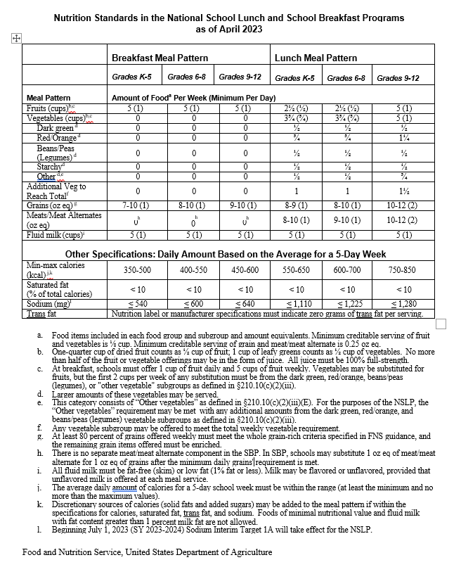



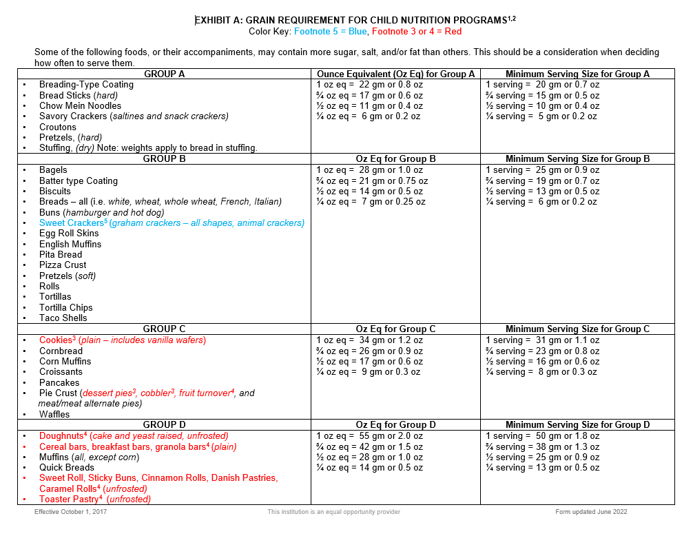

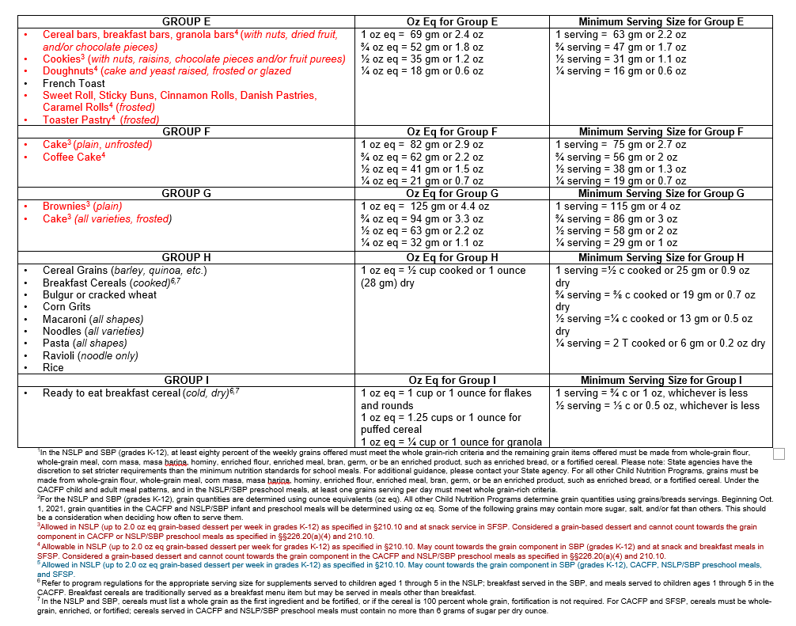

**SECTION 20: EVALUATION CRITERIA**

(DELETE INSTRUCTIONS: SFA to complete ALL areas in red.)

**Information on Evaluation Team/ Scoring Committee**

(DELETE INSTRUCTIONS: SFA to insert details on the evaluation/ scoring committee. Details to include, but not limited to, the size of the evaluation team/scoring committee, the expertise needed on that team, and the names of the team members. It is recommended that a lead is assigned. The lead would be the expert on the procurement and would also train the evaluation team on the objectives/goals, scoring criteria, documentation/information and the scoring forms/rubrix/process)

**Ancillary Materials**

All evaluation/scoring sheets/forms, as applicable, can be found in Exhibit K attached.

**Scoring System**

(DELETE INSTRUCTIONS: SFA to details on how the score will be calculated i.e., the sum of the individual team scores or an average of the total team score.

Summary of evaluation criteria: the criteria listed will be used to evaluate the proposals, and their weights (scores), must be carefully prepared and included in the RFP. These criteria must be followed and documented in evaluating the proposals. Negotiations will then be conducted with those who exceed a pre-determined "cut-off" score.

DELETE INSTRUCTIONS: SFA to Insert Quantity and criteria. Pricing must the maximum weighted criteria. In order for the SFA to utilize the RFP procurement process the first 6 criteria listed below must be included. The SFA can then add as many additional criteria as needed. RFPs must be thoroughly reviewed and subjected to an impartial evaluation.)

Summary of evaluation criteria: the criteria listed will be used to evaluate the proposals, and their weights (scores), must be carefully prepared and included in the RFP. These criteria must be followed and documented in evaluating the proposals. Negotiations will then be conducted with those who exceed a pre-determined "cut-off" score.

**Criteria Weight**

1. Cost/Financial Proposal (insert Quantity) Points
2. Promotion of health and well-being of students (insert Quantity) Points
3. Local food products (insert Quantity) Points
4. Hormone and pest practices (insert Quantity) Points
5. Animal welfare (insert Quantity) Points
6. Contracting with Small and Minority Businesses, Women's (insert Quantity) Points

Business Enterprises, and Labor Surplus Area Firms

7. Insert Criteria (insert Quantity) Points

8. Insert Criteria (insert Quantity) Points

9. Insert Criteria (insert Quantity) Points

10. Insert Criteria (insert Quantity) Points

**TOTAL POINTS: 100/100 points**

The maximum possible points are listed next to each criterion. Evaluation and scoring of Proposals will be based on the assignment of points by the scoring committee and totaled for a final score which will be used for awarding the contract. Only responsive Proposals will be considered for evaluation. For a Proposal to be con­sidered responsive, the Offeror will need to read the entire RFP and provide documentation and information required by all sections of the RFP including attachments. The scoring committee will evaluate all qualifying proposals. The scoring committee will evaluate documentation and information requested throughout the RFP and recommend contract award using this documentation and information including the following evaluation criteria as described below:

(DELETE INSTRUCTIONS: SFA to complete areas in red. Pricing must be the maximum weighted criteria. In order for the SFA to utilize the RFP procurement process the first 6 criteria listed below must be included. The SFA can then add as many additional criteria as needed. The SFA must define in detail the minimum requirements for proposal evaluation and what documents are required for evaluation of criteria. It is the purpose of this section to give detailed direction to proposers so that the SFA can determine which company (if any) is the lowest, responsible and responsive proposer.)

1. **Cost/Financial Proposal**  (insert Quantity) Points

Minimum requirements for proposal evaluation:

* SFA to insert as many requirements as deemed necessary

Documents required for evaluation of criteria

* SFA to insert as many requirements as deemed necessary

1. **Promotion of health and well-being of students**  (insert Quantity) Points

Minimum requirements for proposal evaluation:

* SFA to insert as many requirements as deemed necessary

Documents required for evaluation of criteria

* SFA to insert as many requirements as deemed necessary

1. **Local food products** (insert Quantity) Points

Minimum requirements for proposal evaluation:

* SFA to insert as many requirements as deemed necessary

Documents required for evaluation of criteria

* SFA to insert as many requirements as deemed necessary

1. **Hormone and pest practices** (insert Quantity) Points

Minimum requirements for proposal evaluation:

* SFA to insert as many requirements as deemed necessary

Documents required for evaluation of criteria

* SFA to insert as many requirements as deemed necessary

1. **Animal welfare**  (insert Quantity) Points

Minimum requirements for proposal evaluation:

* SFA to insert as many requirements as deemed necessary

Documents required for evaluation of criteria

* SFA to insert as many requirements as deemed necessary

1. **Contracting with Small and Minority Businesses, Women's Business** (insert Quantity) Points

**Enterprises, and Labor Surplus Area Firms**

Minimum requirements for proposal evaluation:

* SFA to insert as many requirements as deemed necessary

Documents required for evaluation of criteria

* SFA to insert as many requirements as deemed necessary

1. **Insert Criteria**  (insert Quantity) Points

Minimum requirements for proposal evaluation:

* SFA to insert as many requirements as deemed necessary

Documents required for evaluation of criteria

* SFA to insert as many requirements as deemed necessary

1. **Insert Criteria**  (insert Quantity) Points

Minimum requirements for proposal evaluation:

* SFA to insert as many requirements as deemed necessary

Documents required for evaluation of criteria

* SFA to insert as many requirements as deemed necessary

1. **Insert Criteria**  (insert Quantity) Points

Minimum requirements for proposal evaluation:

* SFA to insert as many requirements as deemed necessary

Documents required for evaluation of criteria

* SFA to insert as many requirements as deemed necessary

-

1. **Insert Criteria**  (insert Quantity) Points

Minimum requirements for proposal evaluation:

* SFA to insert as many requirements as deemed necessary

Documents required for evaluation of criteria

* SFA to insert as many requirements as deemed necessary

**SECTION 21: Proposed Fixed Meal Rates**

(DELETE INSTRUCTIONS: SFA to delete any meal types not applicable to the solicitation and/or add any additional meal types needed)

The SFA shall insert the Projected Annual Units and the Offeror shall insert their rate per unit. The SFA will verify and complete the estimated total for each meal type and calculate the total estimated amount of proposal. The Offeror shall not plead misunderstanding or deception because of such estimate of quantities, or of the character, location, or other conditions pertaining to the solicitation and/or Contract.

PER MEAL PRICES MUST BE A FIXED PRICE PER MEAL RATE AND

CALCULATED AS IF NO USDA COMMODITIES WILL BE RECEIVED

Projected Annual Units Rate Per Unit  Estimated Total**

**School Nutrition Programs (SNP)/ Seamless Summer Option (SSO)**

Reimbursable Breakfasts with Milk _________ _________ _________

Reimbursable Lunches with Milk* _________ _________ _________

Reimbursable After-School Snacks _________ _________ _________

Special Milk Program (SMP) _________ _________ _________

Fresh Fruit and Vegetable Program _________ _________ _________

A la Carte Equivalents Fee* _________ _________ _________

Management Fee per School Meal _________ _________ _________

(breakfast and lunch only)

**Child and Adult Food Care Programs (CACFP)**

CACFP Reimbursable Breakfast with Milk _________ _________ _________

CACFP Reimbursable Lunches with Milk _________ _________ _________

CACFP Reimbursable At Risk After-School Snacks _________ _________ _________

CACFP Reimbursable Supper with Milk _________ _________ _________

CACFP Reimbursable AM/PM Snack _________ _________ _________

**Summer Food Service Program (SFSP)**

SFSP Reimbursable Breakfasts with Milk _________ _________ _________

SFSP Reimbursable Lunches with Milk _________ _________ _________

Total Estimated Amount of Proposal** $_______________

*Solicitation rates for SNP reimbursable Lunch and A la carte equivalency fee must be the same.

**All totals must be carried out to the second decimal place and must not be rounded.

_

Name of Offeror

Street Address City State Zip Code

By submission of this proposal, the Offeror certifies that, in the event the Offeror receives an award under this solicitation, the Offeror shall operate in accordance with all applicable current program regulations. This agreement shall be in effect for the period specified, not to exceed one year, and may be renewed by mutual agreement for four additional one-year Contract Terms.

Date Signature of Offeror Title

**SECTION 22: Independent Price Determination Certificate**

Both the School Food Authority (SFA) and the Food Service Management Company (Offeror) shall execute this Independent Price Determination Certificate.

|  |  |  |
| --- | --- | --- |
|  |  |  |
| Name of Food Service Management Company |  | Name of School Food Authority |

By submission of this offer, the Offeror certifies, and in the case of a joint offer, each party thereto certifies as to its own organization, that in connection with this procurement:

1. The prices in this offer have been arrived at independently, without consultation, communication, or agreement for the purpose of restricting competition, as to any matter relating to such prices with any other Offeror or with any competitor.
2. Unless otherwise required by law, the prices which have been quoted in this offer have not been knowingly disclosed to the Offeror and will not knowingly be disclosed by the Offeror prior to opening in the case of an advertised procurement or prior to award in the case of a negotiated procurement, directly or indirectly to any other Offeror for the purpose of restricting competition.
3. No attempt has been made or will be made by the Offeror to induce any person or firm to submit or not submit an offer for the purpose of restricting competition.

Each person signing this offer on behalf of the Offeror certifies that:

1. He or she is the person in the Offeror’s organization responsible within the organization for the decision as to the prices being offered herein and has not participated, and will not participate, in any action con­trary to sections a through c above; or
2. He or she is not the person in other Offeror’s organization responsible within the organization for the decision as to the prices being offered herein, but that he or she has been authorized in writing to act as agent for the persons responsible for such decision in certifying that such persons have not participated and will not participate in any action contrary to sections a through c above, and as their agent does hereby certify; and he or she has not participated, and will not participate, in any action contrary to the above.

|  |  |  |
| --- | --- | --- |
| **TO THE BEST OF MY KNOWLEDGE**, this Offeror, its affiliates, subsidiaries, officers, directors, and employees are not currently under investigation by any government agency and have not in the last three years been convicted of or found liable for any act prohibited by state or federal law in any jurisdiction, involving conspiracy or collusion with respect to bidding on any public contract, accepts as follows: | | |
| Signature of Food Service Management Company’s Authorized Representative  Ø | Title | Date Signed *Mo./Day/Yr.* |
|  | | |
| **IN ACCEPTING THIS OFFER,** the SFA certifies that no representative of the SFA has taken any action that may have jeopardized the independence of the offer referred above. | | |
| Signature of School Food Authority  Ø | Title | Date Signed *Mo./Day/Yr.* |

**NOTE:** **Accepting an Offeror’s offer does not constitute award of the contract.**

**SECTION 23: Proposal Agreement**

|  |  |  |
| --- | --- | --- |
|  | **FSMC Complete section below.** |  |

**THE UNDERSIGNED HEREBY OFFERS** to provide the services of an FSMC as specified in this proposal for the period of (SFA insert contract beginning date) and ending (SFA insert contract ending date). This agreement shall be in effect for the period specified, not to exceed one year, and may be renewed by mutual agreement for four additional one-year Contract Terms.

I understand that the SFA reserves the right to reject any or all proposals, and that this proposal may not be withdrawn during a period of sixty (60) days from the time of opening of the proposal.

**FURTHERMORE, I CERTIFY** that, consistent with section 3 of this RFP, I have not exchanged any gratuities, favors, nor anything of monetary value with the SFA, and this proposal is made without prior understanding, agreement, or connection with any other Offeror submitting a proposal for the same type of service, and is in all respects fair and without collusion or fraud. I agree to abide to all term and conditions of this RFP and certify that I am authorized to sign the RFP for the Offeror.

|  |  |  |  |  |
| --- | --- | --- | --- | --- |
| FSMC Name | | | | |
| FSMC Street Address | City | | State | Zip |
| Signature of Authorized Representative  Ø | | | Date Signed *Mo./Day/Yr.* | |
| Printed Name *First and Last* | Title | | | |
| Email Address | Phone *Area Code/No.* | FAX *Area Code/No.* | | |

|  |  |  |
| --- | --- | --- |
|  | **SFA Complete section below.** |  |

## **Awarding of the Contract**

SFA by signing below is awarding the contract for this RFP to the Offeror of this proposal, herein referred to as “Selected FSMC”. This proposal, all sections of the proposal, all terms and conditions, addendums, including any additional addendums mutually agreed to by both the SFA and Offeror will be incorporated into this Awarded Contract.

The undersigned hereby accepts Offeror’s services of an FSMC as specified in this proposal for the period of (SFA insert contract beginning date) and ending (SFA insert contract ending date). This agreement shall be in effect for the period specified, not to exceed one year, and may be renewed by mutual agreement for four additional one-year Contract Terms.

**FURTHERMORE, I CERTIFY** that, consistent with section 3 of this RFP, I have not received any gratuities, favors, nor anything of monetary value with the FSMC, and this proposal is made without prior understanding, agreement, or connection with any other Offeror submitting a proposal for the same type of service, and is in all respects fair and without collusion or fraud. I agree to abide to all term and conditions of this RFP and certify that I am authorized to sign the RFP for the SFA.

|  |  |  |  |  |
| --- | --- | --- | --- | --- |
| SFA Name | | | | |
| SFA Street Address | City | | State | Zip |
| Signature of Authorized Representative  Ø | | | Date Signed *Mo./Day/Yr.* | |
| Printed Name *First and Last* | Title | | | |
| Email Address | Phone *Area Code/No.* | FAX *Area Code/No.* | | |

**SECTION 24: SOLICITATION CERTIFICATIONS**

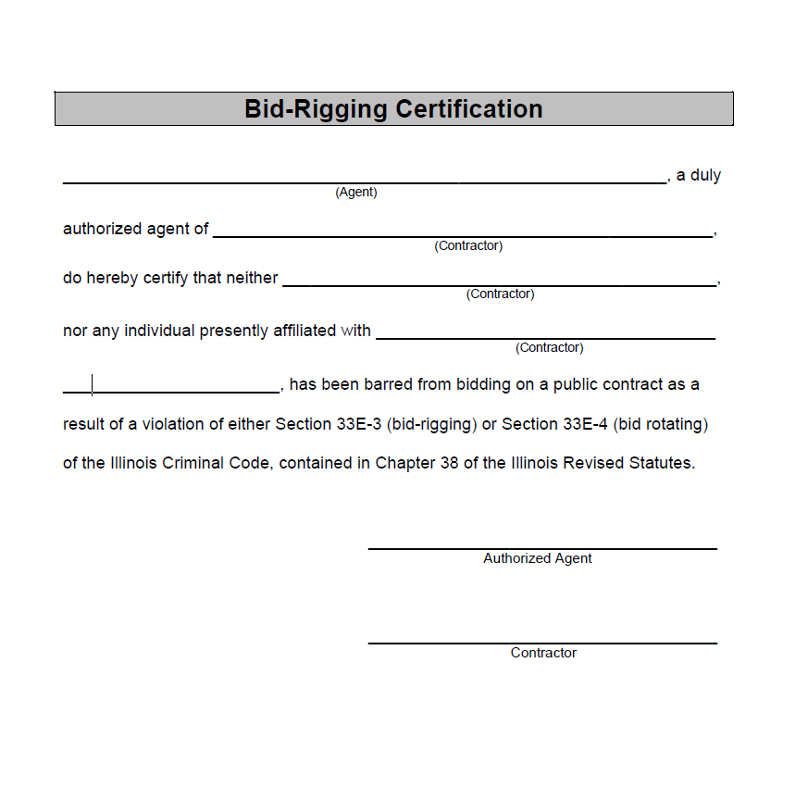

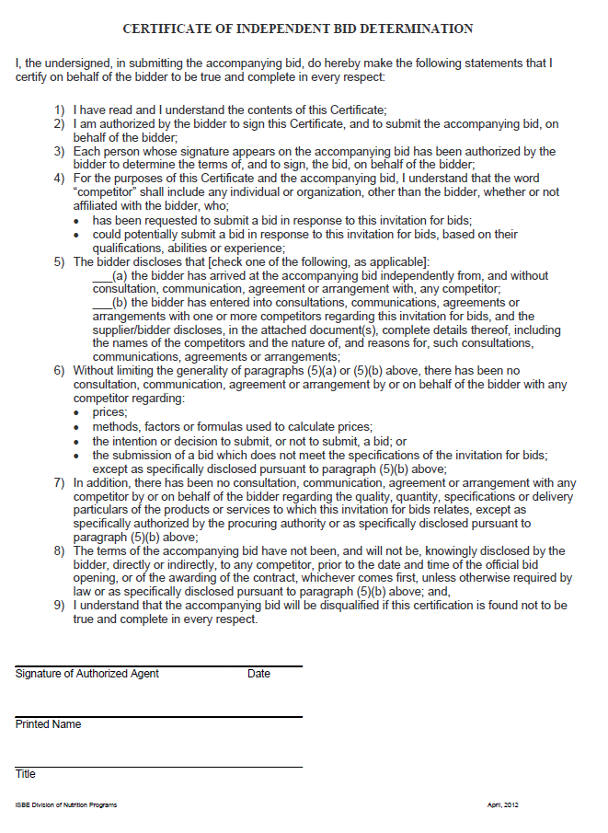

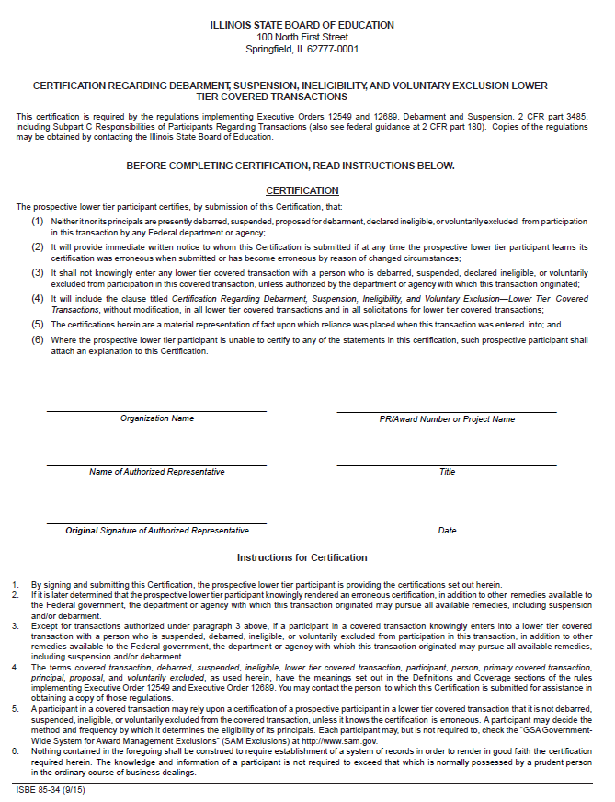

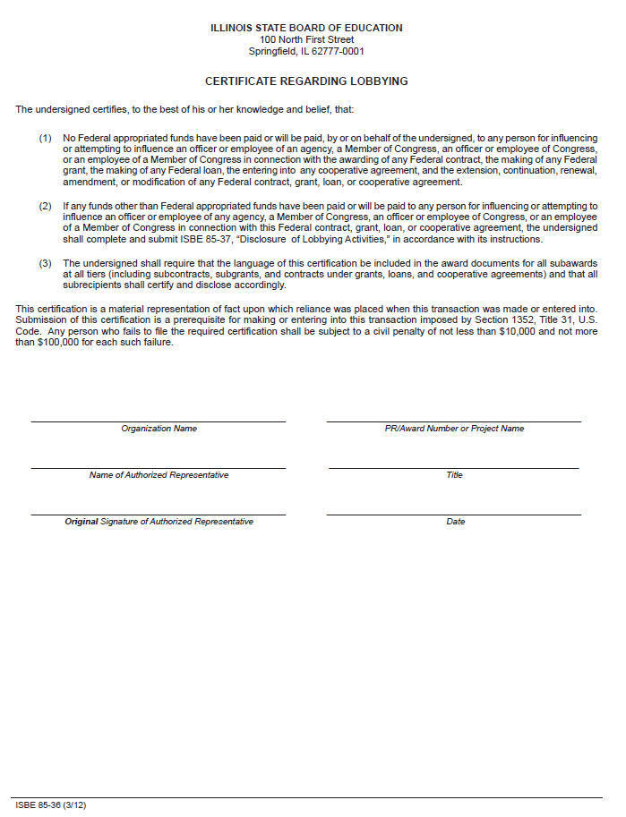

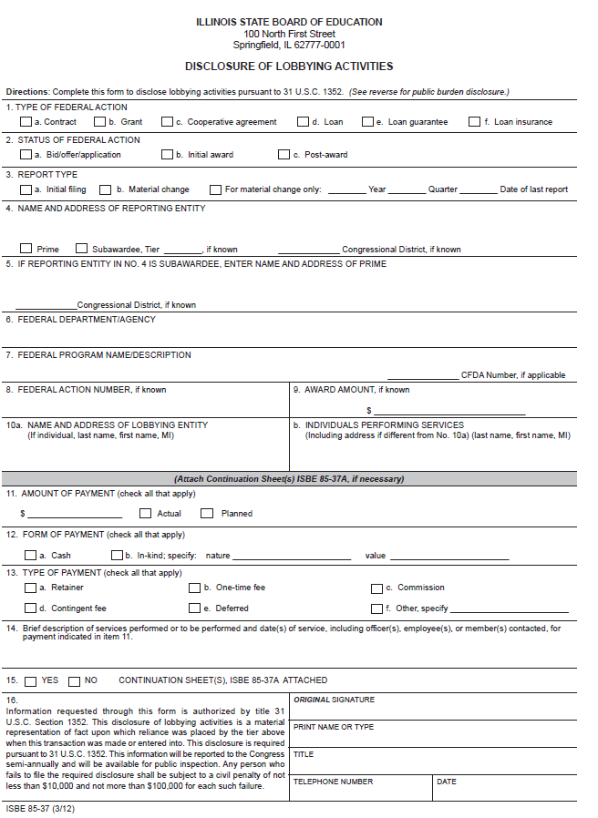

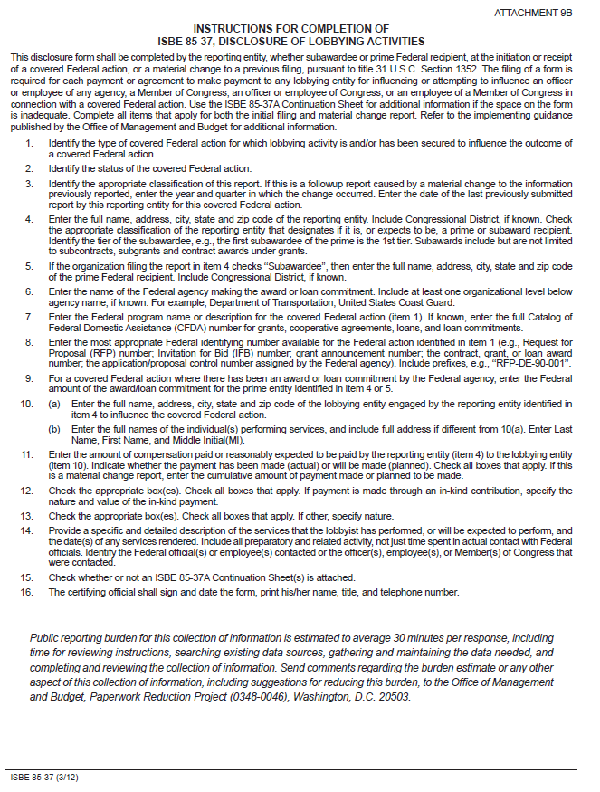

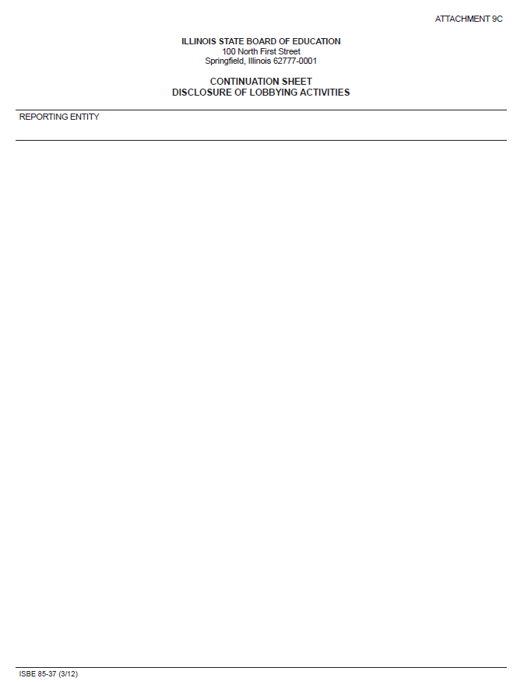

**List of REQUIRED RFP Exhibits**

|  |  |
| --- | --- |
| **Exhibit and Title** | |
| SFA |
|  |
| **A** | A-1: School/Site Data Form (excel file) |  |
|  | A-2: School/Site Average Daily Participation (excel file) **There are 3 tabs one for each Child Nutrition Program (SNP/CACFP/SFSP). Only complete and insert exhibits for programs soliciting. |  |
|  | A-3: School/ Site Meal Service Information (excel file) **There are 3 tabs one for each Child Nutrition Program (SNP/CACFP/SFSP). Only complete and insert exhibits for programs soliciting. |  |
|  | A-4: Current and Projected Enrollment (excel file) |  |
| **B** | B-1: 21-Day Cycle Menu – **There are 3 tabs one for each Child Nutrition Program (SNP/CACFP/SFSP). Only insert exhibits for programs soliciting. |  |
|  | B-2: Meal Choices and Additional Offerings |  |
|  | B-3: A la Carte Price list |  |
| **C** | Minimum Food specifications |  |
| **D** | School Year 2022-2023 Sponsor Claims for Reimbursement (for each month) |  |
| **E** | School Year 2023-2024 Sponsor Claims for Reimbursement (for each month to date) |  |
| **F** | FSMC Equipment List (excel file) |  |
| **G** | Minimum Operational Labor and Benefits (excel file) |  |
| **H** | H-1: Projected Operational In-School Revenue (excel file) |  |
|  | H-2: Projected Operational Federal and State Reimbursement Revenue (excel file) |  |
|  | H-3: Total Projected Operational Revenue (excel file) |  |
| **I** | School District/Operation Calendar |  |
| **J** | Local Wellness Policy |  |
| **K** | Taste Testing and/or Site Evaluation Form, if applicable |  |
| **L** | Collective Bargaining Agreement, if applicable |  |

Exhibit A-1: School/Site Data Form

[DELETE INSTRUCTION: SFA to complete excel and insert]SFA to complete excel and insert

Exhibit A-2: School/ Site Average Daily Participation

[ DELETE INSTRUCTION: SFA to complete excel and insert. **There are 3 tabs one for each Child Nutrition Program (SNP/CACFP/SFSP). Only complete and insert exhibits for programs soliciting.]

Exhibit A-3: School/ Site Meal Service Information

[ DELETE INSTRUCTION: SFA to complete excel and insert. **There are 3 tabs one for each Child Nutrition Program (SNP/CACFP/SFSP). Only complete and insert exhibits for programs soliciting.]

Exhibit A-4: Current and Projected Enrollment

[ DELETE INSTRUCTION: SFA to complete excel and insert]

Exhibit B-1: 21-Day Cycle Menu (s)

[ DELETE INSTRUCTIONs: SFA to complete excel and insert. **There are 3 tabs one for each Child Nutrition Program (SNP/CACFP/SFSP). Only insert exhibits for programs soliciting.]

7 CFR 210.16(b) requires that the RFP contain a 21-day cycle menu developed in accordance with the provisions in 7 CFR 210.10 for meal pattern requirements. When other Programs are also operated, the cycle menu must meet the meal pattern requirements for all Programs as found in the respective Program regulations for meal patterns, i.e., SBP, FFVP, SFSP, etc. The purpose of the SFA providing the 21-day cycle menu in the RFP is for evaluation of offers based on the estimated average cost per meal.

If the SFA determines the bidder will develop a cycle menu, the State Agency will allow the FSMC to develop the 21-day cycle menu as long as doing so was a requirement of the original solicitation. The solicitation must identify, in Section 20, the Proposer Evaluation Criteria that the SFA will use to evaluate the FSMC’s menu, such as meal pattern requirements, components, quantities required in the meal pattern, dietary specifications, affordability, nutrition requirements, and appeal to the students, etc..]

Exhibit B-2: Meal Choices and Options

[DELETE INSTRUCTION: SFA to complete excel and insert]

Exhibit B-3: A la Carte Price List

[DELETE INSTRUCTION: SFA to insert price list (adult meals, bottled water, milk carton, extra entrees, smart snacks, etc)]

Exhibit C: Minimum Food Specifications

(DELETE THESE INSTRUCTIONS: SFA to detail locally required food specifications. At a minimum, any proposed menu plans must comply with the Final Rule Nutrition Standards in the Child Nutrition Programs. Provided below are food specifications that meet the USDA Nutrition Standards, it is required that the SFA review and update to meet local specifications as required in this RFP-specifically mirroring expectation to menu requirements and scoring criteria)

Section 210.16(c)(3) specifically addresses the SFA's development of specifications for each food component or menu item and requires these specifications to be included in the IFBs or RFPs. Specifications must cover items such as grade, purchase units, style, condition, weight, ingredients, formulations, and delivery time. In order to ensure objective contractor performance and eliminate unfair competitive advantage, a person that develops or drafts specifications, requirements, statements of work, invitations for bids, requests for proposals, contract terms and conditions or other documents for use by a grantee or sub- grantee in conducting a procurement under the USDA entitlement programs specified in 2 CFR 200.319(a) shall be excluded from competing for such procurements.

ISBE does not approve, evaluate or endorse minimum food specifications.

All USDA Foods offered to the SFA and made available to the FSMC are acceptable and should be utilized in as large a quantity as may be efficiently utilized.

For all other food components, specifications shall be as follows:

All breads, bread alternates, and grains must be whole grain rich. Any remaining

grain products must be enriched. All breads and grains must be fresh (or frozen, if applicable) and must meet the minimum weight per serving as required and must adhere to the USDA *Nutrition Standards in the Child Nutrition Programs,* and/or other subsequent guidance issued by the USDA. If applicable, product should be in moisture-proof wrapping and pack-code date provided.

All meat and poultry must have been inspected by the United States Department of Agriculture (USDA) and must be free from off color or odor.

* Beef must be at least 70:30 lean to fat, preferably 80:20 lean to fat.
* Poultry should be U.S. Grade A when applicable and should meet the recommendations outlined in *Specifications for Poultry Products, A Guide for Food Service Operators* from the USDA.
* For breaded and battered items, all flours must be enriched for breads/grains credit and breading/batter must not exceed 30 percent of the weight of the finished product.
* For sausage patties, the maximum fat allowed is 50 percent by weight; industry standard of 38 to 42 percent fat preferred.

All cured processed meats (bologna, frankfurters, luncheon meat, salami, others) shall be made

from beef and/or poultry. No variety meats, fillers, extenders, non-fat milk solids, or cereal will be allowed. Meats must not show evidence of greening, streaking, or other discoloration.

All cheese should be firm, compact and free from gas holes; free of mold; free of undesirable flavor and odors; pasteurized when applicable; and preferably reduced or low-fat. All cheese should also have a bright, uniform, and attractive appearance; have a pleasing flavor; demonstrate satisfactory meltability; and contain proper moisture and salt content.

All fish must have been inspected by the United States Department of Commerce (USDC) and meet minimum flesh and batter/breading requirements for USDC Grade A product or a product packed under federal inspection (PUFI) by the USDC. The Agriculture Improvement Act of 2018 requires:

* Farmed fish must be harvested within the United States or any territory or possession of the United States.
* Wild caught fish must be harvested within the Exclusive Economic Zone of the United States or by a United States flagged vessel.

All fresh fruits must be ripe and in good condition when delivered and must be ready for consumption per the USDA *Food Buying Guide*. At a minimum, fruits must meet the food distributors’ second-quality level. Fruits should have characteristic color and good flavor and be well shaped and free from scars and bruises. Size must produce a yield equal to or greater than the attached 21-day cycle menu requirements.

All fresh vegetables must be ripe and in good condition when delivered and must be ready for consumption per the USDA *Food Buying Guide*. At a minimum, vegetables must meet the food distributors’ second quality level. Vegetables should have characteristic color and good flavor, be well-shaped, and be free from discoloration, blemishes, and decay. Size must produce a yield equal to or greater than the attached 21-day cycle menu requirements.

All canned vegetables must meet the food distributors’ first-quality level (extra fancy and fancy) and canned fruits (standard) must meet the second-quality level. Vegetables should have characteristic color and good fresh flavor and be free from discoloration, blemishes, and decay. Fruits should be packed in 100% juice or water and should be free from High Fructose Corn Syrup.

Eggs must be inspected and passed by the state or federal Department of Agriculture and used within 30 days of date on carton. Eggs should be grade A, uniform in size, clean, sound-shelled, and free of foreign odors or flavors.

Sauces, such as gravy, spaghetti sauce, pizza sauce, etc., must be smooth and uniform in color with no foreign substance, flavor, odor, or off color.

If applicable, the food production facility, manufacturing plant, and products must meet all sanitary and other requirements of the Food, Drug, and Cosmetic Act and other regulations that support the wholesomeness of products.

Meals and food items must be stored and prepared under properly controlled temperatures and in accordance with all applicable health and sanitation regulations.

All fruit and vegetables juices must be pasteurized 100 percent fruit and/or vegetable juice.

When the specification calls for “Brand Name or Equivalent”, the brand name product is acceptable. Other products may be considered with proof that such products meet stated specifications and are deemed equivalent to the brand products in terms of quality, performance, and desired characteristics, as determined by the SFA.

All food items must adhere to the sodium target levels in subsequent Contract Terms, if applicable, as required by the USDA *Final Rule: Child Nutrition Program Flexibilities for Milk, Whole Grains, and Sodium Requirements* and/or other subsequent guidance issued by the USDA.

Nutrition labels or manufacturer specifications must indicate zero grams of trans fat per serving for all foods.

Fluid milk must be low-fat (1 percent milk fat or less, unflavored only) or fat-free (unflavored or flavored). Two choices must be offered daily, one of which must be unflavored as required by the USDA.

**SFA REQUIRED FOOD SPECIFICATION REQUIREMENTS AS PER LOCAL WELLNESS POLICY, DISTRICT REQUIREMENTS.**

* **(SFA to insert as many food specifications as needed)**

Exhibit D: School Year 2022-2023 Sponsor Claims for Reimbursement

[DELETE INSTRUCTION: SFA to insert Sponsor Claims for Reimbursement to date for school year 2023–2024, for all programs operated (SNP, CACFP, SFSP)]

Exhibit E: School Year 2023-2024 Sponsor Claims for Reimbursement

[DELETE INSTRUCTION: SFA to insert Sponsor Claims for Reimbursement to date for school year 2023–2024, for all programs operated (SNP, CACFP, SFSP)]

Exhibit F: FSMC Equipment List

SFA to complete excel and insert. If the SFA is not requiring FSMC to provide any equipment, put none requested on the excel and insert the excel.

Exhibit G: Minimum Operational Labor and Benefits

[DELETE INSTRUCTION: SFA to complete excel and insert]

Exhibit H-1: Projected Operational In-School Revenue

[DELETE INSTRUCTION: SFA to complete excel and insert]

Exhibit H-2: Projected Operational Federal and State Reimbursement Revenue

[DELETE INSTRUCTION: SFA to complete excel and insert]

Exhibit H-3: Total Projected Operational Revenue

[DELETE INSTRUCTION: SFA to complete excel and insert]

Exhibit I: Projected School District/Operational Calendar

[DELETE INSTRUCTION: SFA to insert]

Exhibit J: Local Wellness Policy

[DELETE INSTRUCTION: SFA to insert]

Exhibit K: Taste Testing Evaluation Form

[DELETE INSTRUCTION: SFA to insert. If not requiring delete this page]

Exhibit L: Collective Bargaining Agreement

[DELETE INSTRUCTION: SFA to insert. If not applicable delete this page]