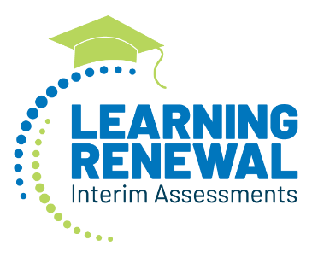
[district letterhead/logo]

[date]

Dear Families,
Welcome back to school! Thank you for entrusting us with your children’s education. We hope to make this school year a time of renewal, reconnection, growth, and even fun.
Thank you also for doing your part to control the spread of COVID-19. Each person who has worn a mask, observed social distancing protocols, and gotten vaccinated has played a big part in helping our schools re-open classrooms so students can learn in-person. We know that many of you have also taken on extra duties related to your students’ school work, and we appreciate the vital role you’ve played in keeping your students engaged progressing to the best of their capacity.
Our teachers and you at home went to extraordinary lengths to support students and get them through an unprecedented, challenging year. Now, as we enter a new chapter and put the pandemic behind us, the question on all our minds is: What exactly do students need to reach their fullest potential this year?
Supporting students’ growth in this critically important year after the pandemic will take all of us partnering together. To help equip teachers and families with the best tools and information possible, we are excited to announce a new initiative this school year called the Learning Renewal Interim Assessments. These three, short checkpoints will deliver immediate, individual, diagnostic information about your child’s learning. They will take 45 minutes or less for each content area– shorter than most movies – and occur three times during the school year: once in the fall, once in the winter, and once in the spring. This information can support your conversations with your child’s teachers throughout the school year.
These short tests are tailored to our district and will only look at the standards students have learned so far in the year. They are informational and will not factor into any child’s grade, class placement, or academic standing in any way. They will not affect school accountability or teacher evaluations. Rather, these assessments are designed to help teachers and families pinpoint how the pandemic has affected student learning and immediately adjust instruction and supports to match students’ needs.
We are looking forward to partnering with you to have a terrific school year and to be able to see just how much students are learning and growing as we go along.
If you have any questions, please do not hesitate to ask. You can call [number] or email [address].
Sincerely,
[signature]

