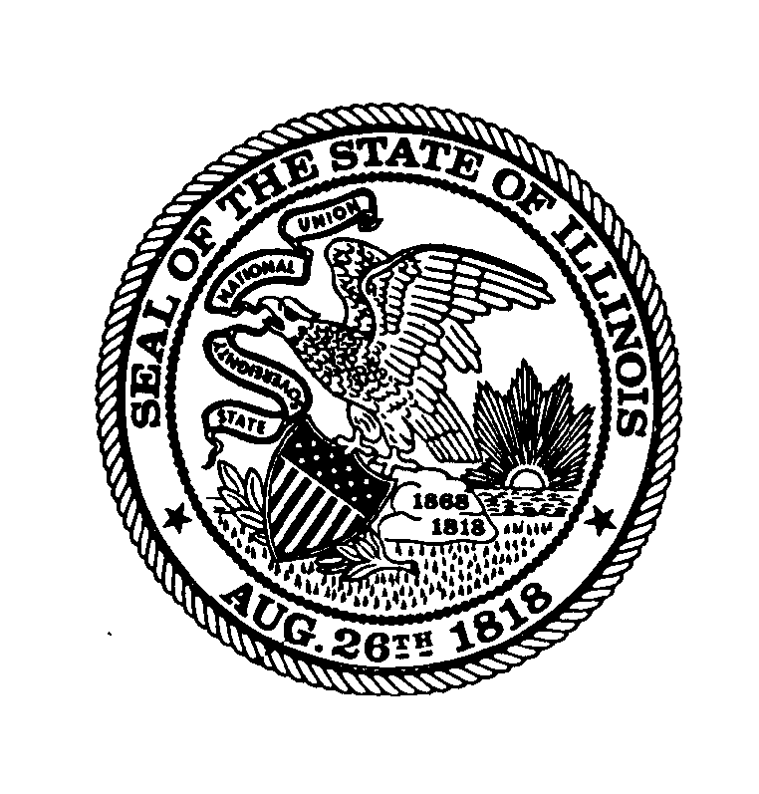 | Illinois State Board of Education  100 North First Street • Springfield, Illinois 62777-0001  www.isbe.net  James T. Meeks Tony Smith, Ph.D.  Chairman State Superintendent of Education

Three things you need to know about
ILLINOIS LEARNING STANDARDS
August 2015, ISBE Division of Public Information
1
The clear, consistent, and higher expectations of the Illinois Learning Standards in English language arts and math paved the way for a complete review and update of all learning standards to help us better address the needs of the whole child.
Full implementation of the new science standards will occur during the 2016-17 school year, emphasizing a more engaged, hands-on science education that aims to give students a deeper understanding of the core concepts in science and engineering as well as practice applying those concepts – linking knowledge and real-world skills.
2
The State Board recently approved new social studies standards, developed by a task force led by the Illinois Civic Mission Coalition, that build on Illinois’ focus on critical thinking and real-life experiences. Arts Alliance Illinois is leading a review of the existing arts education standards and has convened a committee to analyze public input and evaluate research and best practices in arts education. Their work will culminate in a recommendation to the Board later this school year.
3

