
Title: Introduction to the Common Core State Standards for Mathematics (CCSSM) and PARCC Assessments Webinar

Intended Audience: Teachers, Administrators, Professional Development Coordinators

Description: This 15-minute webinar provides information about the origin, need and format of the Common Core State Standards for Mathematics and the PARCC (Partnership for the Assessment of Readiness for College and Careers) Assessment that will be aligned to the CCSSM. This webinar is intended to be used as a 1-hour professional development workshop with discussion and question time.

Suggested Use for these Documents:
- Professional development coordinators could use this to lead a professional development workshop.
- Teachers, administrators or other stakeholders could use this to get an overview of the CCSSM.

Materials Necessary:
- CCSSM Overview PPT or Webinar
- Copy of the Common Core State Standards for Mathematics

For further information/feedback:
SSoS/ISBE Math Specialists
Heather Brown Alanna Mertens Patricia Reisdorf
hbrown@pdaonline.org almertens@cps.edu preisdor@kidsroe.org



Illinois State Board of Education
www.isbe.net
100 N. 1st Street • Springfield, IL 62777
100 W. Randolph, Suite 14-300 • Chicago, IL 60601

Webinar Facilitator’s Guide  Introduction to the CCSSM and PARCC Assessment | 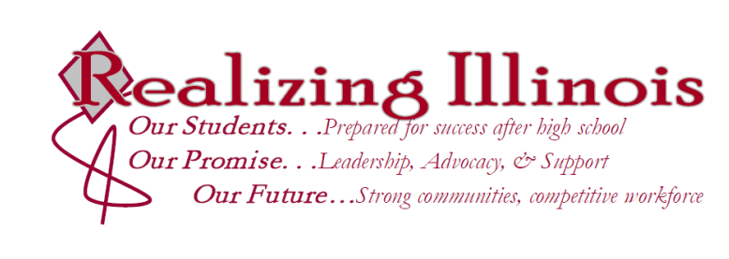

Session Description
Participants will receive information about the origin, need and format of the Common Core State Standards for Mathematics and the PARCC (Partnership for the Assessment of Readiness for College and Careers) Assessment that will be aligned to the CCSSM.

Goal of the Session
Participants will gain a working knowledge of the CCSSM document and receive the latest information about assessments that are being created to align to the CCSSM.

Expected Outcomes:
By the conclusion of the webinar, participants will:
- Know the history, rationale and format of the CCSSM
- Understand the current proposed design of the new assessment
- Understand in addition to creating assessments, PARCC will support educators by providing resources such as model curricula, webinars, assessment frameworks, sample assessment items, and peer to peer training

TIME | CONTENT/ACTIVITIES | MATERIALS
5 min | Introduction  Slide 1
10 min | CCSSM Background  Slide 2 - 5  Explain that the CCSSM were not initiated or mandated by the federal government. These standards are state led.  The authors backwards mapped from college readiness to Kindergarten.  Previously textbooks become so large because they were trying to cover varying standards from all states. | Copy of the CCSSM for participants to review.
15 min | Information about the CCSSM  Slides 6 – 14  The contents focus on higher order thinking and application. The statement “clearer, fewer, higher” refers to the concern that states’ former standards were a “mile wide and an inch deep.” On average 27 different topics were taught at each grade, vs. 2-6 topics in top performing countries. Now, the CCSSM have 2-4 critical areas per grade level to focus instruction.  The standards do not delve into differentiation. Teachers and curriculum material are necessary to fully implement the standards.  One of the major differences is that the CCSSM include not only content standards, but practice standards. These standards are required. When a state adopts the CCSSM, they are adopting both parts – the content and the practice standards. The practice standards are the same from K-12 grade and describe what a mathematically proficient student should be able to do. These are often referred to the students’ habits of mind.  The content standards are broken down differently in K-8 and high school. These slides detail how. Slide 13 displays how the domains progress over the K-8 years. There is focus by limiting topics to when they are the focus for the year.  Pause for questions and/or discussion, as needed.
5 min | Assessment Consortia  Slides 15 - 16  These slides explain the process of the proposal and the current assessment consortia developing state assessments.
10 min | PARCC  Slides 17 – 26  PARCC includes 24 states and the D.C. including more than 25 million students. Florida is the fiscal agent and Massachusetts houses the governing board.  Slides 18-22 explain PARCC’s focus on the spirit of the CCSSM. The goals of PARCC are created to aid in implementation. Slide 23 explains the additional supports that PARCC plans to provide to educators. Slide 24 – 25 explain the technology component. And Slide 26 explains the process of the yearly assessments. The first two assessments are optional, but the last two assessments of the year are required.
5 min | PARCC Timeline  Slide 27 – 29  These slides explain what PARCC has already completed and what it plans to complete in the next 3 years. The last slide explains how PARCC is implementing and aiding in transition to the CCSSM.
10 min | Wrap-up  Slide 30 - 31  Consider the questions listed and discuss with each other. If you still have questions, email addresses have been provided.

