Illinois State Course System (ISCS)
User Manual
March 1, 2011

Illinois State Course System (ISCS)



On behalf of the
Illinois State Board of Education
100 North First Street
Springfield, IL 62777-0001
TABLE OF CONTENTS

1 Change History 4
2 Introduction 5
2.1 Using this Manual 6
3 ISBE Illinois State Course System Overview 7
3.1 Project Overview 7
3.2 System Functions 8
3.3 Access Levels 9
3.4 Audit Functions 10
3.5 Data Validations 11
4 Accessing ISBE Illinois State Course System 12
4.1 Connecting to IWAS 12
4.2 Logging in to ISBE - Illinois State Course System 15
4.3 Home Page and Navigation 16
5 Online Processes 17
5.1 Course 17
5.1.1 Search Course 17
5.1.1 View Course 19
5.1.2 Edit Course 20
5.1.1 Create State Course 22
5.2 CIPs 25
5.2.1 Search CIPs 25
5.2.1 View CIP 27
5.2.1 Edit CIP 28
5.3 EFE User - Assigning Courses to Schools 32
5.3.1 Search EFE Assignments 32
5.3.1 View EFE Assignments 35
5.3.2 Edit EFE Assignments 38
5.4 Reports 52
5.4.1 Illinois State Course System Report Navigation 53
6 Data Quality 64
6.1 Introduction 65
6.2 Orderly Information from Disorderly Setting 65
6.3 What is a Culture of Quality Data? 65
6.4 NCES Components of a Culture of Quality Data 66
6.5 Key Elements to Achieving Quality Data 66
6.6 Summary 67
7 Acronym Glossary 67

TABLE OF FIGURES

Figure 1 – User Access Levels and Functions 10
Figure 2 – IWAS Login Screen 13
Figure 3 – IWAS Home Page 14
Figure 4 – IWAS System Listing 15
Figure 5 – ISBE Illinois State Course System Home Page 16
Figure 6 – Illinois State Course System Home Page – Course Function 17
Figure 7 – Search Course 18
Figure 8 – Search Course (No Matching State Records) 19
Figure 9 – Search Course (Matching Records) 19
Figure 10 – View Course 20
Figure 11 – Edit Course 21
Figure 12 – Review Course 22
Figure 13 – Search Course 22
Figure 14 – Search Course (No Match) 23
Figure 15 – Edit Course 24
Figure 16 – Review Course 24
Figure 17 – Illinois State Course System Home Page – CIP Function 26
Figure 18 – Search CIP 26
Figure 19 – Search CIP (Search Results) 27
Figure 20 – View CIP 28
Figure 21 – Edit CIP 29
Figure 22 – Edit CIP 30
Figure 23 – Edit CIP – Edit Course 31
Figure 24 – Review CIP 32
Figure 25 – Illinois State Course System Homepage – EFE Assignment Function 33
Figure 26 – EFE User – Search CIP 33
Figure 27 – EFE User – Search CIP - Results (No CIPs Assigned) 35
Figure 28 – EFE User – View Assignments 36
Figure 29 – EFE – CIP Assignment View 37
Figure 30 – EFE User - Edit Assignments - Description 38
Figure 31 – EFE User - Edit Assignments – Assign Course 39
Figure 32 – EFE User - Edit Assignments 40
Figure 33 – EFE User - Edit Assignments – Assign Course 41
Figure 34 – EFE User - Edit Assignments 42
Figure 35 – EFE User – Review Assignments 43
Figure 36 – EFE User – View Assignments – Update Successful 44
Figure 37 – EFE User – Edit Assignments - Unassign 45
Figure 38 – EFE User – Edit Assignments 46
Figure 39 – EFE User – Review Assignments 47
Figure 40 – EFE User – View Assignments – Successful Update 48
Figure 41 – EFE User - Search CIP 49
Figure 42 – EFE User - Search CIP - Results 50
Figure 43 – EFE User- View Assignments 51
Figure 44 – EFE User- Search CIP – Results - Successful Update 52
Figure 45 – Illinois State Course System Reports Screen 53
Figure 46 - ISBE SIS Crystal Report Menu 53
Figure 47 – Report Export Selection Criteria 55
Figure 48 – Report Print Selection Criteria 56
Figure 49 – State Course Catalog Criteria Screen 57
Figure 50 – State Course Catalog Report 58
Figure 51 – CIP Catalog Criteria Screen 59
Figure 52 – CIP Catalog Screen 59
Figure 53 – State Course Catalog Criteria screen 60
Figure 54 – State Course Catalog Screen 61
Figure 55 – State CIP Catalog Criteria Screen 62
Figure 56 – State CIP Catalog Report 63

Change History
Changed Date 03/01/2011
- Changed system name from “Career and Technical Education Course (CTEC) system” to “Illinois State Course System (ISCS)”.
Changed Date 01/14/2011
- Changed Career and technical Education Course (CTEC) system Illinois State Course System.
Changed Date 06/18/2010
- Creation.

Section
2

Introduction

elcome to ISBE’s Illinois State Course System user manual. The ISBE Illinois State Course System is designed to create a standardized State course catalog and administrate the creation and mapping of a state of courses to federal course codes. The system also allows Career and Technical Education (CTE) Education for Employment (EFE) System Directors to assign course lists according to school. This system serves as the vehicle to collect course-related information electronically from ISBE personnel and EFE/school related staff. The result of successful implementation is the ability to provide the state education agency, state and federal entities, the education community, and the public with state standardized State course administration and reporting software.

The ISBE Illinois State Course System application allows authorized users at ISBE and EFE sites to access the system via IWAS - www.isbe.net. This application is the creation of a course through secure online web forms. The Illinois State Course System web application is designed from the user’s perspective to include all the functions necessary to perform the user’s role effectively and efficiently.

Using this Manual
The ISBE Illinois State Course System User Manual introduces the user to the ISBE Illinois State Course System and provides instruction to enable each user to utilize the system effectively in a short period of time. It explains how to accomplish the most common tasks and utilize the special features within the ISBE Illinois State Course System application.

The ISBE Illinois State Course System User Manual is constructed in a manner to allow the user to find the answers to application questions easily. It uses specific language found in the Illinois State Course System, as well as application pictures to create direct references between the application and the supporting section of the manual.

For ease of use, the manual is organized as follows:
- The manual is divided into multiple sections, with each section separated with numbered tabs.
- Each section of the manual is divided into subsections with a hierarchical section number.
Section
3

ISBE Illinois State Course System Overview

his section provides an overview of the ISBE Illinois State Course System project, application, and the major system functions within the application. Through this section, the user becomes familiar with the different data access levels within the application and the system functions that can be performed based on a particular Illinois State Course System user role.

Project Overview
The goal of the ISBE Illinois State Course System project is to develop and deploy a State Course system that provides the state education agency, state and federal entities, the education community, and the public with timely and accurate data collection and reporting for courses, schools, school districts, and the state. This course system developed and deployed for the Illinois State Board of Education, will provide secure and appropriate access for applications such as course record inquiry, retrieval, and transfer. This system will serve as the vehicle to collect all State course-related information electronically from both ISBE personnel and EFEs. The system will provide for:
- Creation of a State Level Course
- Editing State Level Courses
- Retiring State Level Courses
- Mapping of State Level Course Information to a Single Federal Course
- Mapping of State Level Course Information to the appropriate CIPs
- Tracking changes, additions, and removal of courses
- Creation of CIPs
- Tracking changes, additions, and removal of CIPs
- Mapping of CIPs to Clusters
- Assignment of Courses to CIPs
- Assignment of CIPs to schools
- Assignment of courses to schools
- Reports on State courses
- Reports on CIPS and EFE assignments
- Reporting timely and accurate information/data through standardized reporting capabilities

System Functions
The ISBE Illinois State Course System applications facilitate online creation of a course, as well as the collection and the maintenance of course information for data reporting purposes. Dependent on which system function is utilized; users are able to do the following:
- Search for an existing Federal or State Course
- Create a new State Course and map it to a Federal Course
- Create a CIPs mapped to Clusters
- Add courses to CIPs
- Assign CIPs to schools
- Assign courses to schools
- View reports of State Courses, CIPs, and EFE assignments

The Illinois State Course System application provides users with an online interface that uses validations to ensure the data is entered correctly.

The major functions of the ISBE Illinois State Course System and their applications are listed below:

- Online Process
- View, add, and update records through ISBE Web Application Security (IWAS) with system interfaces
- Allows a user to perform the following applications:
        - Search Course
        - Create State Course and map to Federal course
        - Create CIPs and map to Clusters
        - Assign Course to CIP
        - Assign CIP to School
        - Assign Course to School
        - View Reports

Access Levels
The ISBE Illinois State Course System allows for three types of user roles to be assigned to individuals. Each Illinois State Course System user role has certain access rights to system functions that one can operate. These roles include:

- View Only
The View Only user access level grants view only access.
- View Course,
- View CIP,
- View Assignment, and
- Reports.

- EFE Director (ROE Administrator (ROE Admin))
The EFE Directors role is in charge of a district or a private entity that has been granted access to the Illinois State Course System from the Illinois State Board of Education. The role of the EFE Director is managing and granting user access to those in his or her region. In the Illinois State Course System this EFE user will have the ability to View Reports and enter EFE Course Assignments to each school located within the region.

The system functions available to the EFE Director users include:
- Grant User Access,
- View Course,
- Assign Course,
- View CIP,
- Assign CIP,
- View Assignments
- Reports, and
- Help.

- EFE Administrator (RCDT Administrator (District Admin))
The EFE Administrator has access to everything within the Illinois State Course System except the ability to Grant Access to others. These include the ability to View Reports, and enter EFE Course Assignments to each school located within the region.
- View Course,
- Assign Course,
- View CIP,
- Assign CIP,
- View Assignments
- Reports, and
- Help.

- ISBE Administrator (Admin)
The ISBE Administrator role is appointed by ISBE personnel for administrative purposes at a state level.

The system functions available to the ISBE Administrator users include:
- View Course,
- Create Course,
- View CIP,
- Create CIP,
- View Assignments,
- Reports, and
- Help.

Below is a chart that shows the different Approval Groups and the associated user rights.

Figure 1 – User Access Levels and Functions

Functions | View Only | EFE Director | EFE Administrator | ISBE Admin
Approval Group Number | 1 | 3 | 4 | 5
Create Courses |  |  |  | X
View Courses | X | X | X | X
Create CIPs |  |  |  | X
View CIPs | X | X | X | X
Assign Courses to CIPs |  | X | X | X
Assign CIPs to Schools |  | X | X
Assign Courses to Schools |  | X | X
View School Assignments | X | X | X | X
Reports | X | X | X | X

Audit Functions
The ISBE Illinois State Course System application generates audit trail entries for all online processes. An audit trail is maintained when the user creates a course or CIP and when courses are assigned to schools.

The following audit information is kept for all additions and modifications to the database records:
Activity code - Code designating either Creation or Update;
User ID - who is making the transaction;
Time Stamp - Date/Time of transaction;
Old value;
New value; and
Table Name.

Data Validations
The ISBE Illinois State Course System performs edit checks on the student attributes for the online processes. Through the online process, the users receive interactive error messages when one or more validation checks fail. The user then has the opportunity to correct any errors on the screen and resubmit the transaction.

Course Creation Validations

- State courses created must be mapped to a Federal Course.
- A course can never be deleted, moved, or edited if students are enrolled in them.

CIP Creation Validation

- A CIP can never be deleted, moved, or edited if students are enrolled in them.

Course Assignment Validations

- CIPs and courses can only be assigned to schools within an EFE’s region.
- EFEs cannot un-assign a course if students are enrolled in it.
- EFEs cannot un-assign a CIP if students are enrolled in it.

Section
4

Accessing ISBE Illinois State Course System

his section provides an overview of accessing the ISBE Illinois State Course System, as well as system-navigating techniques. Through this section, the user becomes more familiar with logging into the ISBE Web Application Security portal, connecting to the ISBE Illinois State Course System, and viewing the various functions of the application.

To access IWAS and Illinois State Course System, a user must have an Internet connection. The browsers used to access IWAS and Illinois State Course System must be Microsoft Explorer 6.0 or higher or Netscape Communicator 7.2 or higher.

Connecting to IWAS
ISBE Illinois State Course System is accessible through ISBE’s Web Application Security System, (IWAS). An IWAS Login allows authorized users at a school, district, EFE , and ISBE to login into IWAS and access the system. IWAS can be accessed through the website - www.isbe.net.

An IWAS link is displayed on the top of the page. Once the user clicks the IWAS link, the IWAS login page is displayed.

Below is an illustration of the IWAS Login Screen.

Figure 2 – IWAS Login Screen
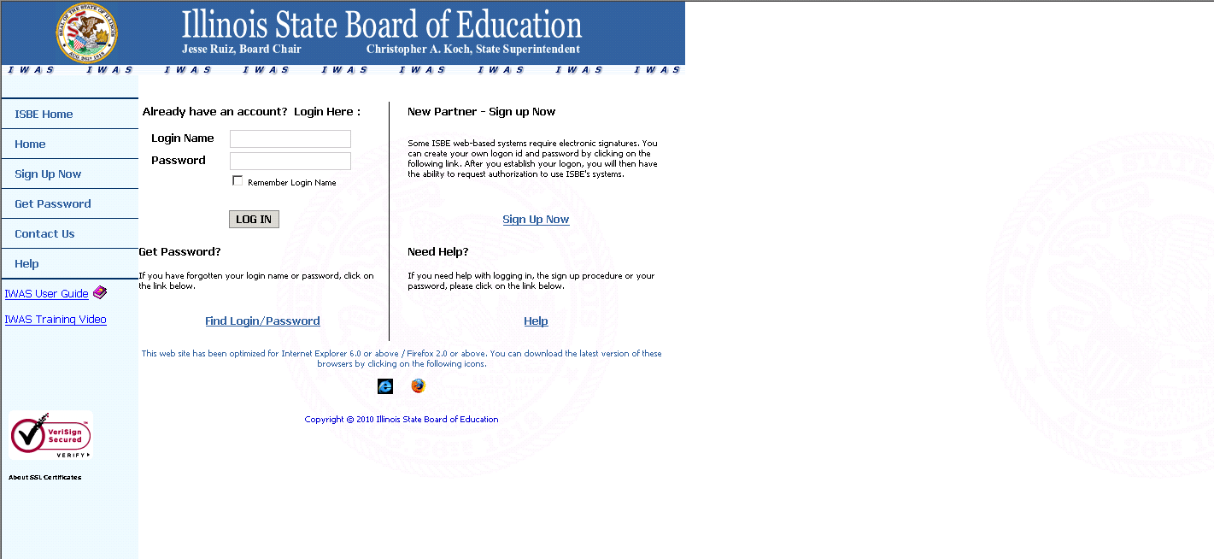

The user must type in their IWAS Login Name and Password and click the Login button.

Once the user has successfully logged in through IWAS, the IWAS home page is displayed. Following is an illustration of the IWAS Home Page Screen.

Figure 3 – IWAS Home Page
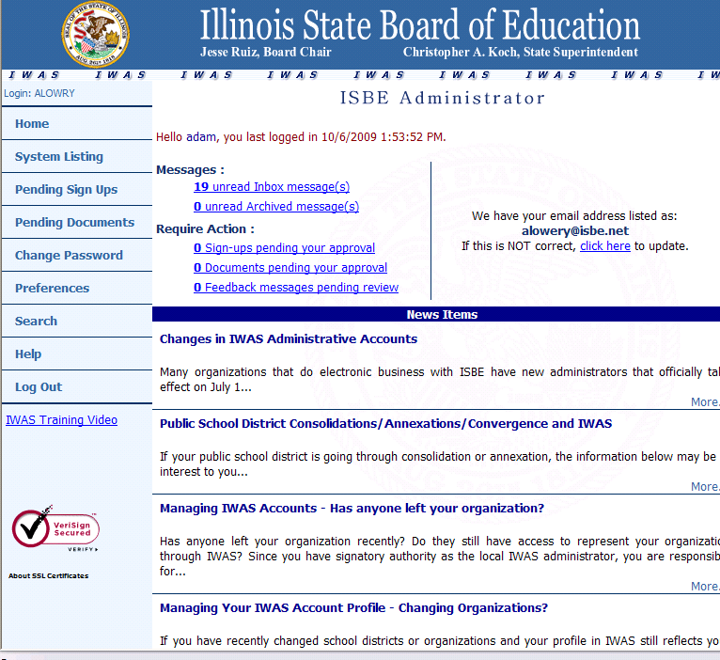

The user must click System Listing on the left-hand side to access the link to ISBE Illinois State Course System.
Below is an illustration of the IWAS System Listing Screen.

Figure 4 – IWAS System Listing
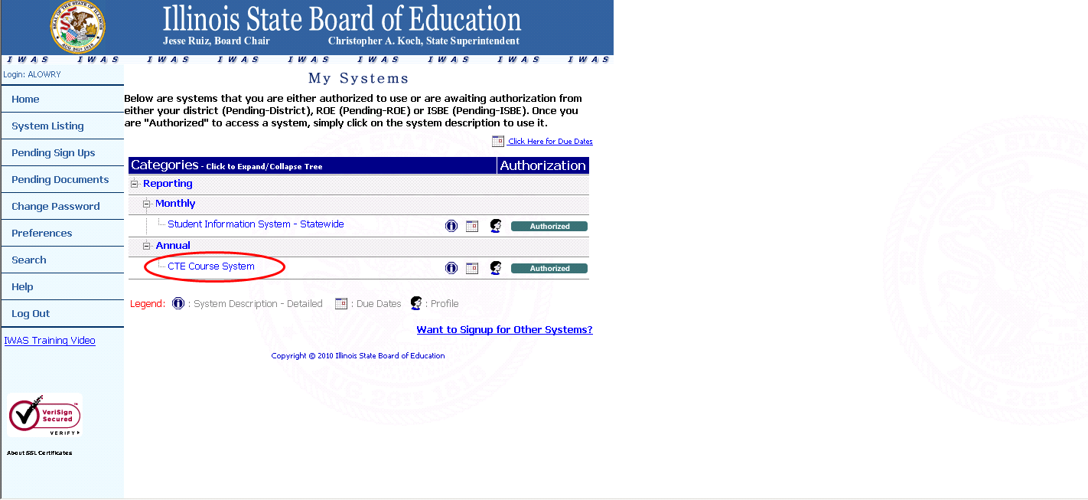

The ISBE Illinois State Course System is located under the Annual section of the Reporting category.

Logging in to ISBE - Illinois State Course System
Once the user has successfully logged in through IWAS, they must click System Listing on the left-hand side to access the link Illinois State Course System. If the user is not authorized for access to System, they must sign up for access and get approval from their Administrator. Once the user is authorized to access Illinois State Course System, the user is able to click the “Illinois State Course System” link.

After the user successfully logs in to IWAS and clicks the ISBE “Illinois State Course System” link, the Illinois State Course System opens in a separate window and the Home Page is displayed.

Home Page and Navigation
The home page allows the user to navigate throughout the entire Illinois State Course System application. All of the major functions of the Illinois State Course System application are accessed through the links on the Illinois State Course System Home Page.

The system functions so that a particular user can have access depending on their data access role. The user is granted the level of access based on their IWAS/ Illinois State Course System login account profile. The major system functions are discussed in detail in the following sections of the User Manual.

The navigation links for accessing the major system functions appear at the left of all Illinois State Course System online screens. A user is able to access the major system functions from any page within the application.

Once the user presses the navigation link, the link title becomes underlined to indicate the function the user has activated. In the following example Home is underlined to indicate the Home Page is active.

Following is an illustration of the ISBE Illinois State Course System Home Page Screen.

Figure 5 – ISBE Illinois State Course System Home Page
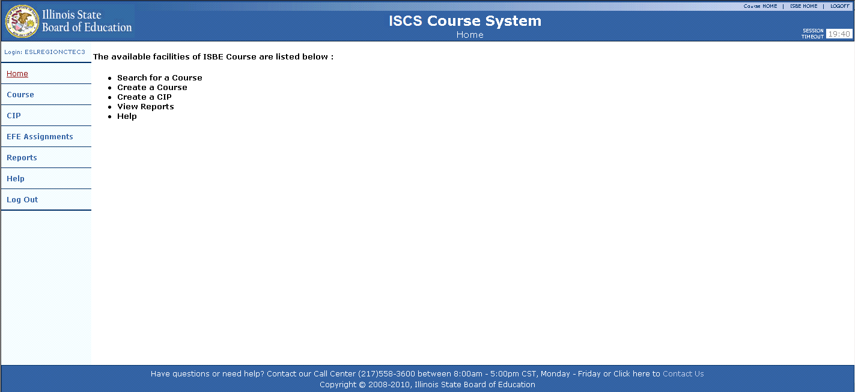

Additionally, the Illinois State Course System includes a Session Timeout feature that aids in the prevention of unauthorized access and use of the system. If the user remains on a web page for 20 minutes without any activity, the user’s session expires and the user is automatically logged off of the Illinois State Course System. The user must enter their IWAS Login Name and Password to re-log into the system.
Section
5

Online Processes

his section provides information related to the functions available online in the Illinois State Course System. Illinois State Course System provides the following functions online:
- Search course (existing courses)
- Create and map State Course to a Federal Course
- Create CIPs and map to Clusters
- Assign CIPs to schools
- Assign Courses to schools
- View Reports on Courses, CIPs, and schools

Illustrated are the ISBE Illinois State Course System screen views along with the supporting information necessary to perform these system functions.

Course

Search Course
The ISBE Illinois State Course System application allows a user to search system for existing Federal and/or State Course records. A State Course will always have a Federal parent course. When a Federal Course is selected using the Subject Area and Course ID dropdowns, all State Courses that relate to the selected Federal Course are displayed back to the user. If the course needs to be added and the user would like to ensure it has not previously been entered, they may use this function to search the system for a matching course.

The following is an illustration of the Illinois State Course System Home Page - Course Function.

Figure 6 – Illinois State Course System Home Page – Course Function

From the Illinois State Course System Home Page, the user selects the Course option. The Search Course screen is displayed.

The following is an illustration of the ISBE Illinois State Course System Search Course screen.
Figure 7 – Search Course
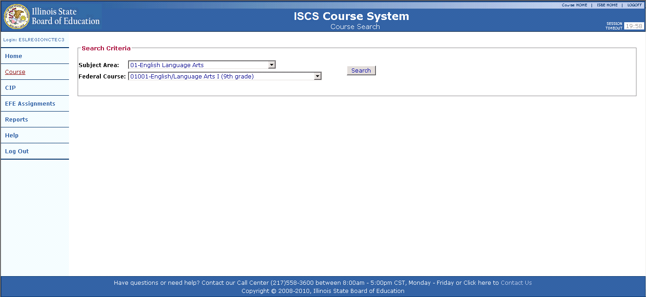

The user must input the following to search for a course in the Illinois State Course System:
- Subject Area
and
- Federal Course ID

When the “Search” button is selected, the system performs edit checks to ensure both fields are selected. If all validations pass, the Illinois State Course System returns the matching course. If State courses have already been mapped to a Federal Course, the State Course will appear at the bottom of the screen and the mapped Federal Course will appear on top. If the State course selected has not been mapped to a Federal Course, only the Federal Course will appear at top of the screen.

Below is an example of the course search screen with no matching records.

Figure 8 – Search Course (No Matching State Records)
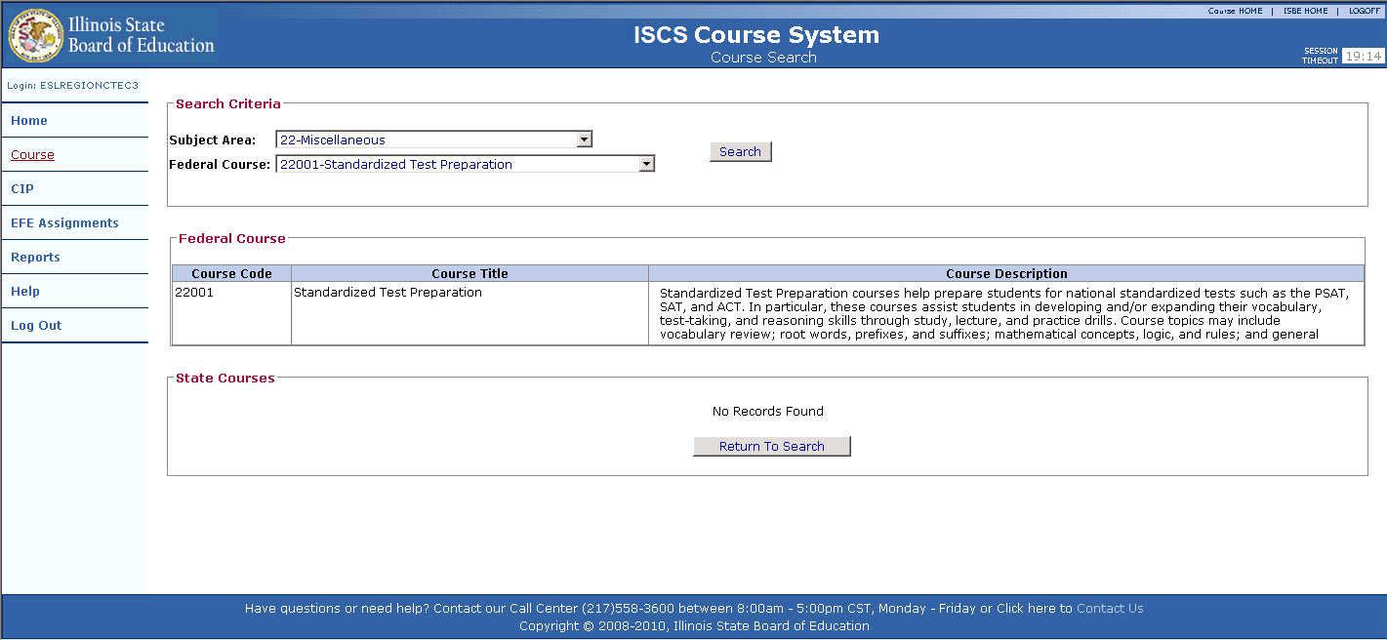

View Course
If there is one or more potential matching State Course records found, the Potential State Course record matches are displayed at the bottom of the screen.

Below is an illustration of the ISBE Illinois State Course System Search Course screen with two matching course records displayed in the State Course results section.

Figure 9 – Search Course (Matching Records)
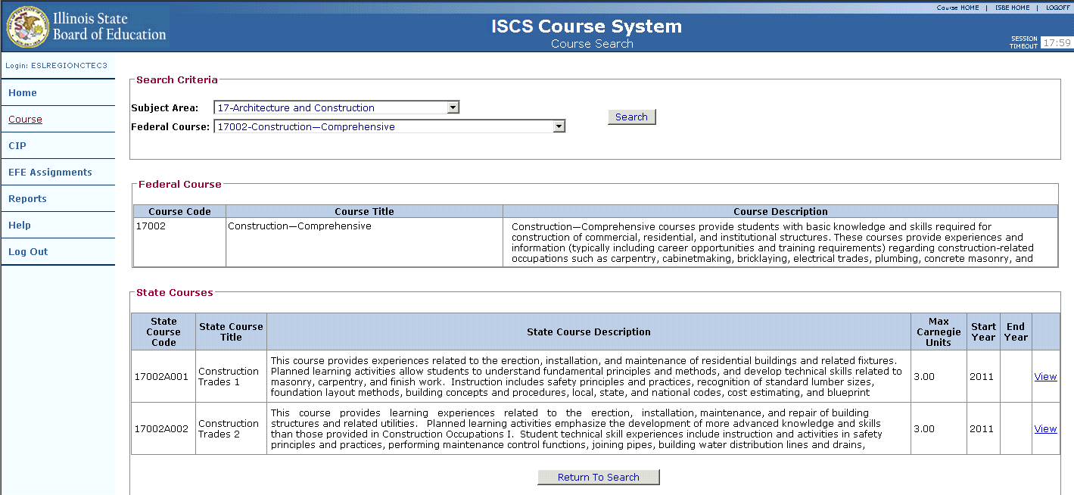

Edit Course

The search function stays active at the top of the screen. The “Subject Area” and “Federal Course ID” can be selected to choose a new course. The selected Federal Course is listed next on the page. The following fields are displayed for the Federal Course.
- Federal Course Code
- Federal Course Title
- Federal Course Description

The State Courses are listed below the Federal Course. Each resulting State Course is tied to the Federal Course that is displayed above. The user can select the “View” link to edit an existing State Course code or select the “Add New” button to create a new State Course that will be appended to the displayed Federal Course code at the top of the screen. If the “Add New” button is selected the user is directed to a blank “Edit State Course” screen.

When the “View” link is selected, the View State Course screen is displayed.

Following is an illustration of the ISBE Illinois State Course System View State Course screen.

Figure 10 – View Course
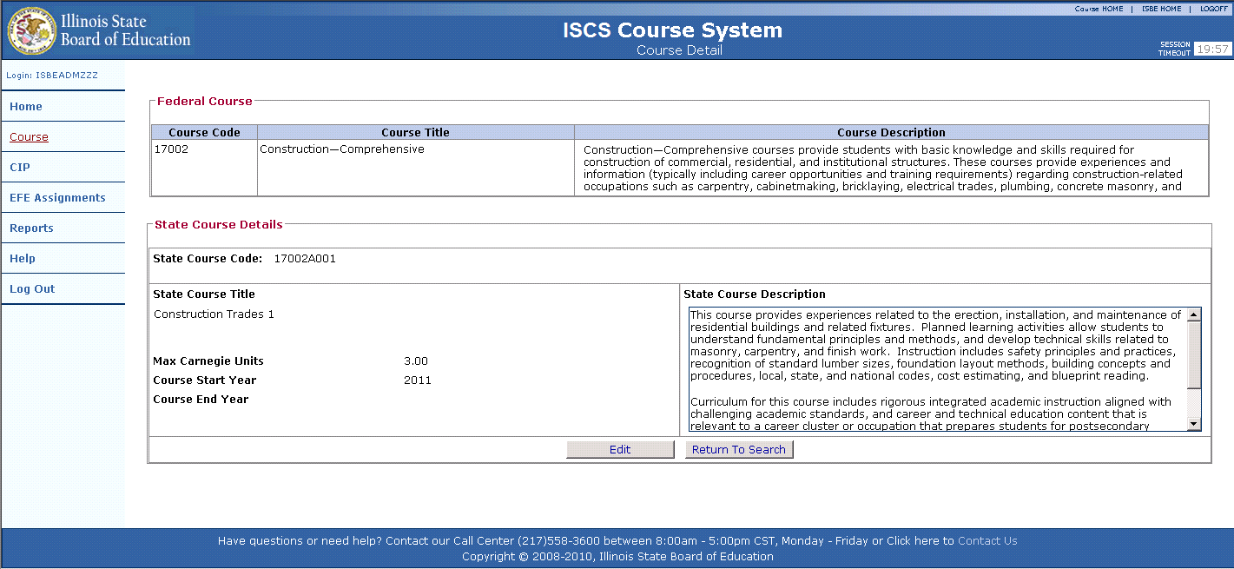

The Federal Course details are displayed across the top of the screen and the selected State Course now appears across the bottom. The State Course elements can be updated by selecting the “Edit” button at the bottom of the screen. Once selected, the user will be directed to the Edit Course screen. The “Cancel” button can also be selected returning the user to the Search Course screen.

Following is an illustration of the ISBE Illinois State Course System Edit Course screen.

Figure 11 – Edit Course
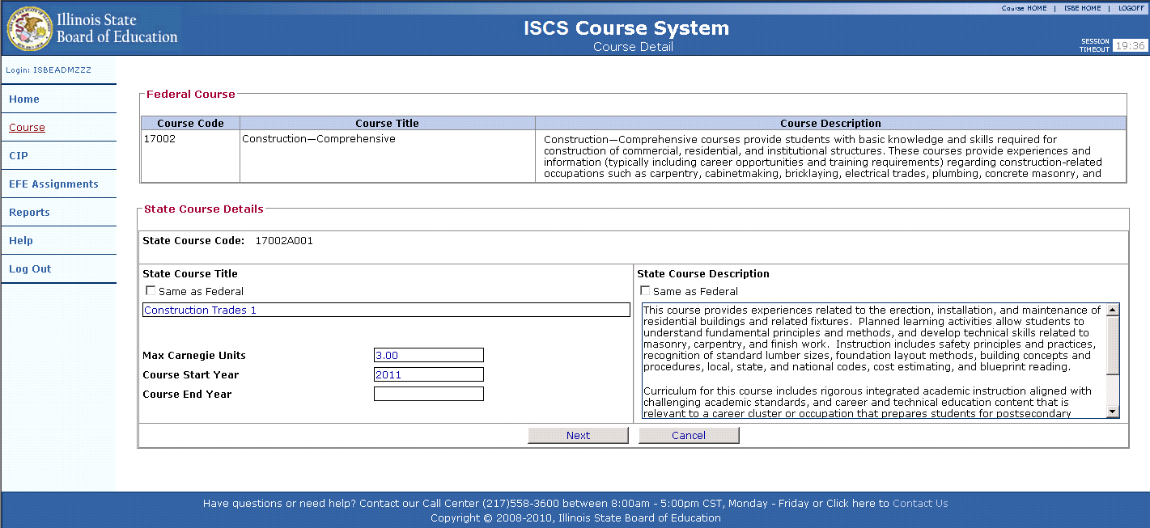

The user must enter the following mandatory information before continuing:
- State Course Title
- State Course Description
- Max Carnegie Units
- Course Start Year

Optional information can be entered if known:
- Course End Year

Once the State Course data is updated and the user selects the “Next” button and all validations pass, the Review Course screen is displayed. If the user selects the “Cancel” button, the user is returned the View Course screen.

Following is an illustration of the ISBE - Illinois State Course System Review Course screen.

Figure 12 – Review Course
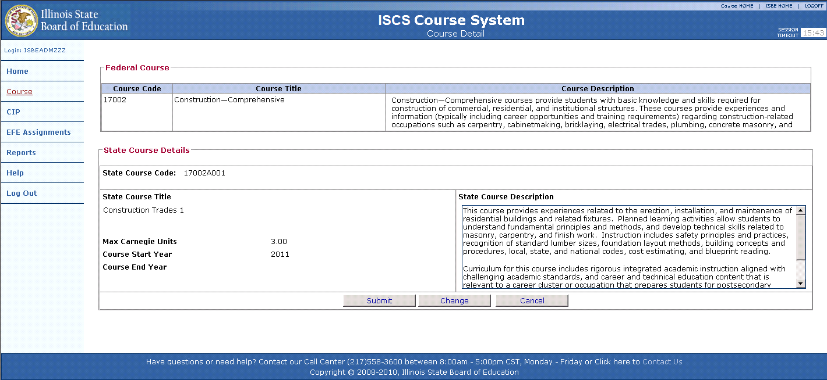

Create State Course
The previous section explained how to search for a course and how a course can be edited by selecting the “Edit” button on the View Course screen. This section will explain how to create State Courses and map them to a Federal Course. The “Course” link on the navigation bar located on the left side of the homepage can also be used to create a new State Course. When the user selects the “Course” link, to the Search Course screen is displayed.

The following is an illustration of the ISBE Illinois State Course System Search Course screen.
Figure 13 – Search Course

The user must input the following to search for a course in the Illinois State Course System:
- Subject Area
And
- Federal Course ID

When the “Search” button is selected, the system performs edit checks to ensure both fields are selected. If all validations pass, the Illinois State Course System returns a Federal Course and any related State Courses.

If there are no existing State Course records only the Federal Course will appear at the top of the screen, if state records existed for the displayed Federal code the State Courses would be displayed at the bottom of the screen.

Following is an illustration of the ISBE Illinois State Course System Search Course screen with no matching State Course records.

Figure 14 – Search Course (No Match)
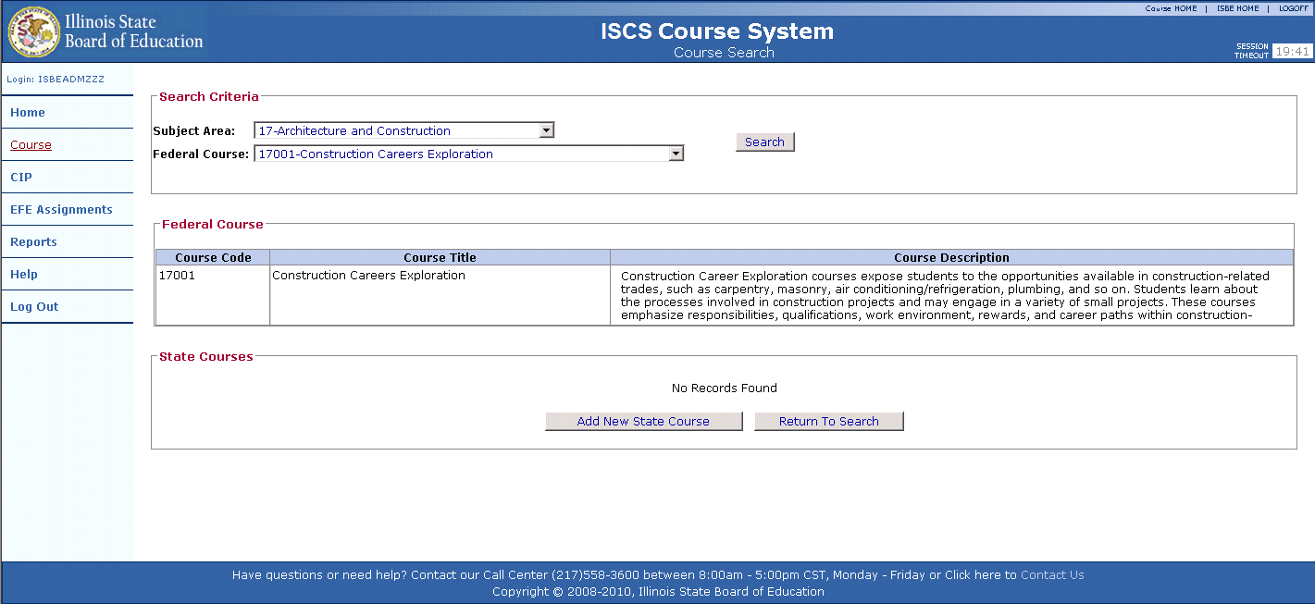

The user can select the “Add New State Course” button at the bottom of the screen to continue.

Once the “Add New State Course” button is selected a blank View Course screen is displayed to the user. The Federal Course and definition are displayed at the top of the screen and the State Course fields below are blank. In order to edit the State Course, the “Edit” button must be selected. Once the user selects the “Edit” button the Edit Course screen is displayed.

Below is an illustration of the Illinois State Course System Edit Course screen with no matching State Course records.

Figure 15 – Edit Course
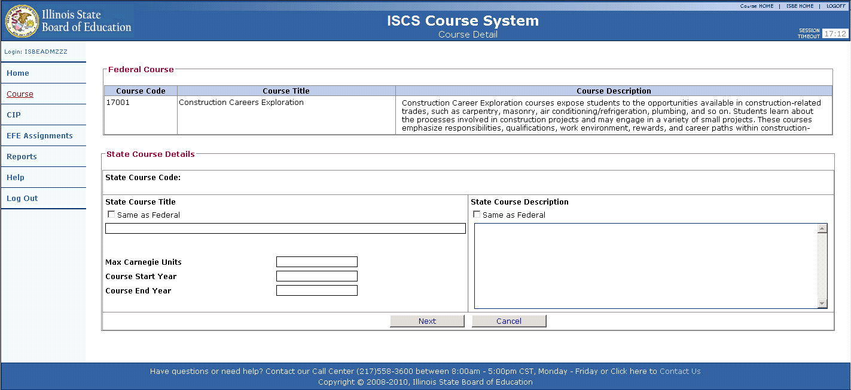

This screen requires the user to enter the following mandatory information on a State Course record:
- State Course Title
- State Course Description
- Max Carnegie Unit
- Course Start Year

Optional information can be entered if known:
- Course End Year

Once the State Course data is edited and the user selects the “Next” button the Review Course screen is displayed. If the user selects the “Cancel” button, the user is returned the View Course screen.

Following is an illustration of the ISBE - Illinois State Course System Review Course screen.

Figure 16 – Review Course

If all data entered is correct, the “Submit” button must be selected to commit the record. The user is returned to the View Course screen. The Federal Course appears at the top of the screen and the newly created State Course is now listed at the bottom of the screen.

CIPs

Search CIPs

The ISBE Illinois State Course System application also allows a user to search the system to edit CIPs. This function can be accessed from the Illinois State Course System Home Page.

Following is an illustration of the Illinois State Course System Home Page – CIP Function.

Figure 17 – Illinois State Course System Home Page – CIP Function
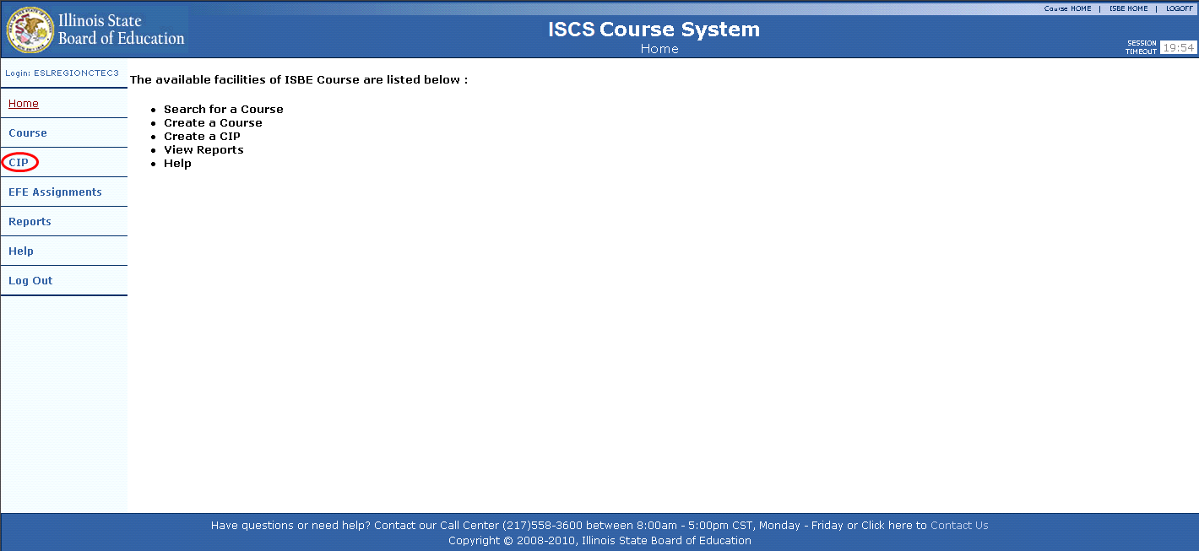

Every state generated CIP belongs to a cluster. When a cluster is selected using the “Cluster” dropdown, all related CIPs are displayed back to the user. A user can also use the “Status” dropdown to view closed CIPs. The “Status” dropdown defaults to view “Open”. Closed CIPs are identified by a populated and expired “CIP End Year” field.

Following is an illustration of the Illinois State Course System Search CIP screen.

Figure 18 – Search CIP
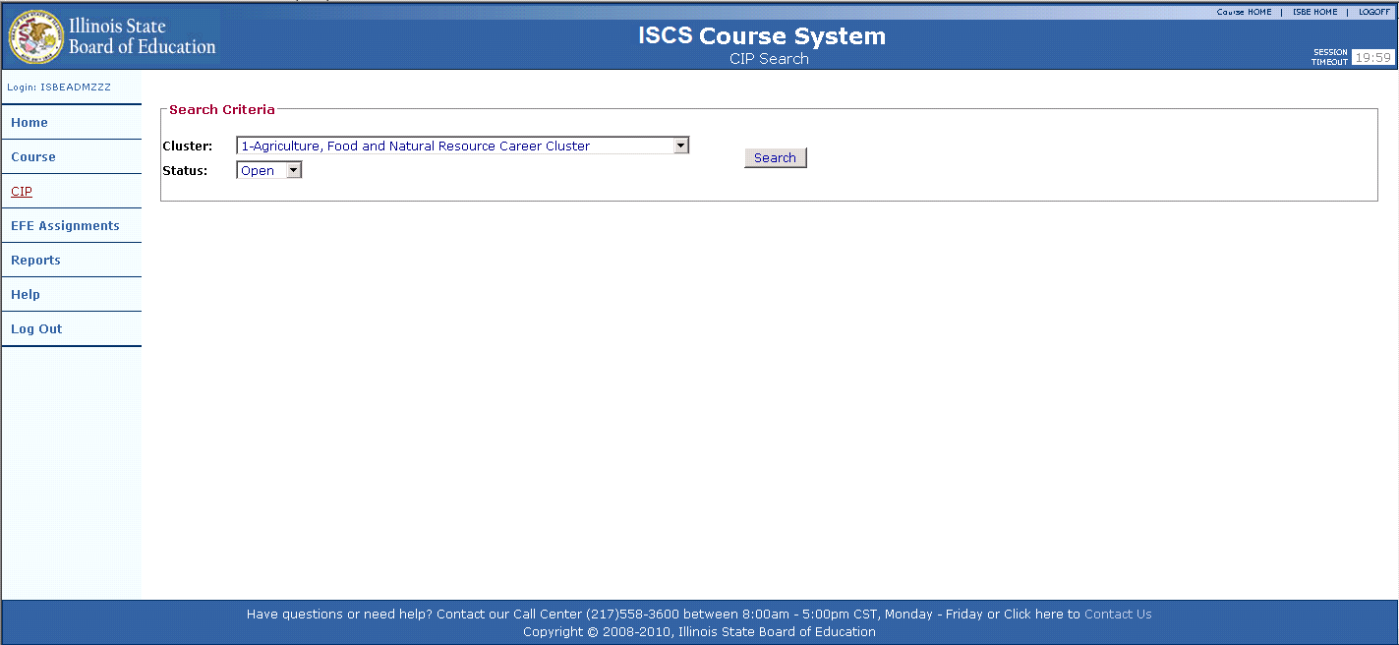

Once the cluster has been selected from the dropdown, the related CIPs are displayed back to the user.

Following is an illustration of the Search CIP (Search Results).

Figure 19 – Search CIP (Search Results)
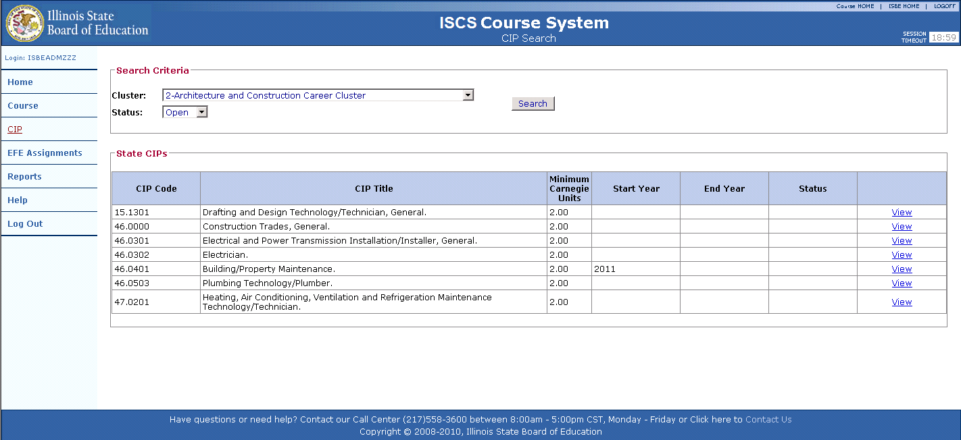

View CIP
The user can select a CIP from the resulting search by selecting the “View” link. Once the “View” link is selected, the CIP is displayed to the user on the View CIP screen.

Following is an illustration of the View CIP screen.
Figure 20 – View CIP
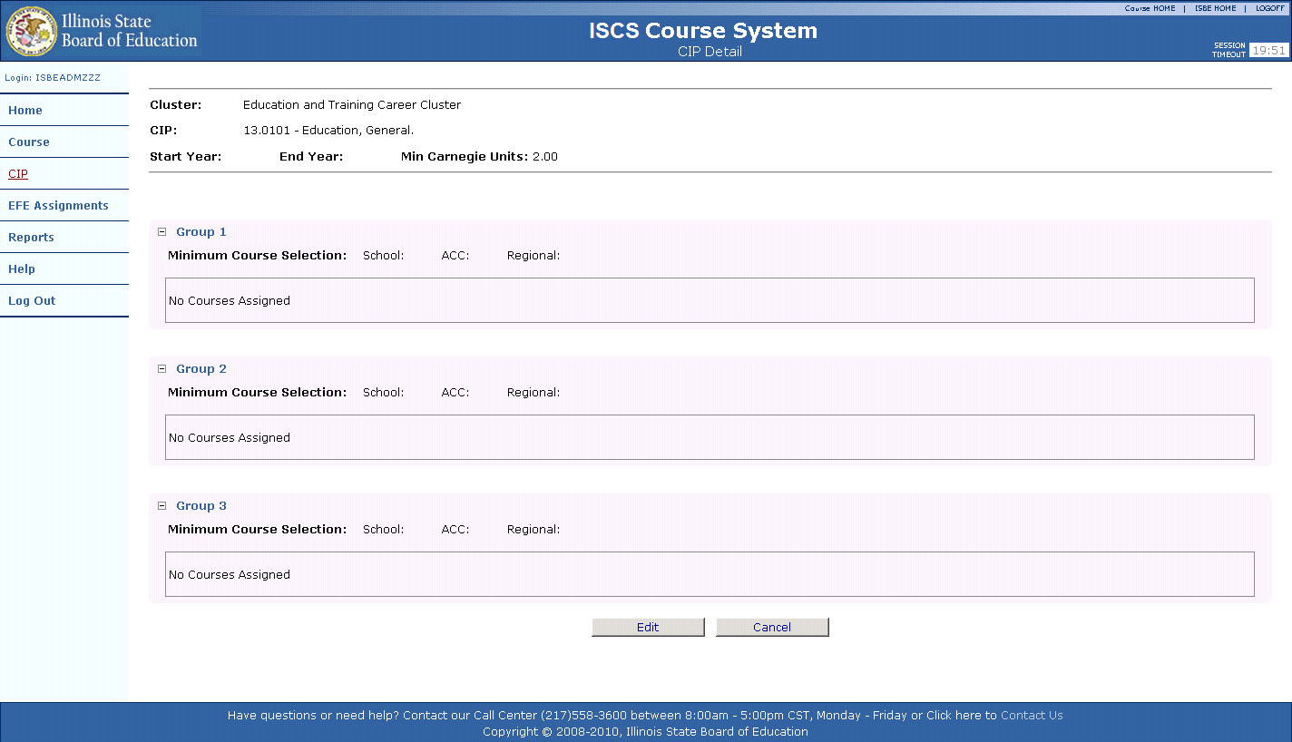

Edit CIP

The View CIP screen includes details on the CIP selected and courses that are assigned to the CIP. If the CIP is empty, the Review CIP screen will look as it does in the above illustration. If data has already been entered, it will be displayed. The user can select the “Cancel” button and be directed back to the Search CIP screen, or the CIP can be edited by selecting the “Edit” button at the bottom of the screen. Once the “Edit” Button is selected the Edit CIP screen is displayed.

Following is an illustration of the Edit CIP screen.

Figure 21 – Edit CIP
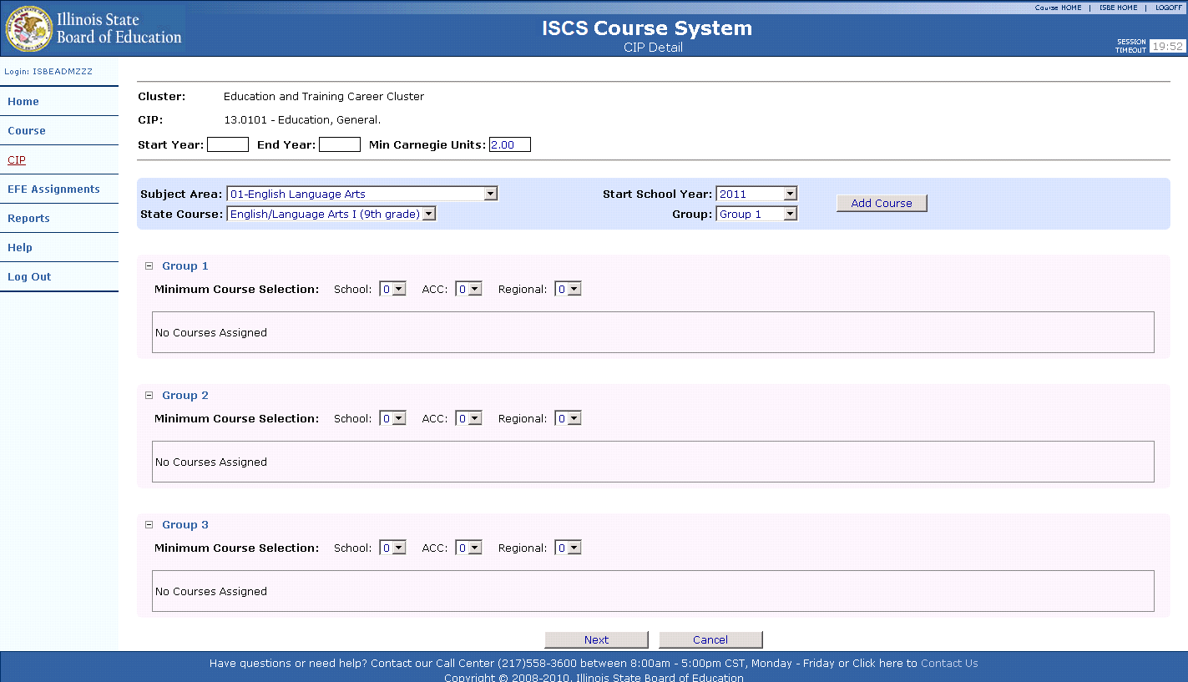

The Edit CIP screen allows the user to edit information directly pertaining to the CIP and what courses are assigned to the CIP. The following fields about the CIP can be edited:
- CIP Start Year,
- CIP End Year, and
- Minimum Carnegie Unit.

The course selection criterion allows the user to add courses to the groups below. The following criteria must be selected to add a course to the CIP:
- Subject Area,
- State Course Title,
- CIP Course Start Year, and
- Group.

Once the criterion for the course has been selected, the course is added to the group by selecting the “Add Course” button. This process is repeated until all courses have been assigned to the CIP.

A CIP consists of three different groups. The groups were created to give priority to class selection when the EFE begins to assign courses to schools. Each group contains an editable minimum course selection for the following:
- Schools,
- ACC (Area Career Center), and
- Regional programs.

Following is an illustration of the Edit CIP screen.

Figure 22 – Edit CIP
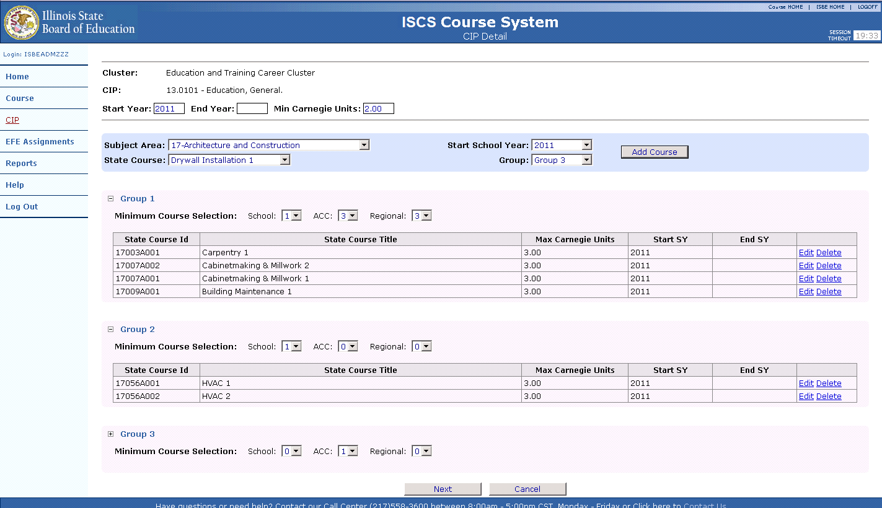

After courses are assigned to the appropriate “Groups” within a CIP, the course “Start Year” and “End Year” can be edited or the course can be deleted. Each course contained in the CIP will display an “Edit” link and “Delete” link. If the “Delete” link is selected, the course is removed from the CIP. If the “Edit” link is selected, the course “Start Year” and the “End Year” fields become editable. Once edits have been made, the “Update” link can be selected to update the course record.

Following is an illustration of the Edit CIP screen – with the course “Edit” link selected.

Figure 23 – Edit CIP – Edit Course
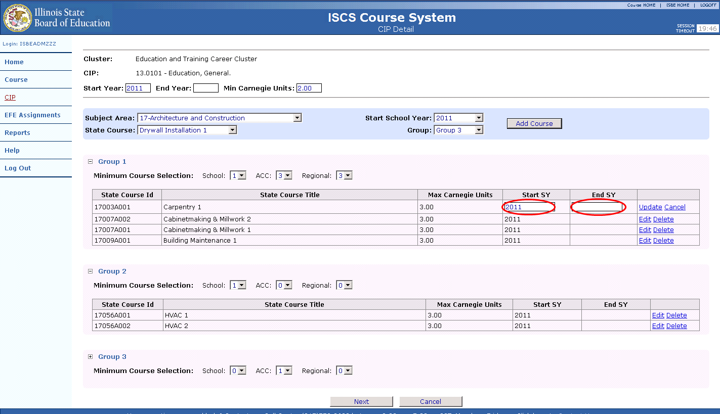

Once all courses are assigned to the CIP in the correct groups and all minimum course selections have been assigned to each group, the “Next” button must be selected to continue to the Review CIP screen. If the user wishes to cancel the transaction, the “Cancel” button can be selected and the user will be returned to the View CIP screen.

Following is an illustration of the Review CIP screen.

Figure 24 – Review CIP
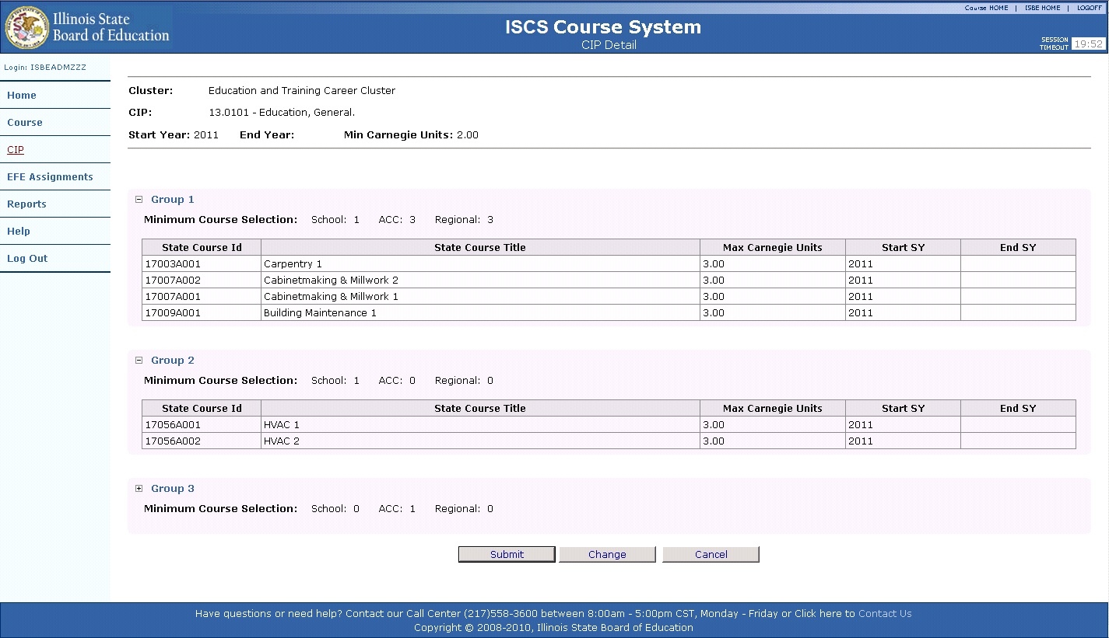

If all data entered into the CIP is correct, the “Submit” button can be selected to update the CIP and the user will be returned to the View CIP screen. The user may also select the “Change” button to return to the Edit CIP screen to make corrections. If the “Cancel” button is selected the transaction is cancelled and the user is returned to the View CIP screen.

EFE User - Assigning Courses to Schools
After Illinois State Board of Education personnel have completed the preparation of the CIPs and courses for the year, EFEs must assign the CIPs and courses to the schools that are located within their region. To access the Illinois State Course System “EFE Assignment” function, the user must log in Illinois State Course System via IWAS. From the Illinois State Course System home page the “EFE Assignment” function must be selected

Following is an illustration of the Illinois State Course System Homepage – EFE Assignment function.

Search EFE Assignments

Figure 25 – Illinois State Course System Homepage – EFE Assignment Function
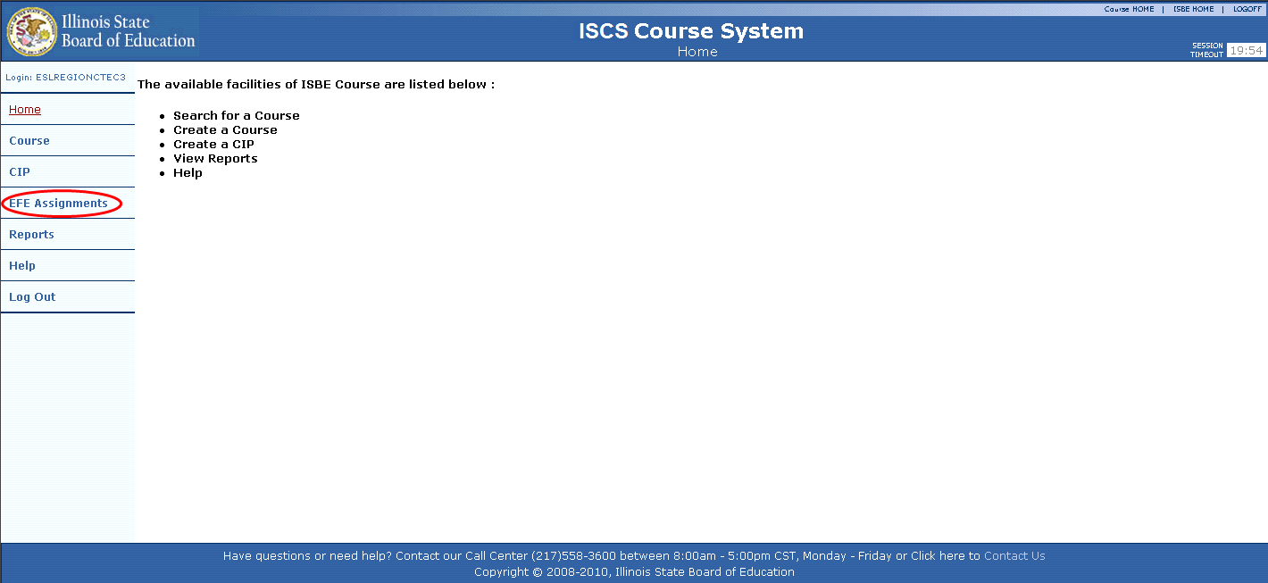

Once the user selects the EFE Assignment link from the Illinois State Course System home page the EFE User - Search CIP screen is displayed.

Following is an illustration of the EFE User - Search CIP.

Figure 26 – EFE User – Search CIP
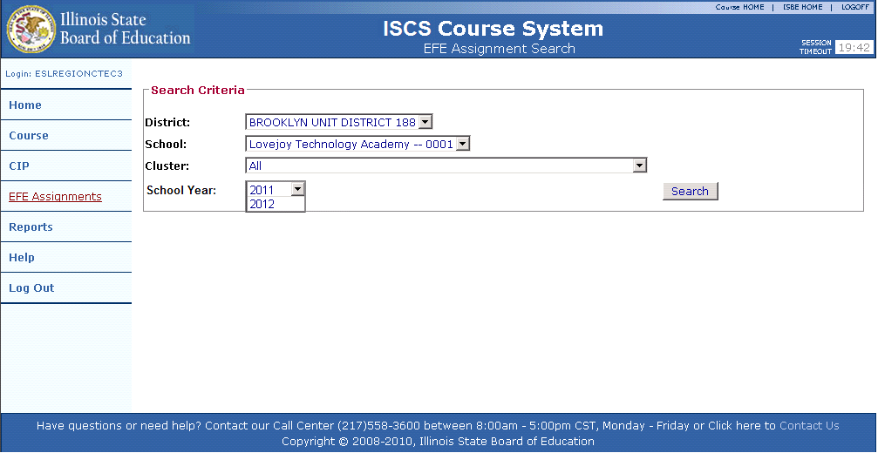

User chooses all of the following and selects the “Search” button:
- District,
- School,
- Cluster, and
- School Year.

The following is an illustration of the EFE User – Search CIP - Results screen (No CIPs assigned).

Figure 27 – EFE User – Search CIP - Results (No CIPs Assigned)
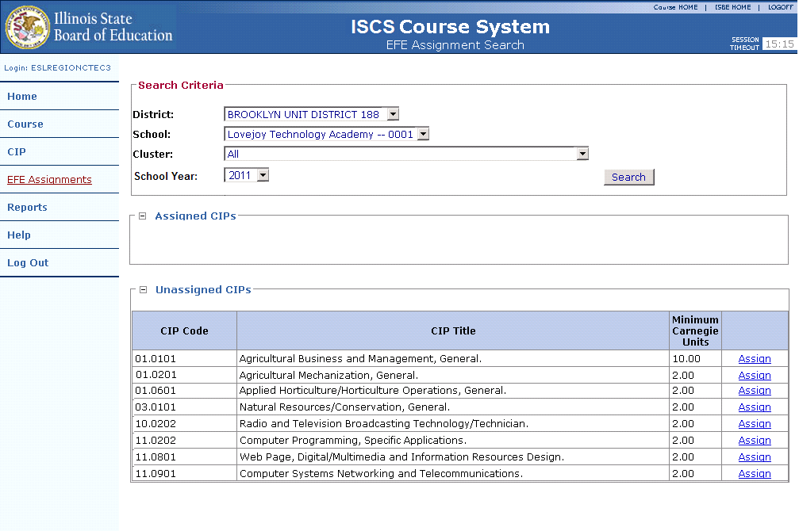

View EFE Assignments
Once the “Search” button has been selected the results are returned to the user. If CIPs were assigned to the school selected at an earlier time, they would be listed in the “Assigned” Category. The user must select the “Assign” link next to the CIP they would like to assign to the selected school.

Following is an illustration of the EFE User – View Assignments screen.

Figure 28 – EFE User – View Assignments
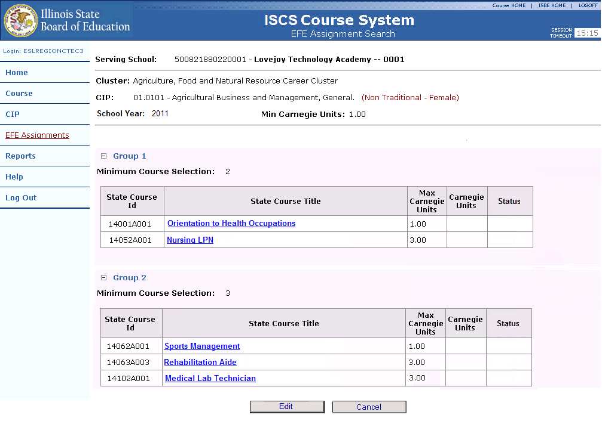

After the “Assign” link is selected, the user is directed to the EFE User - View Assignments screen. This screen shows all assigned courses and the minimum selections for each group within the school selected. The EFE user must adhere to the minimum selections that were pre-selected by ISBE when entering the courses. To edit the course assignments the user must select the “Edit” button at the bottom of the screen.

Following is an illustration of the EFE – CIP Assignment View screen.

Figure 29 – EFE – CIP Assignment View
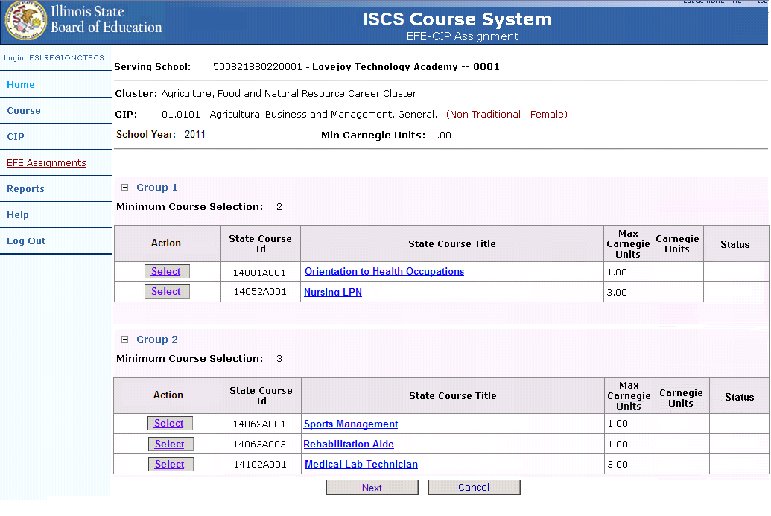

If the user is curious about the description of a State Course, the “Course Title” link can be selected and the user will be presented with a pop-up box that includes the entire State description of the selected course.

Following is an illustration of the EFE User - Edit Assignments – Description Screen.

Figure 30 – EFE User - Edit Assignments - Description
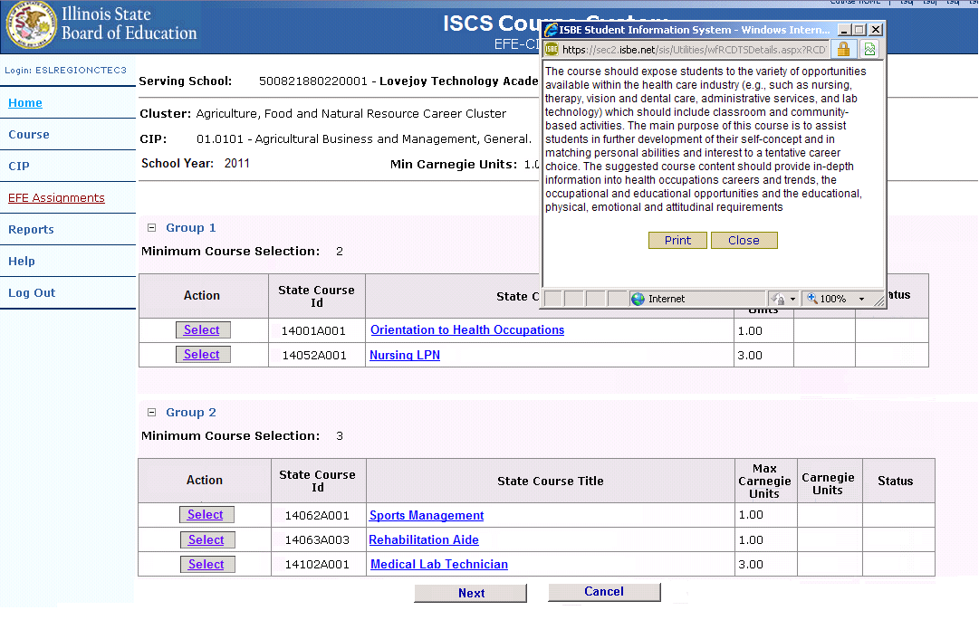

Edit EFE Assignments
On the Edit Assignments screen, links appear on the screen next to each course record. If the “Select” link is selected on a course, the record becomes editable and the user can assign the course to the school.

Assign Course

Following is an illustration of the EFE User - Edit Assignments screen with a course selected.

Figure 31 – EFE User - Edit Assignments – Assign Course
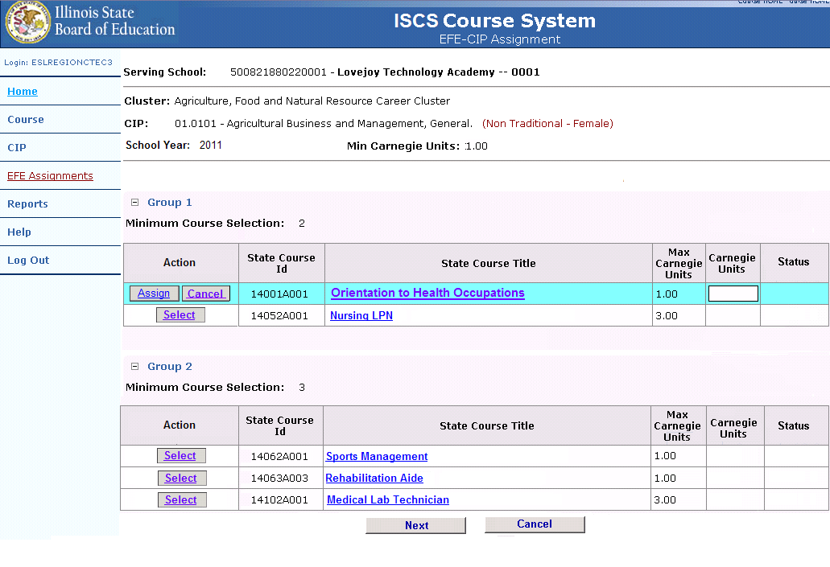

After the course is selected, the user is presented with two buttons. The “Assign” button will assign the course to the school. If the course was selected in error, the user can select the “Cancel” button to be returned to the Edit Assignments screen.

Following is an illustration of the EFE User - Edit Assignments screen.
Figure 32 – EFE User - Edit Assignments
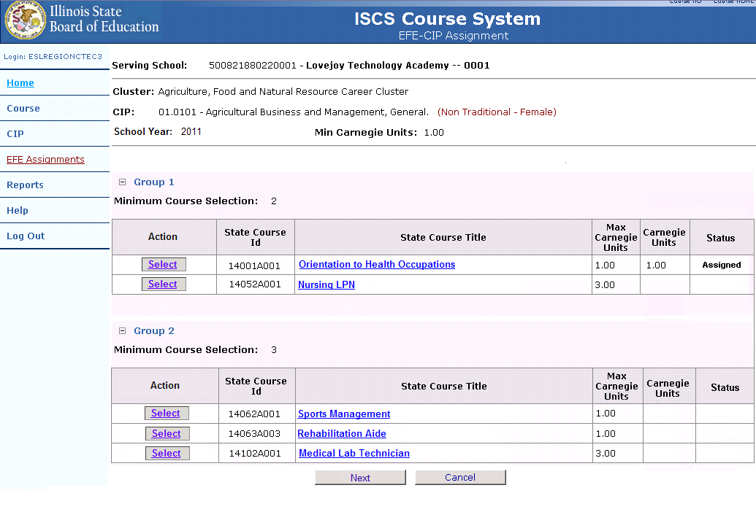

After a course has been assigned, the user is returned to the Edit Assignments screen where they can select other courses that are being taught at the school. Once the “Select” link is selected the record becomes editable.

Following is an illustration of the EFE User - Edit Assignments – Assign Course screen.

Figure 33 – EFE User - Edit Assignments – Assign Course
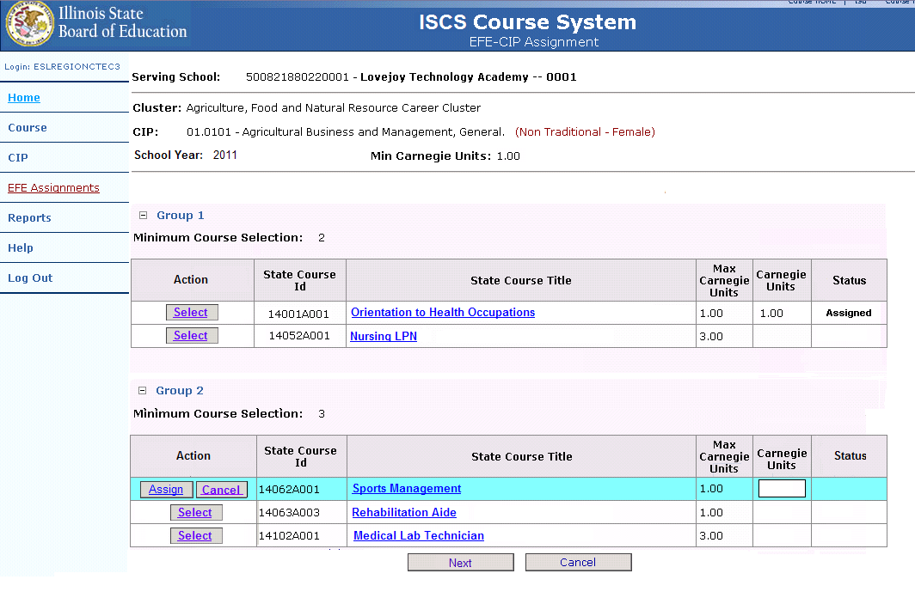

The user can select the course they would like to assign to the school. Once the user selects the “Assign” button, they are returned to the Edit Assignments screen.

Following is an illustration of the EFE User - Edit Assignments screen.

Figure 34 – EFE User - Edit Assignments
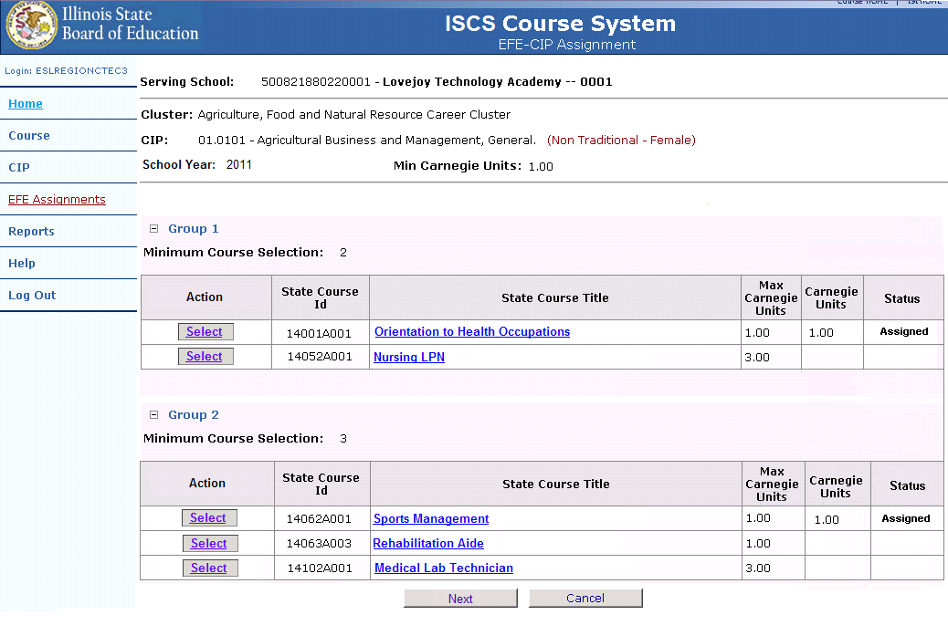

After the desired courses have been selected for the school, the user must select the “Next” button located at the bottom of the screen to continue to the EFE User – Review Assignments screen. Illinois State Course System will validate that all minimum selections for each group have been satisfied. If the minimum selections are not met, the user is displayed an error identifying which group did not meet the requirement.

Following is an illustration of the EFE User - Review Assignments screen.

Figure 35 – EFE User – Review Assignments

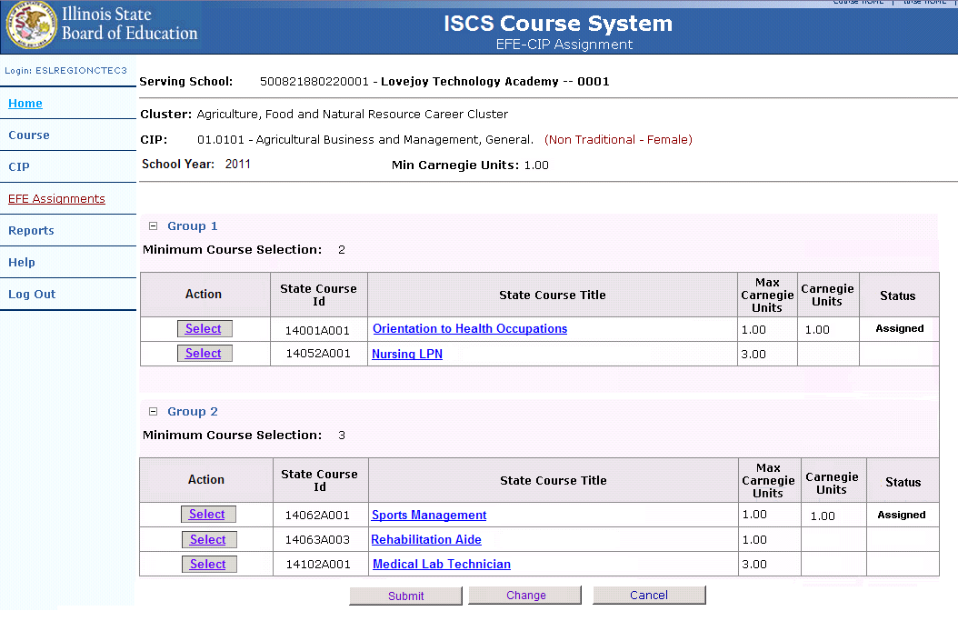

The user is displayed a Review Assignments screen which contains all courses and Carnegie Units assigned to the school. The user should review this information for accuracy. If all information is accurate, the user can select the “Submit” button to commit the course assignments. The “Change” button can be selected to return to the Edit Assignments screen if changes are identified. The user can also select the “Cancel” button to be returned to the Edit Assignments screen and cancel all transactions.

The following is an illustration of the EFE User - View Assignments – Update Successful screen.

Figure 36 – EFE User – View Assignments – Update Successful
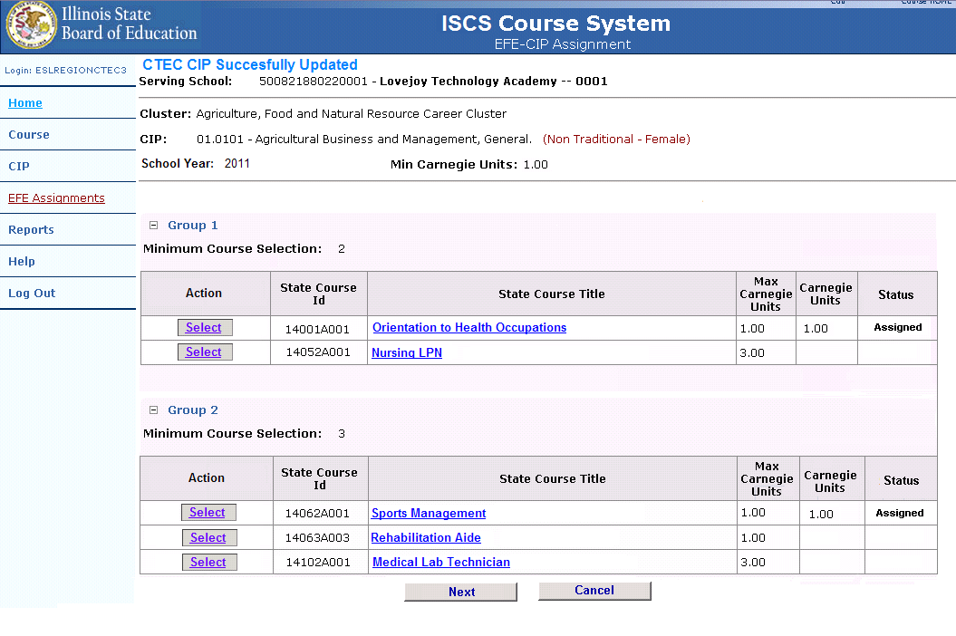

Once the user has chosen to commit the record and selects the “Submit” button on the Review Assignments form, the View Assignments screen is returned with a “Successful Update” message at the top.

Unassign Course

Once the assignments have been made to a school, the assignments can be also unassigned until ISBE policy dictates otherwise. To unassign a course, the “Select” link must be selected from the Edit Assignments screen.

Following is an illustration of the EFE User - Edit Assignments – Unassign screen.

Figure 37 – EFE User – Edit Assignments - Unassign
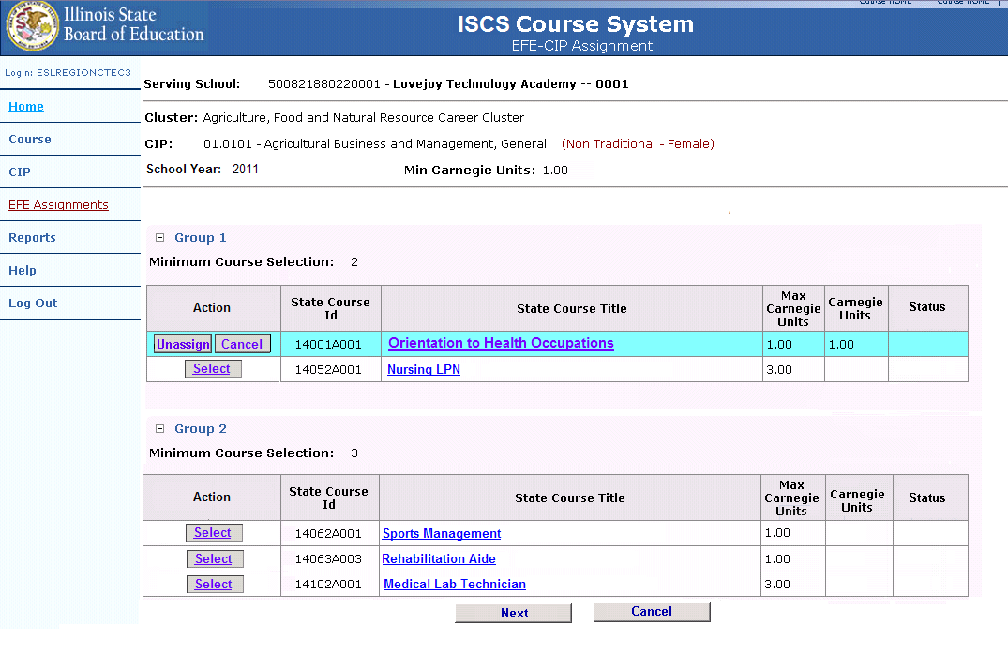

After the “Select” link has been selected the individual course record will display two buttons, “Unassign” and “Cancel”. If the “Unassign” button is selected, the course will be unassigned from the school and the user will be directed back to the EFE User - Edit Assignments screen. The “Cancel” button will return the user to the EFE User - Edit Assignments screen without taking any action.

Following is an illustration of the EFE User - Edit Assignments screen.

Figure 38 – EFE User – Edit Assignments
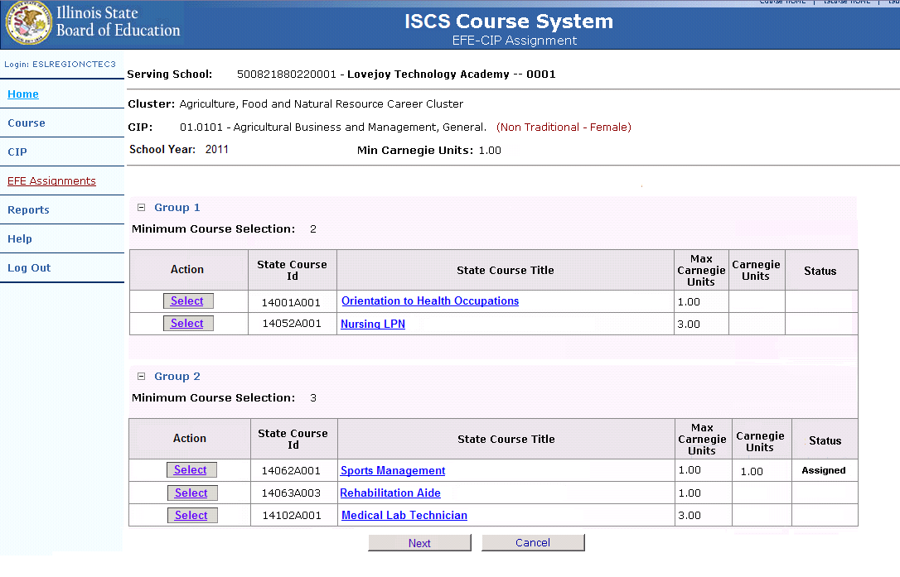

Once all the assignments are corrected, the user must select the “Next” button at the bottom of the screen to continue to the Review Assignments screen

Following is an illustration of the EFE User – Review Assignments screen.

Figure 39 – EFE User – Review Assignments
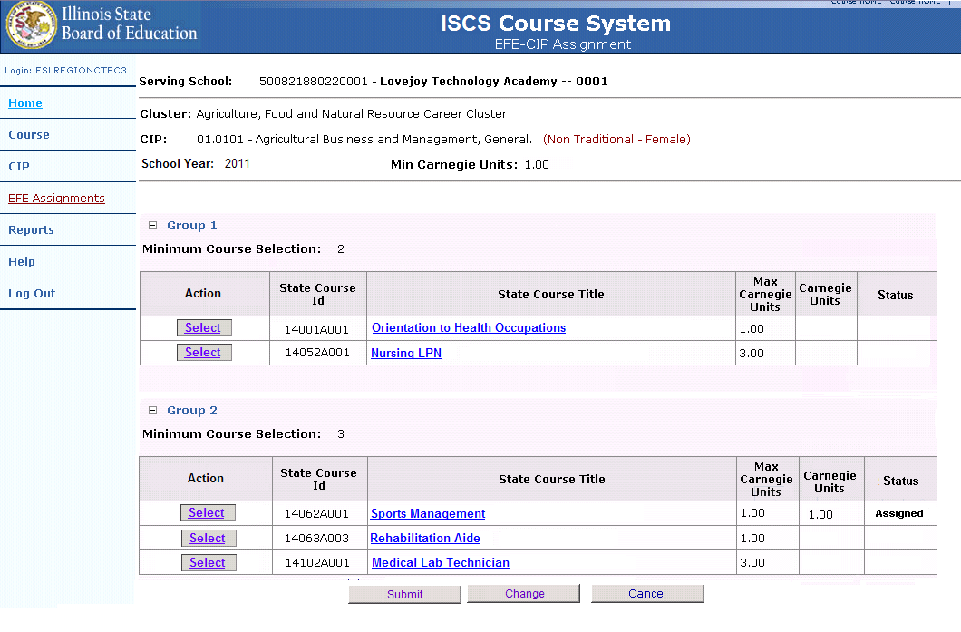

The user should review all assignments and select the “Submit” button to commit the transaction if all assignments are correct. If changes need to be made, the user can select the “Change” button to be returned to the Edit Assignments screen. The user can also select the “Cancel” button to cancel all transactions and return to the EFE User - Edit Assignments screen.

Following is an illustration of the EFE User – View Assignments – Successful Update screen.

Figure 40 – EFE User – View Assignments – Successful Update
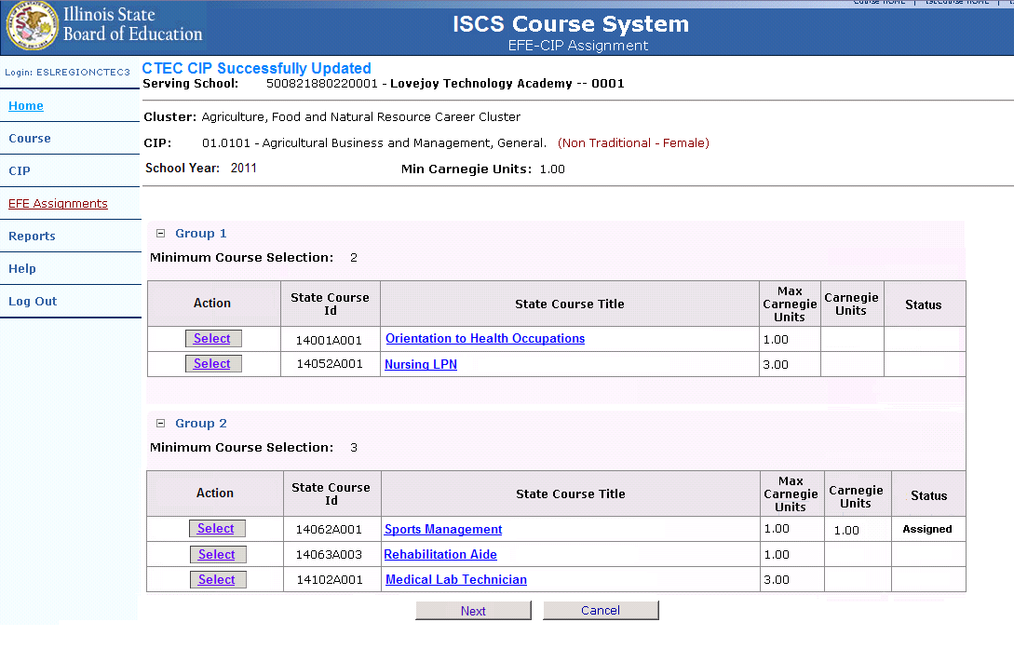

Once the user has chosen to commit the record and selects the “Submit” button on the Review Assignments screen, the View Assignments screen is returned with a “Successful Update” message at the top of the screen.

Unassigning CIPs
Once a CIP has been assigned to a school, it can also be unassigned. To unassign a CIP, the user must first select the district, school, cluster, and school year. They can use the EFE Assignment function. Once the “EFE Assignment” link is selected, the user is displayed the Search CIP screen.

Following is an illustration of the EFE User - Search CIP screen.

Figure 41 – EFE User - Search CIP
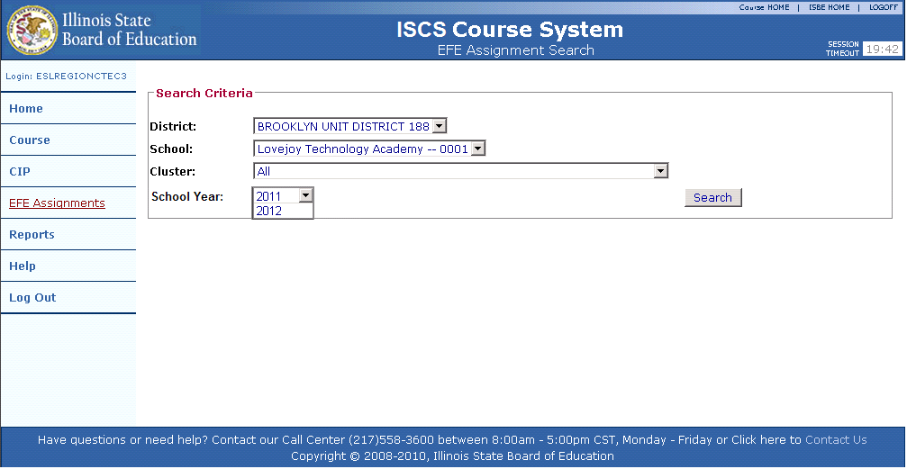

User chooses all of the following and selects the “Search” button:
- District,
- School,
- Cluster, and
- School Year.

Following is an illustration of the EFE User - Search CIP - Results screen.

Figure 42 – EFE User - Search CIP - Results
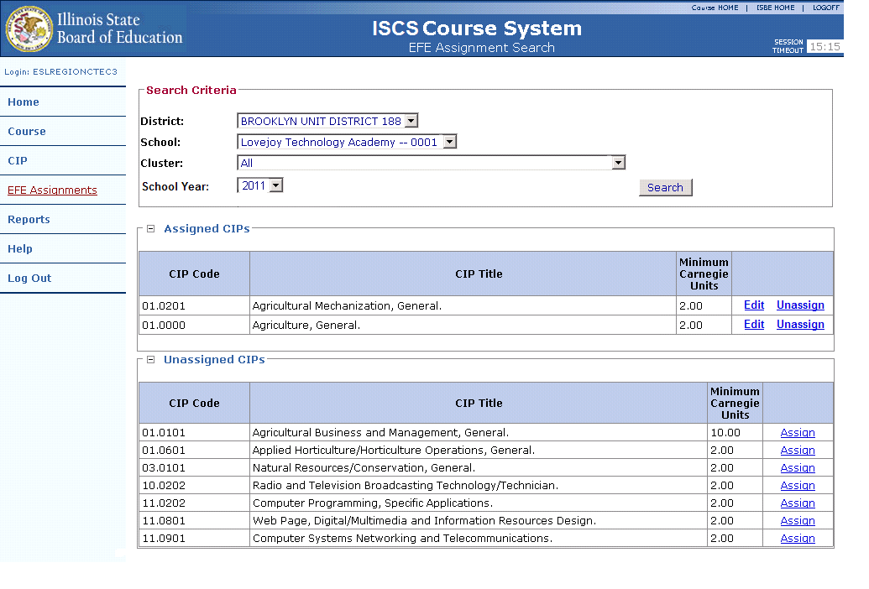
Results are returned to the user. Any CIPs assigned will be listed in the “Assigned” category. The user must select the “Unassign” link next to the CIP they would like to Unassign. Once the link is selected the user is directed to the EFE User – View Assignments screen.

Following is an illustration of the EFE User- View Assignments screen.

Figure 43 – EFE User- View Assignments
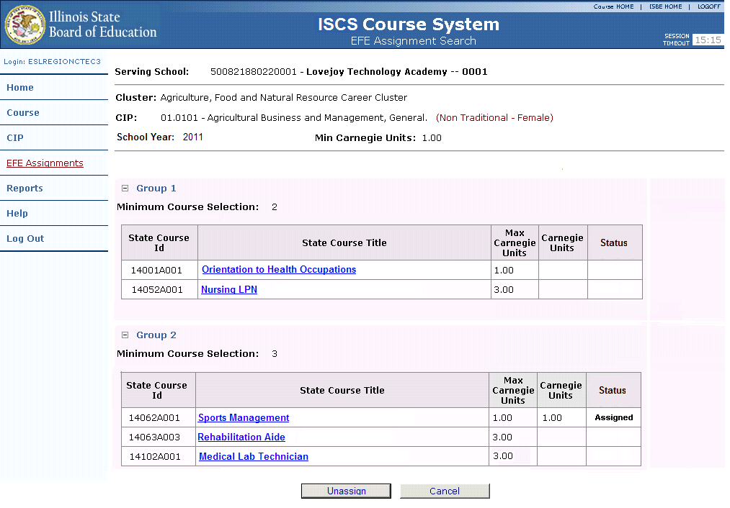

Once the CIP to be unassigned has been selected, the View Assignments screen is displayed. After the user reviews the assignments, they can choose to unassign the CIP by selecting the “Unassign” button located at the bottom of the screen. The “Cancel” button can also be selected, returning the user to the Search CIP screen.

Following
is an illustration of the EFE User- Search CIP – Results - Successful Update screen.

Figure 44 – EFE User- Search CIP – Results - Successful Update
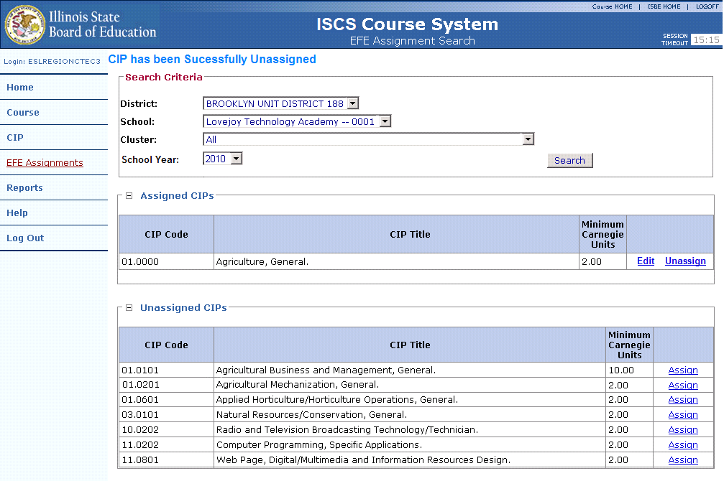

After the “Unassign” button has been selected, the user is returned to the Search CIP form with an “Update Successful” message displayed to the user at the top of the screen.

Reports
The Illinois State Course System online reports allow an authorized user to view summary and detail data. The reports may be used to verify course, CIP, and EFE assignment records.

Following is an illustration of the Illinois State Course System Reports Screen.

Figure 45 – Illinois State Course System Reports Screen
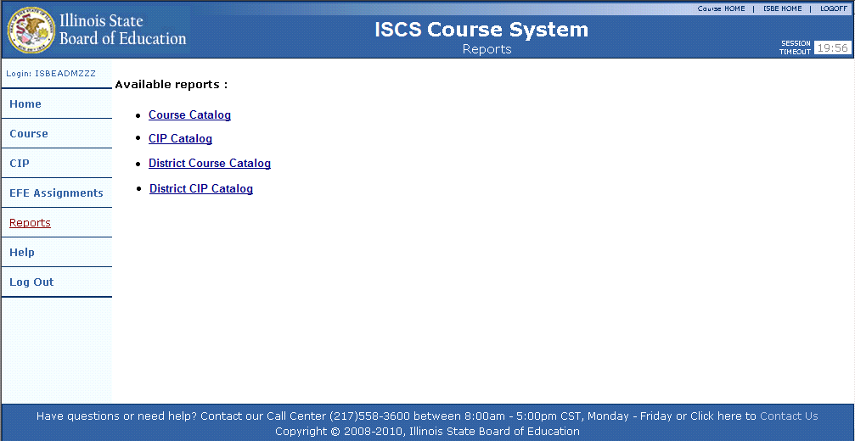

Illinois State Course System Report Navigation
All ISBE Illinois State Course System reports are displayed using a Crystal Reports viewer. The reports will display in a new browser. If reports are not displaying correctly, a user should check the pop-up blocker settings for the browser. Once the report is displayed, a user may navigate from page to page, search for a value, change the display size, export the data, as well as print the report.

Below is an illustration of the Illinois State Course System Crystal Report menu bar.

Figure 46 - ISBE SIS Crystal Report Menu

Navigation
To navigate from page to page, the user must click the right or left arrow to navigate to the next page or navigate to the first or last page of the report. To navigate, the user must click the following buttons:

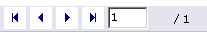

Additionally, a user may navigate to a specific page by typing the page number in the following text box and clicking the “Go To” button.

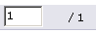

Display Size
To change the display size, the user may click the following drop-down arrow to make the display smaller or larger.

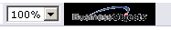

Search
To search for a word or value, the user may type the value in the text box and click on the binocular icon to conduct the search. The user must click the following button to conduct the search:

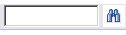

Export
The Crystal reports menu bar allows a user to export data to a desired format. For example, a user may select to export the report to Excel or MS Word. Additionally, a user may choose to only export specific pages of the report. The export function should only be used to review data at a local level. The user must click the following button to export the data:

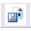

Once the button is selected, an export selection screen is displayed. Following is an illustration of the Report Export Selection Criteria Screen.

Figure 47 – Report Export Selection Criteria
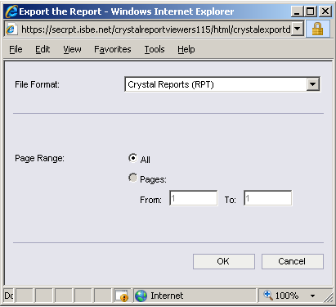

Print
A user is given the option to print the report. The entire report or specific pages may be printed. A user must click the following button to print the report:

Once the button is selected, a print selection screen is displayed.

Following is an illustration of the Report Print Selection Criteria Screen.

Figure 48 – Report Print Selection Criteria
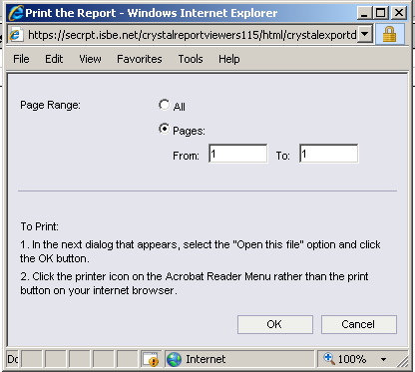

Once the Print button is pressed, the report is generated in Adobe Acrobat (PDF) format and the user may then print the report from the PDF format.

State Course Catalog Report
The Course Catalog report is a complete catalog of both Federal and State Courses. Once the report link is selected on the Illinois State Course System reports screen, the user is directed to the criteria screen for the course catalog report.

Following is an illustration of the selection criteria for the Course Catalog report.

Figure 49 – State Course Catalog Criteria Screen
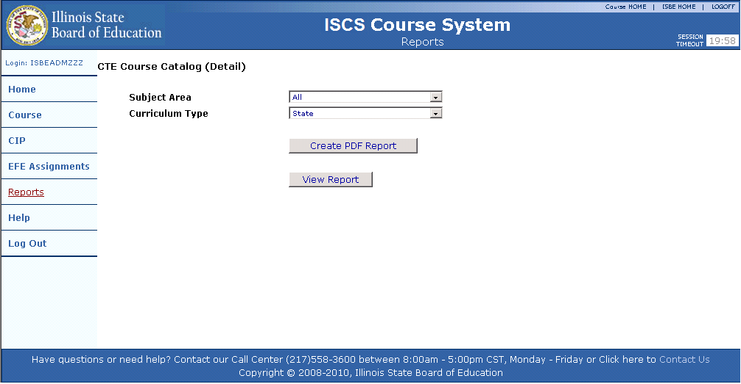

After all criteria selections have been made, the user must select the “View Report” or “Create PDF Report” buttons to run the report.

Fields displayed on the report include:
- Subject Area
- Federal Course ID
- Federal Course Title
- Federal Course Description
- State Course ID
- State Course Title
- State Course Starting Year
- State Course Ending Year
- State Course – Maximum Carnegie Units
- State Course Description

Following is an illustration of the State Course Catalog Report.

Figure 50 – State Course Catalog Report
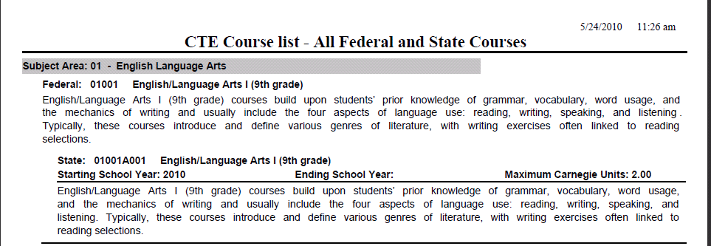

CIP Catalog Report
When selecting the CIP Catalog Report, an authorized user must select the school year and school (Home School) to be displayed on the report. A user may select all schools or a specific school.

The fields available to filter the report include:
- Cluster
- Status

Following is an illustration of the selection criteria for the CIP Catalog Report.

Figure 51 – CIP Catalog Criteria Screen
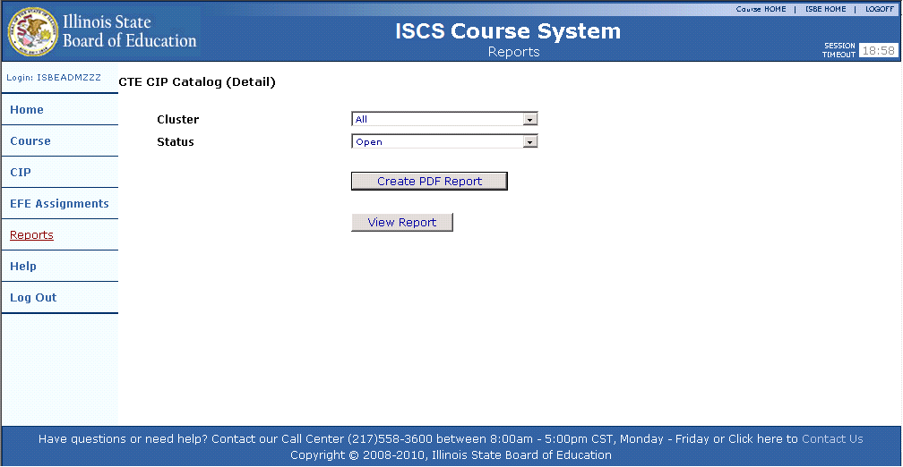

After all criteria selections have been made, the user must select the “View Report” or “Create PDF Report” buttons to run the report.

Below is an illustration of the CIP Catalog Report.

Figure 52 – CIP Catalog Screen
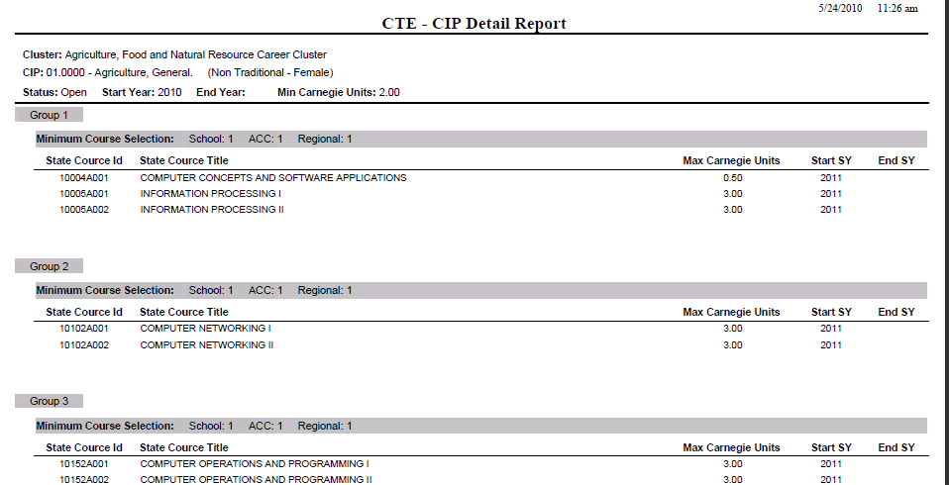

State Course Catalog Report
The State Course Catalog Report is a complete catalog of Federal and State Courses by district and/or school. Once the report link is selected on the Illinois State Course System reports screen, the user is directed to the criteria screen for the District State Course Catalog Report.

Following is an illustration of the selection criteria for the State Course Catalog Report.

Figure 53 – State Course Catalog Criteria screen
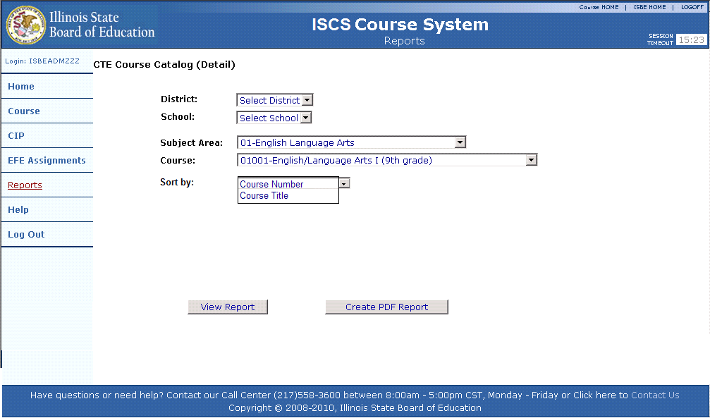

After all criteria selections have been made, the user must select the “View Report” or “Create PDF Report” buttons to run the report.

Following is an illustration of the State Course Catalog Report.

Figure 54 – State Course Catalog Screen
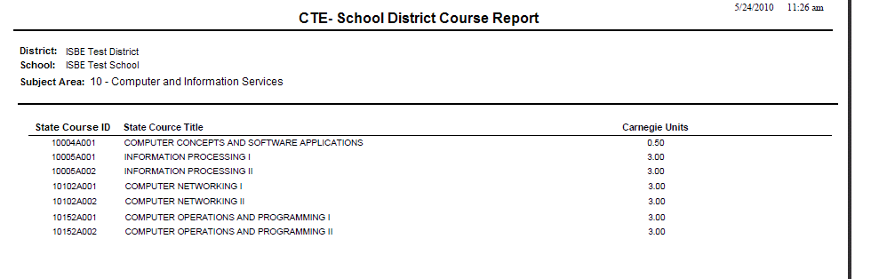

State CIP Catalog Report
When selecting the State CIP Catalog Report, an authorized user must select the school (Home School), Cluster, and the CIP to be displayed on the report. A user may select all schools or a specific school.

The fields available to filter the report include:
- Home School
- Cluster
- CIP

Following is an illustration of the selection criteria for the State CIP Catalog Report.

Figure 55 – State CIP Catalog Criteria Screen
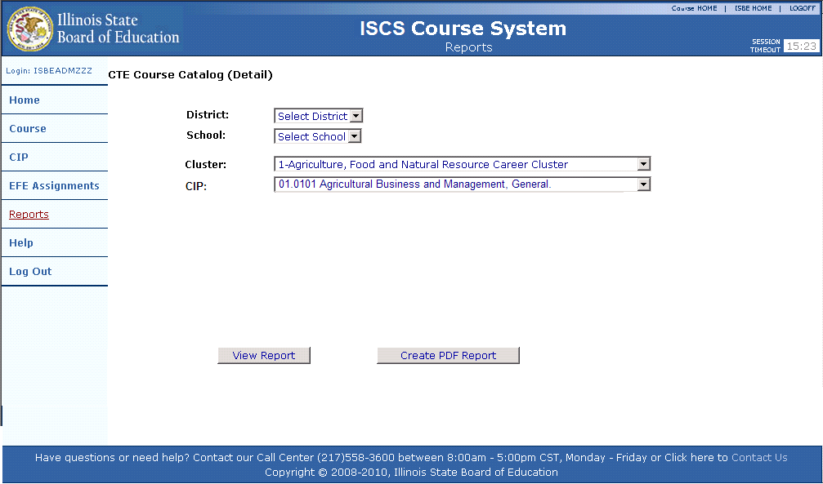

After all criteria selections have been made, the user must select the “View Report” or “Create PDF Report” buttons to run the report.

Following is an illustration of the State CIP Catalog Report.

Figure 56 – State CIP Catalog Report
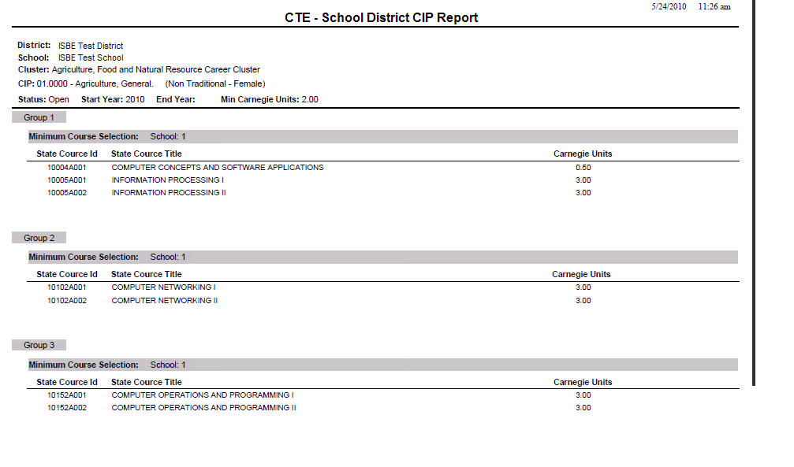

Section
6

Data Quality

SBE believes in the importance of collecting quality data about Illinois courses and agrees with the National Forum on Education Statistics’ (NFES) recommendations for creating a “Culture of Quality Data” which is explained in their publication, “Forum Guide to Building a Culture of Quality Data.” This guide expresses the need for school and district personnel to focus on the quality of the data being collected on course information that has many uses - statistics, school budget planning, a child’s placement in a class, and instructional plan development.

To help your schools and districts move toward a “Culture of Quality Data,” a brief overview of NFES’s “Forum Guide to Building a Culture of Quality Data” is provided below.

“The intent of this [NFES] guide is to point out some common principles that can help increase the likelihood that data will be secure, accurate, and useful.”

Individual copies of the Guide may be printed from the Forum website at: http://nces.ed.gov/forum/pub_2005801.asp. Tip sheets on the Roles of Key Players may also be found and duplicated so that each person can retain a copy of the appropriate suggestions for their role in the collection of Quality Data student information.

Introduction
Quality data, like quality students, come from schools. While it is undeniably harder to teach a student than it is to collect statistics, there are procedures that can help us achieve our goals in both cases. Recently, there has been a growing awareness that effective teaching, efficient schools, and quality data are linked. The quality of information used to develop an instruction plan, run a school, plan a budget, or place a student in a class depends upon the school data clerk, teacher, counselor, and/or school secretary who enter data into a computer. With that in mind, the focus of this guide is on data entry - getting things right at the source.

Orderly Information from Disorderly Setting
Data often enter electronic systems from a school or school district office, which may not be an optimal setting for paying careful attention to numbers. Office staff members are expected to perform many tasks, from greeting parents to answering the phone, sorting the mail, producing memos, and bandaging wounded knees. While all these things are going on, often simultaneously, staff members are expected to fill out forms and enter data into computers. During conference periods in classrooms when teachers are trying to enter attendance information or grades into computers, the situation can be just as busy.

We want trained data entry personnel who work in an environment that assists, not hinders, data entry. When people are doing important work, we want them to concentrate on the task. We do not expect, for example, the person preparing our tax returns to be eating lunch or talking on the phone with clients while entering our itemized deductions into a computer. However, those may be the conditions of a school secretary’s life. And remember, bad data about a student or school can cause bigger problems than a lost tax refund.

It is important to understand that “quality data” is not something that just occurs when an office clerk hits the right number on a keyboard. It is a process. We need to pay attention to the process involved because the information derived from school data is vital. The intent of data entry and collection is to produce information that reflects reality - that lets us know what is actually happening in a school. It is important for all staff members to understand the issues involved in data collection and data entry and to recognize that those issues reflect the values of the organization. Based on an analysis of these processes, we can work toward developing a “Culture of Quality Data” that will result in good information.

What is a Culture of Quality Data?
A Culture of Quality Data is the belief that good data are an integral part of teaching, learning, and managing the school enterprise. Everyone who has a role in student outcomes - teachers, administrators, counselors, office support staff, school board members, and others - shares this belief. Because good data are as much a resource as staff, books, and computers, a wise education system is willing to invest time and money in achieving useful information and respects the effort taken to produce it.

NCES Components of a Culture of Quality Data
According to the Forum, “everyone whose job touches students has a role in ensuring data quality. When a school or district embraces a Culture of Quality Data, it shows its concern in the following major areas:
- Accuracy. The information must be correct and complete. Data entry procedures must be reliable to ensure that a report will have the same information regardless of who fills it out.
- Security. The confidentiality of student and staff records must be ensured, and data must be safe.
- Utility. The data have to provide the right information to answer the question that is asked.
- Timeliness. Deadlines are discussed and data are entered in a timely manner.”

Key Elements to Achieving Quality Data
- Clear standards and guidelines for data quality:
  - Policies and Regulations
  - Standards and Guidelines
- School staff with the needed skills and information to enter data correctly:
  - Training and Professional Development
- Workable calendars and timelines to make sure the data are available when needed:
  - Timelines
  - Calendars
- Technology and technology support in place to support these efforts:
  - Technology (Hardware + Software + Network)
  - Data Entry Environment

Summary
Effective policies, guidelines, professional development, and efficient environments are all earmarks of a school or district that values data quality. It is understandable that these conditions will not develop overnight. Like the creation of any other successful program, the creation of a quality data system takes time and requires the development of a systematic process.

When an effective data entry and collection environment exists, staff will spend less time and money correcting data errors and more time on other tasks, such as the instructional program. This can happen when all those involved in the collection and use of data are communicating, when all those involved respect the contributions of the staff who enter the data, and when all staff understand how the data are used.

Acronym Glossary
Acronym | Definition
CFC | Child and Family Connections
CIP | Classification of Instructional Programs
CSV | Comma-Separated Value
CTE | Career and Technical Education
EFE | Education for Employment
FAQ | Frequently Asked Questions
FERPA | Federal Educational Rights and Privacy Act
ISBE | Illinois State Board of Education
ISIS | Illinois Student Information System
IWAS | ISBE Web Application Security System
LEA | Local Education Agency
NCES | National Center for Education Statistics
NCLB | No Child Left Behind Act of 2001
NFES | National Forum of Education Statistics
RCDT | Region, County, District, Type
RCDTS | Region, County, District, Type, School
ROE | Regional Offices of Education
SAP | Student Assistance Program
SES | Supplemental Educational Services/Socio-Economic Status
SID | Student Identifier
SIF | Schools Interoperability Framework
SIFA | Schools Interoperability Framework Association
SIS | Student Information System
TXT | Text
XML | eXtensible Markup Language

